**BÀI TẬP NHÓM: KIỂM THỬ PHẦN MỀM**

**Thành viên nhóm:**

* **Phạm Quốc Văn – 19IT3 (Trưởng nhóm)**
* **Nguyễn Đăng Anh Tú – 19IT3**
* **Phạm Đức Trung – 19IT1**
* **Phạm Gia Huy – 19IT3**
* **Dương Thành Đạt – 19IT3**

**Chọn Bài tập 1**: <https://demo.openmrs.org/openmrs/login.htm>

1. **Login Module**

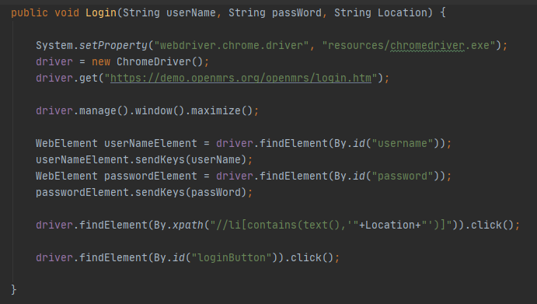

* 1. **Verify Login Functionality**
     1. **Verify User is able to login with CORRECT User Id and Password, Inpatient Ward is selected**

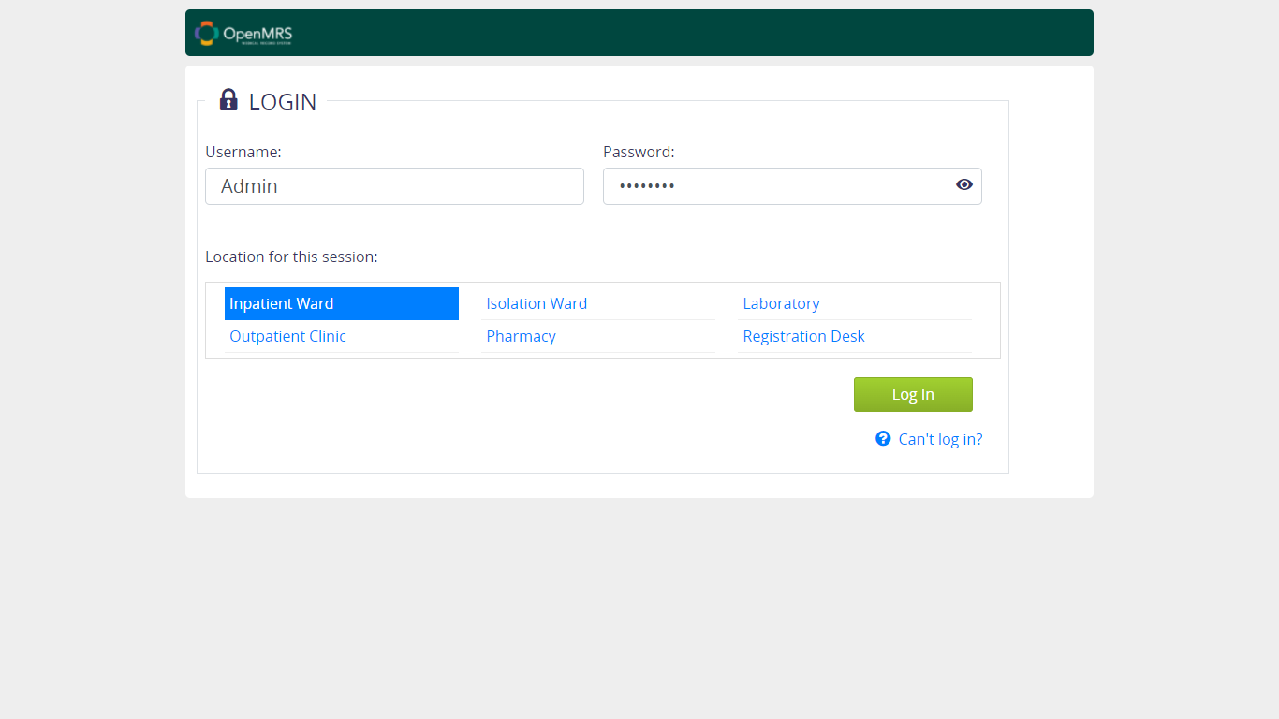

* 1. **Verify Cancel Functionality**
     1. **Verify User is able to login with CORRECT User Id and CORRECT Password, Inpatient Ward is NOT selected**

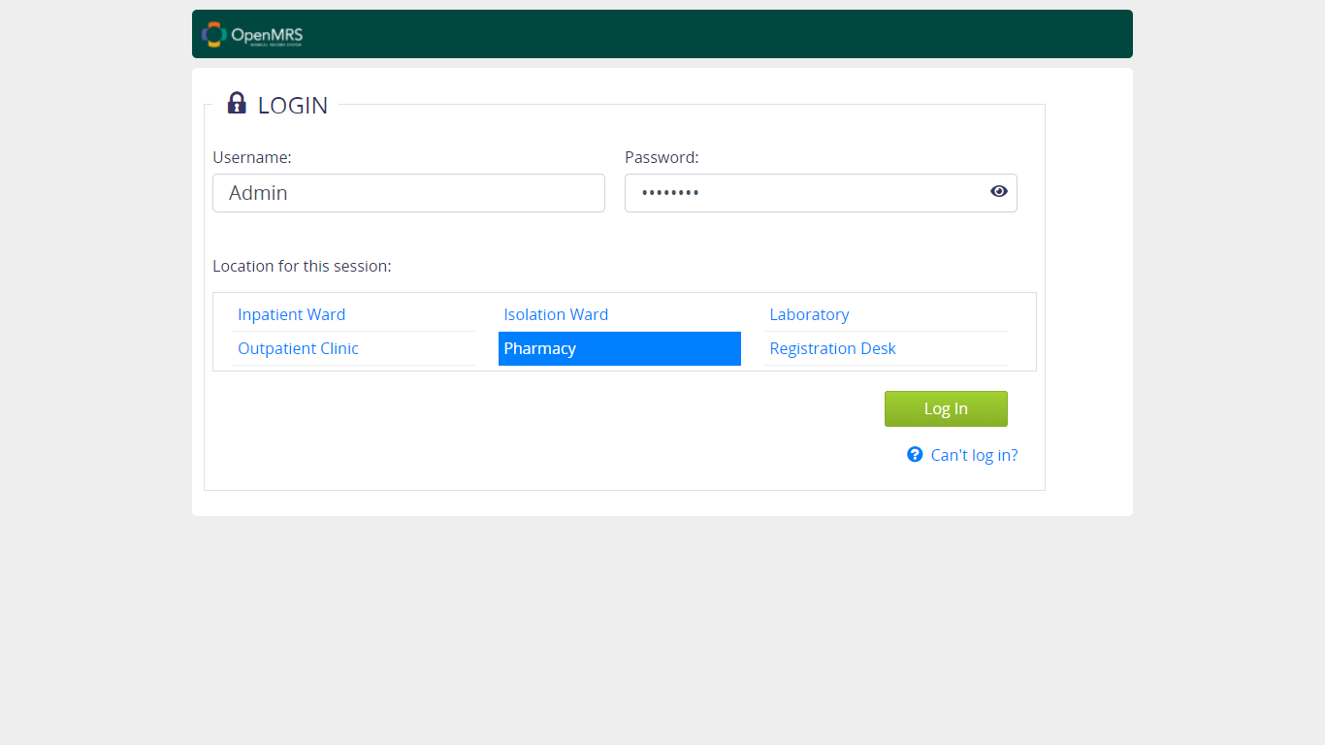

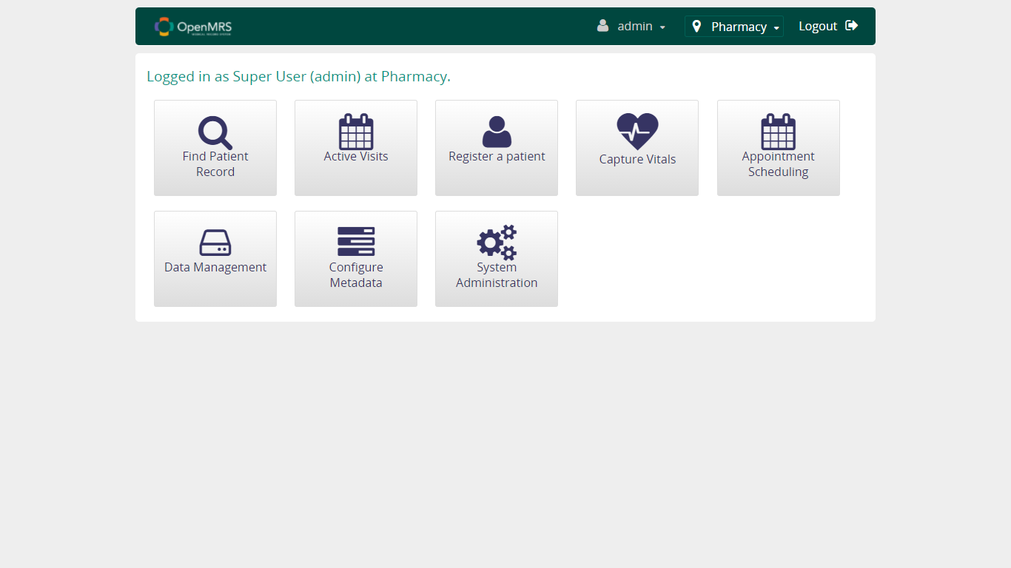

* + 1. **Verify User is able to login with CORRECT User Id and CORRECT Password, NO Location selected**

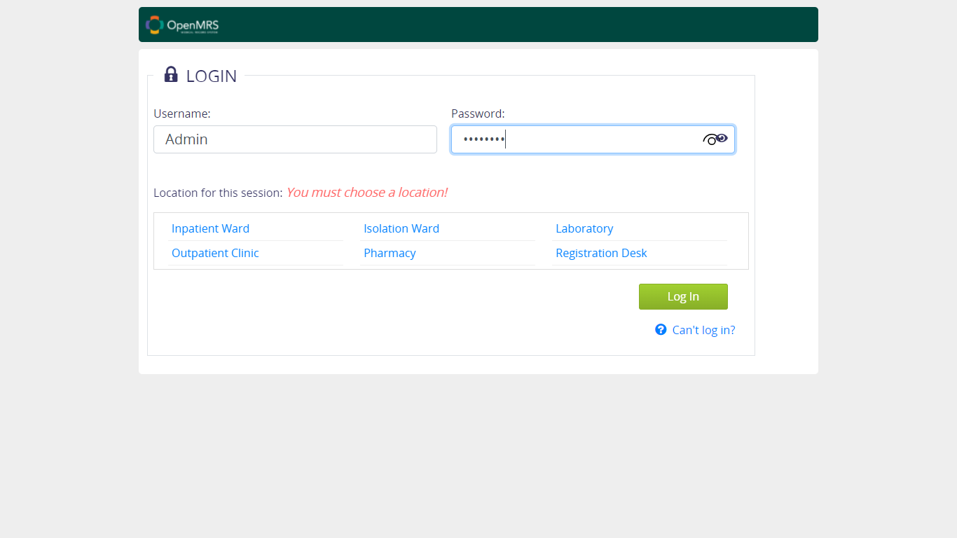

* + 1. **Verify User is able to login with CORRECT User Id and WRONG Password, Inpatient Ward is selected**

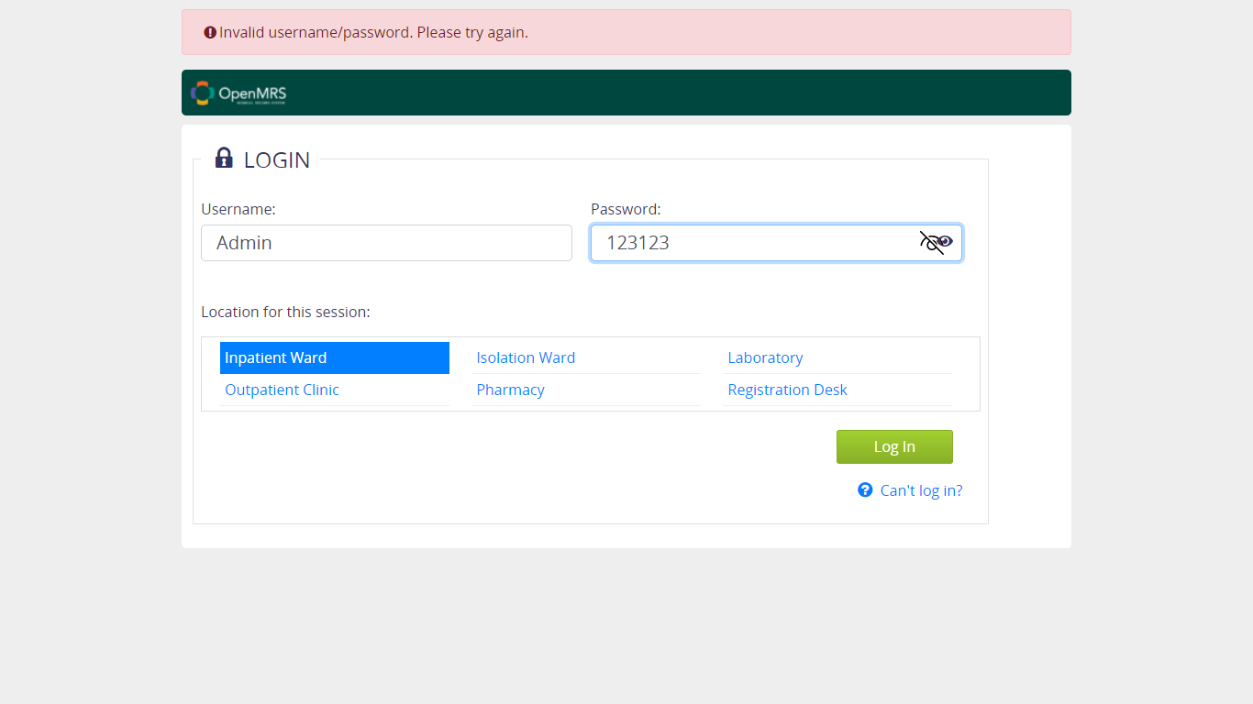

* + 1. **Verify User is able to login with CORRECT User Id and WRONG Password, Inpatient Ward is NOT selected**

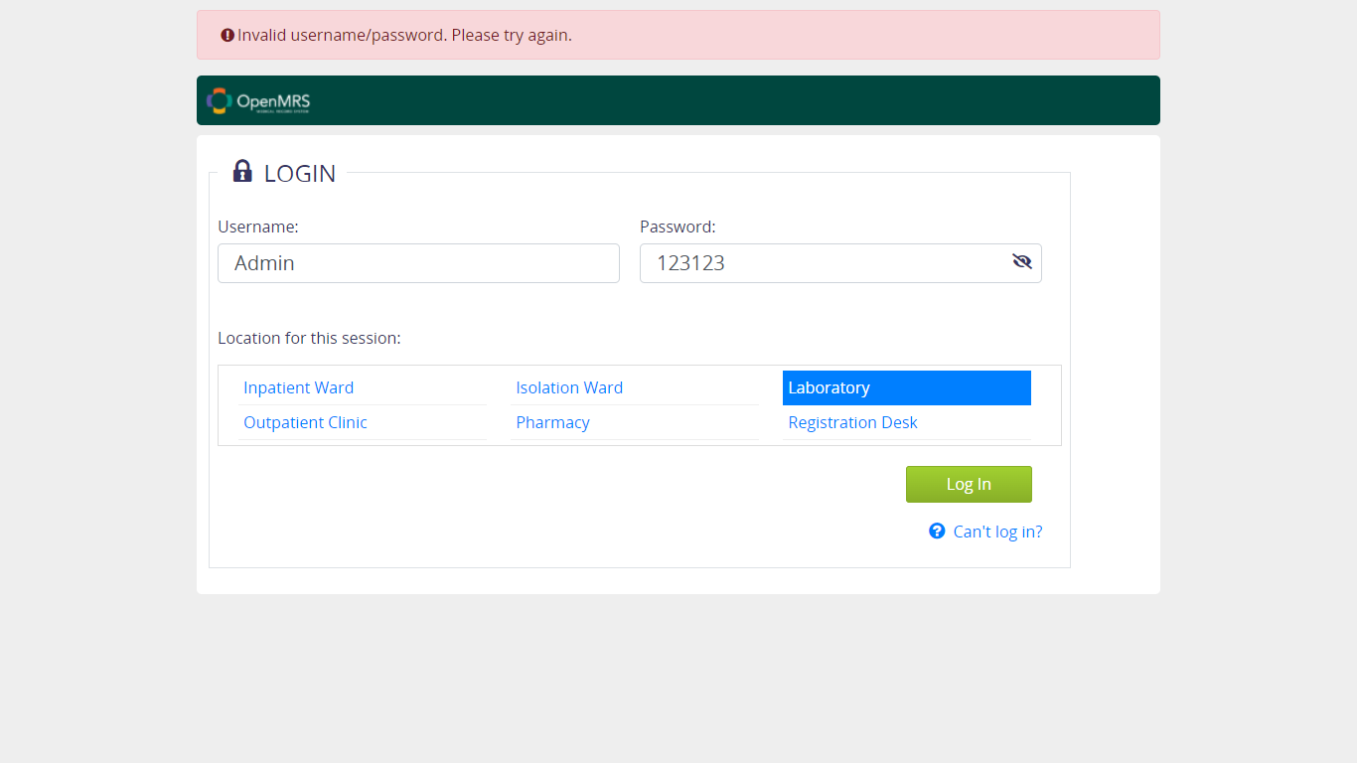

* + 1. **Verify User is able to login with CORRECT User Id and WRONG Password, NO Location selected**

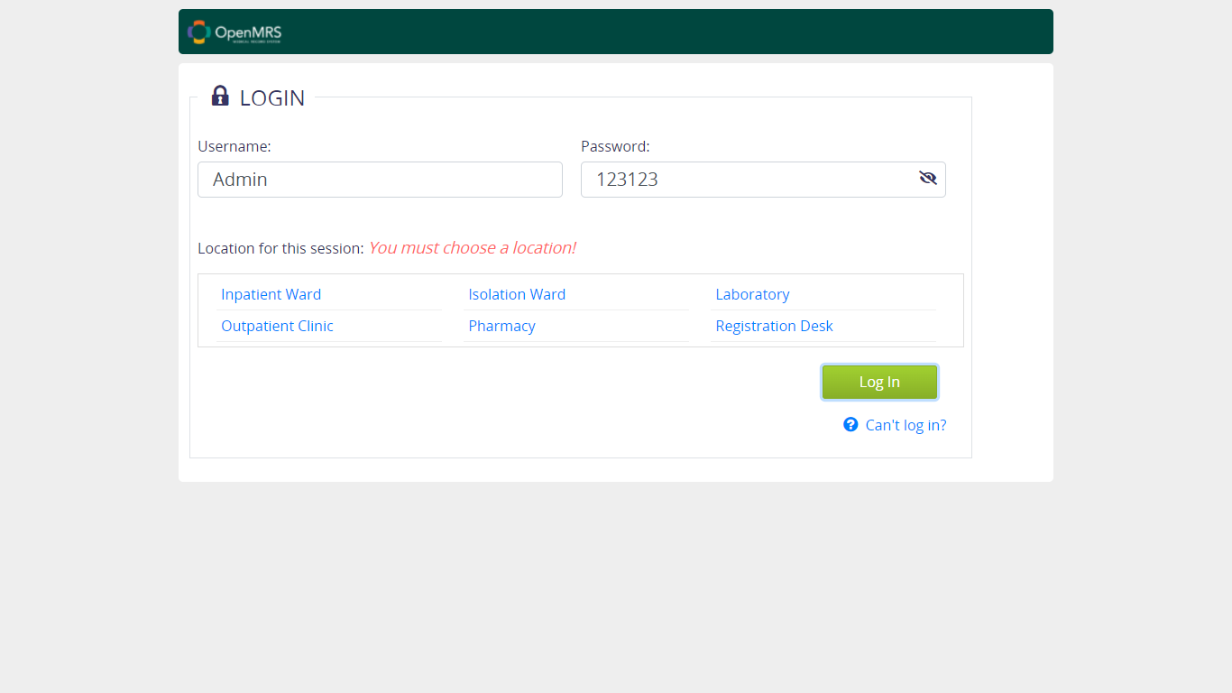

* + 1. **Verify User is able to login with WRONG User Id and CORRECT Password, Inpatient Ward is selected**

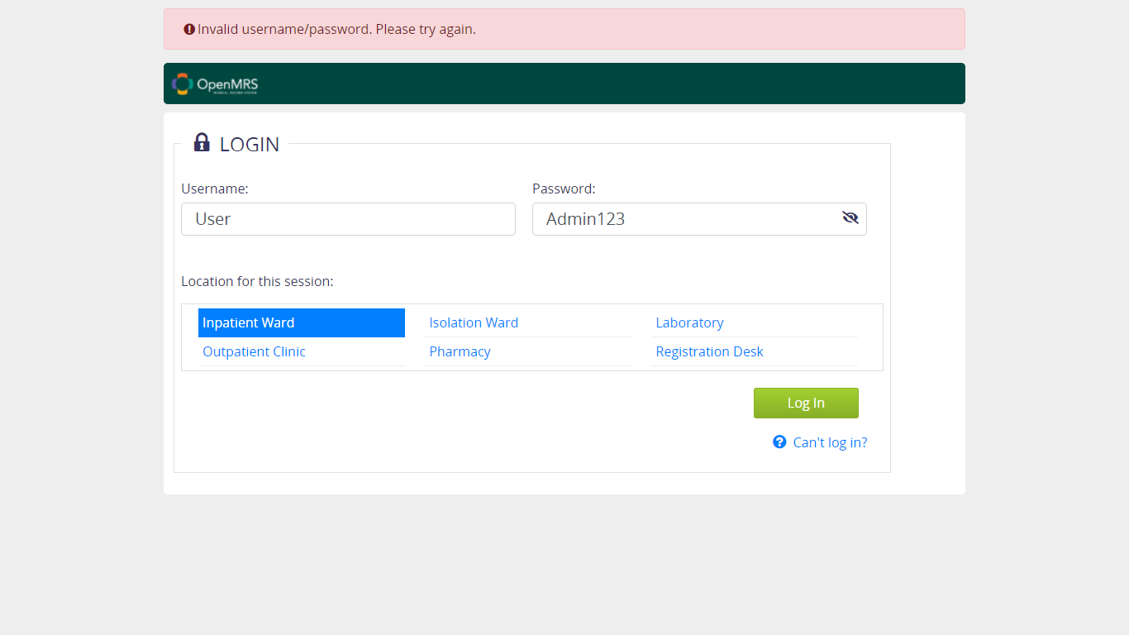

* + 1. **Verify User is able to login with WRONG User Id and CORRECT Password, Inpatient Ward is NOT selected**

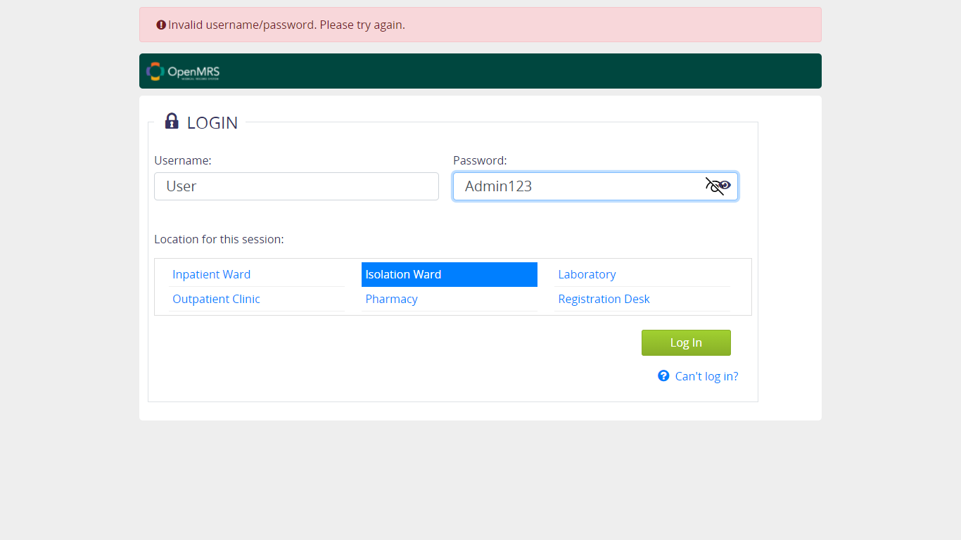

* + 1. **Verify User is able to login with WRONG User Id and CORRECT Password, NO Location selected**

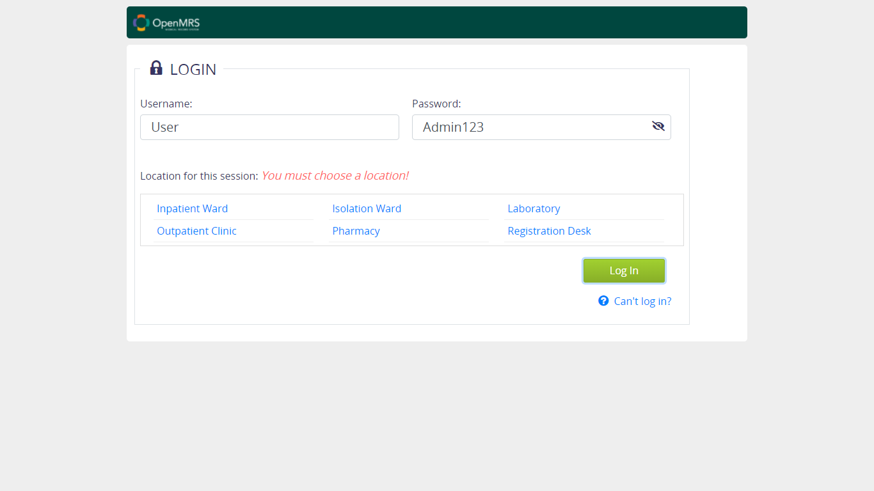

* + 1. **Verify User is able to login with WRONG User Id and WRONG Password, Inpatient Ward is selected**

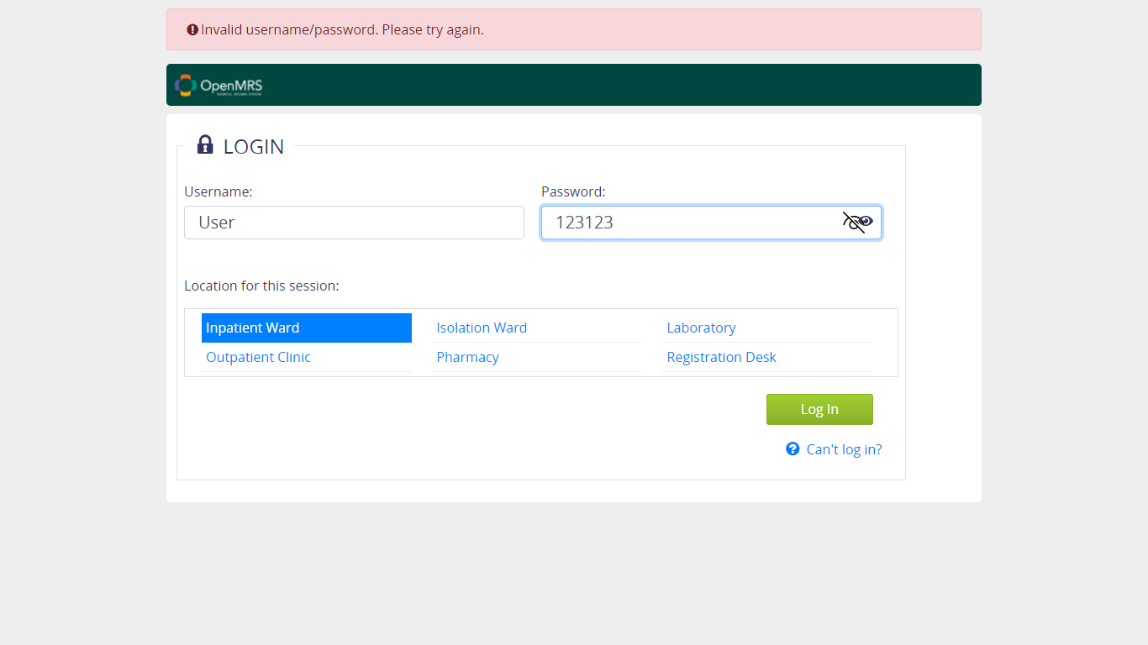

* + 1. **Verify User is able to login with WRONG User Id and WRONG Password, Inpatient Ward is NOT selected**

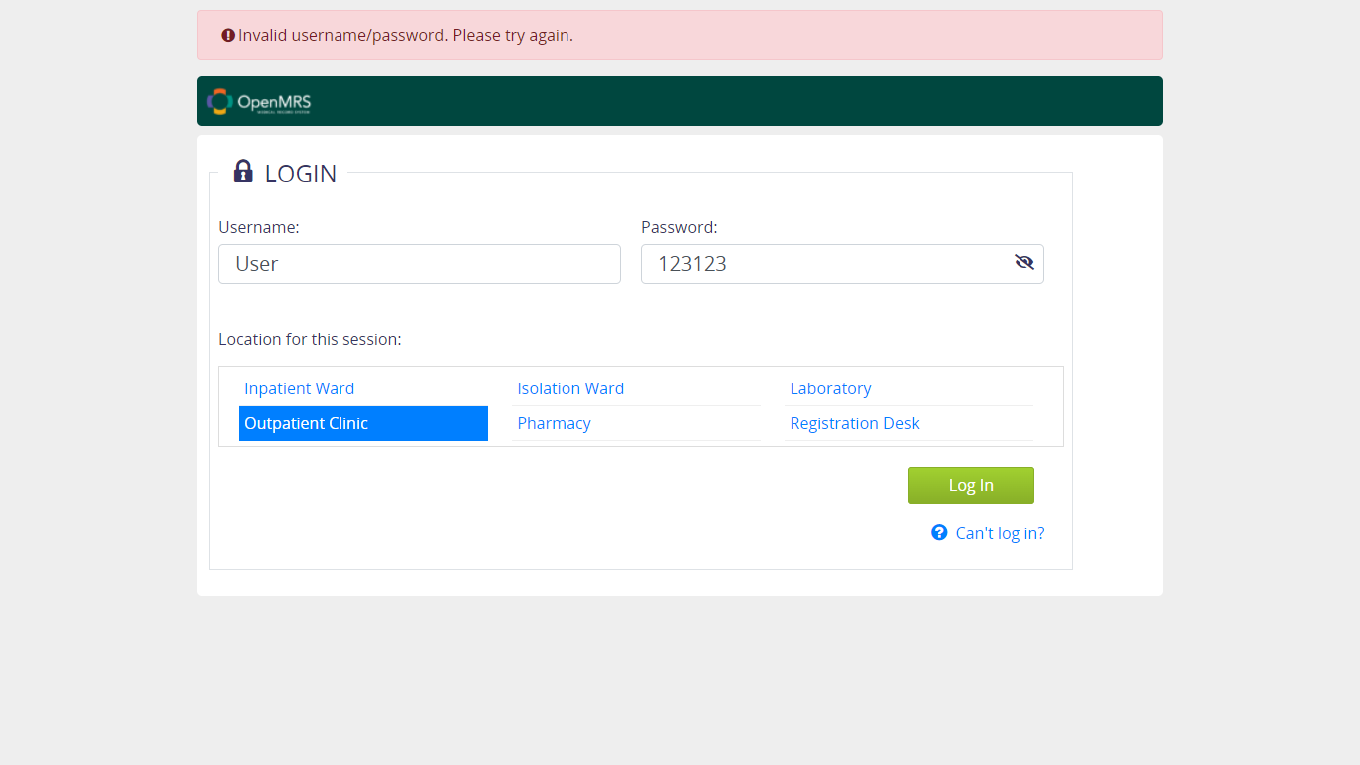

* + 1. **Verify User is able to login with WRONG User Id and WRONG Password, NO Location selected**

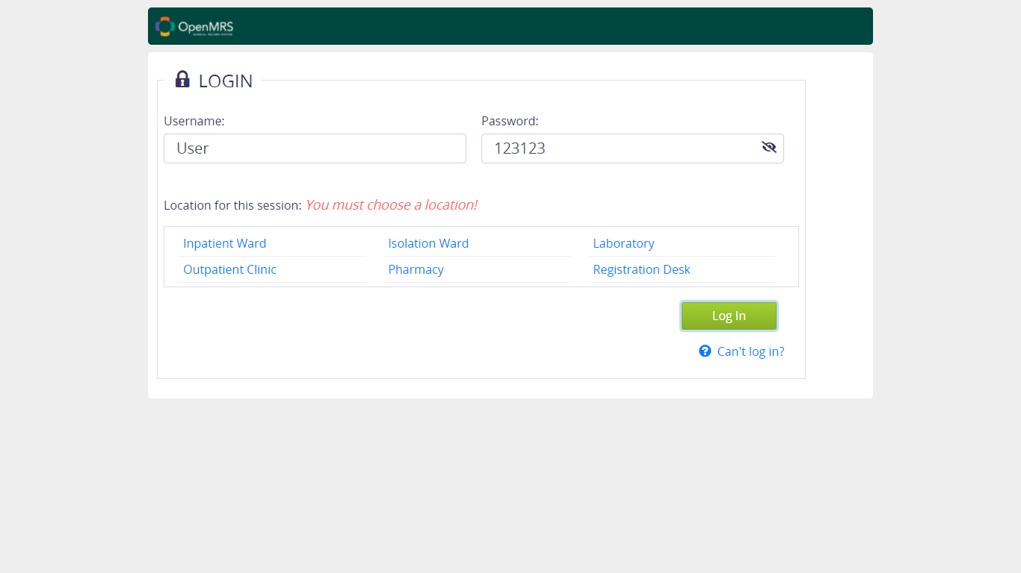

1. **Logout Module**

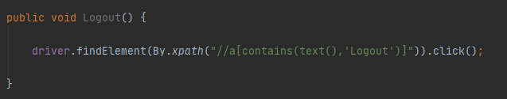

* 1. **Verfiy Logout Functionality**
     1. **Verify User is able to Logout when Login is done**

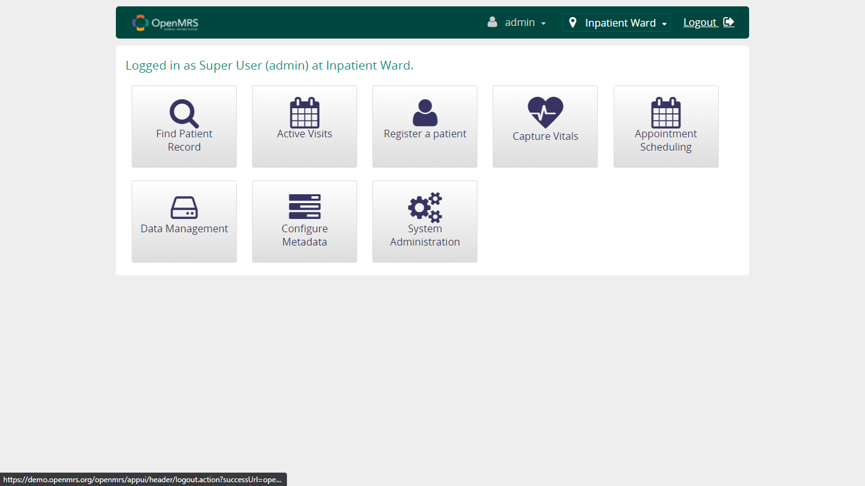

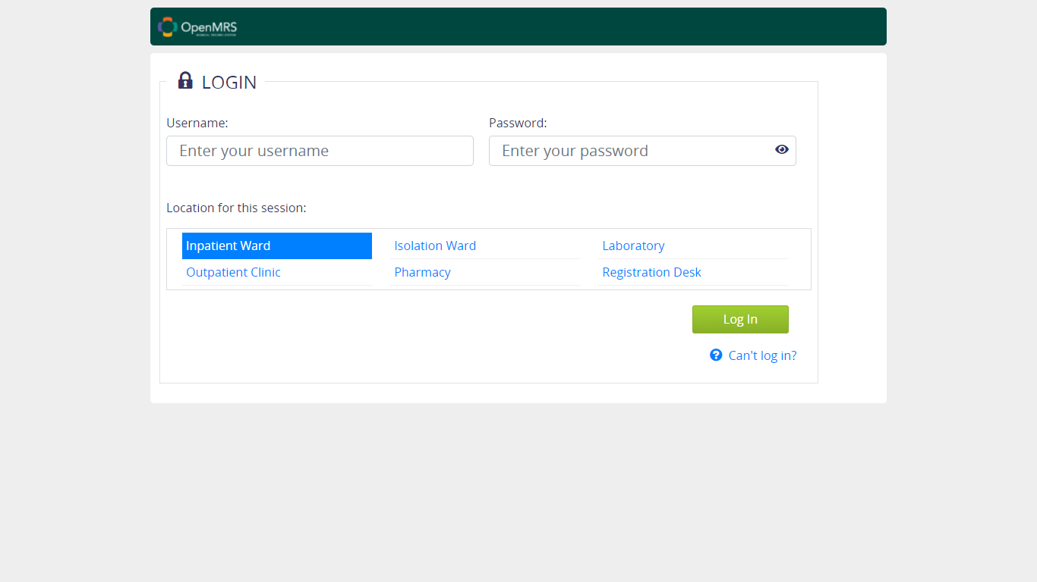

1. **Register Patient Module**

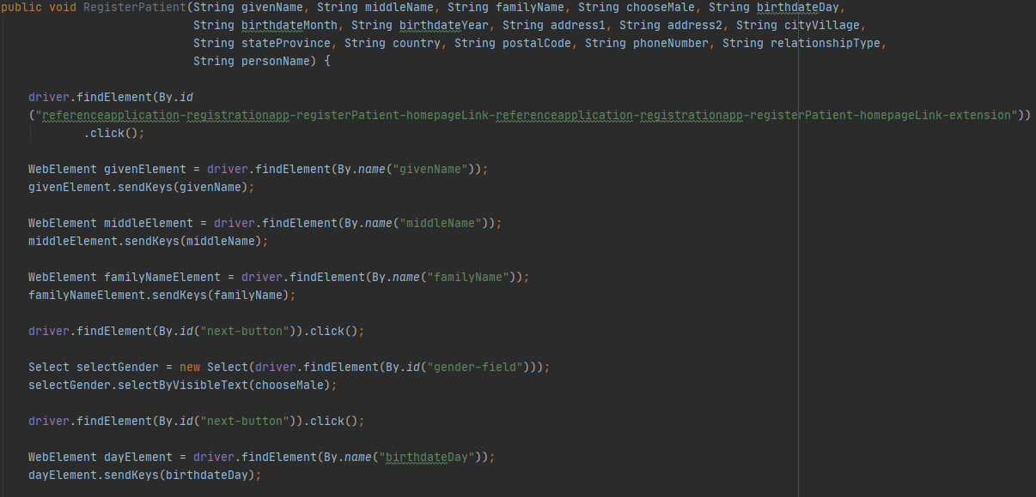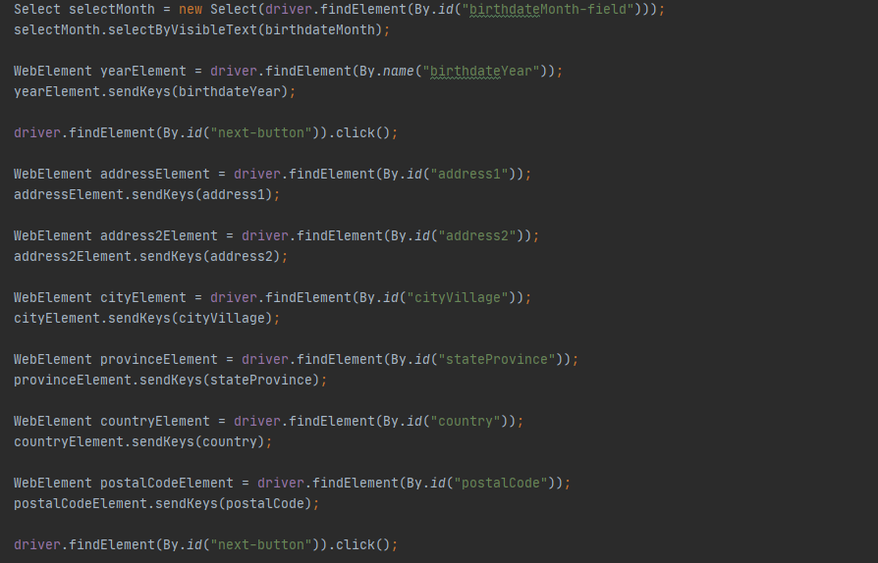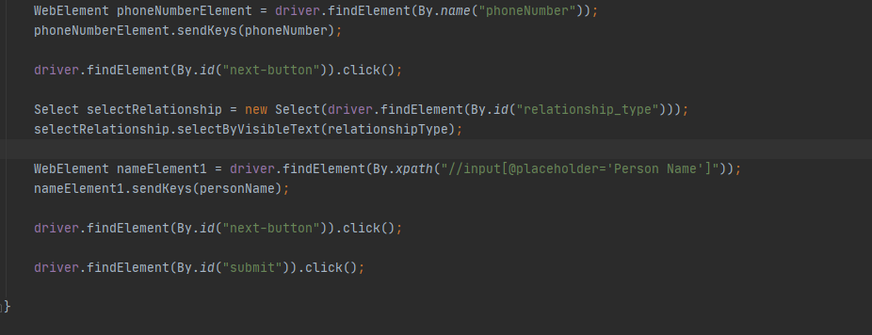

* 1. **Verify Fill in Patient's Name Functionality**

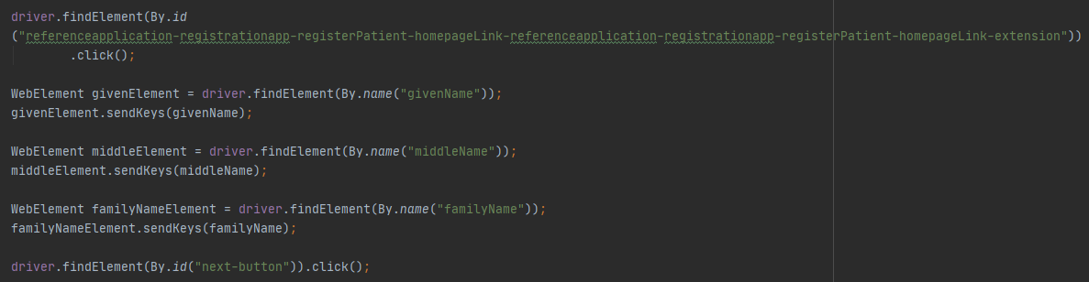

* + 1. **Verify User is able to continue to fill form with FILLED Given name, Middle name and Family name**

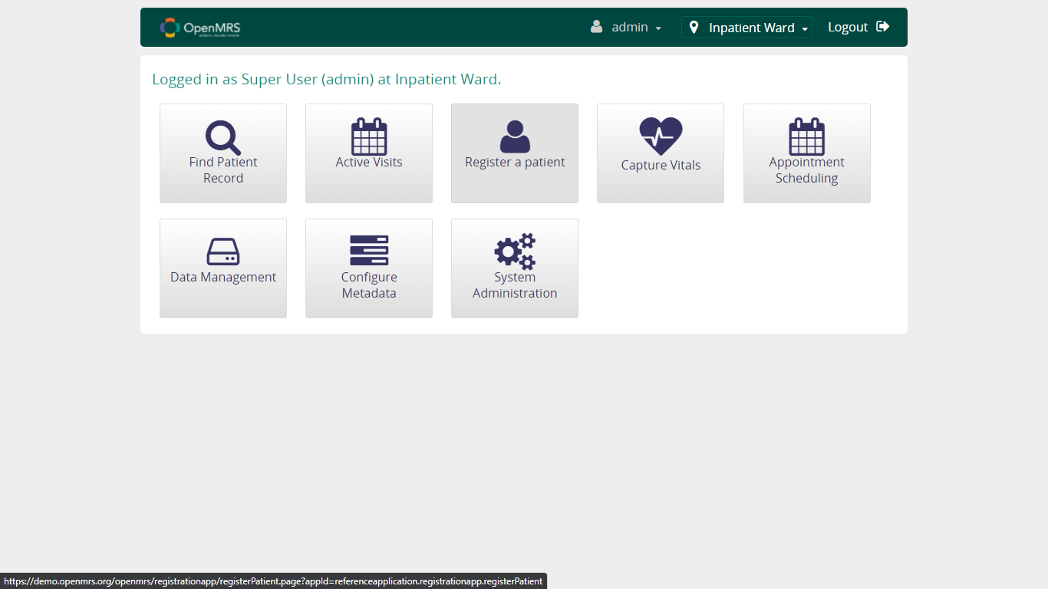 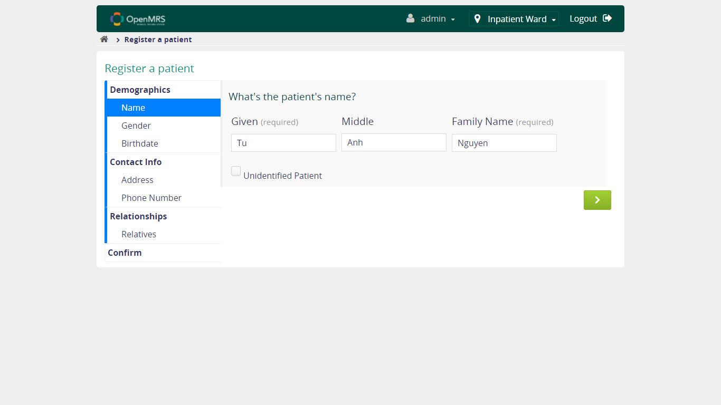 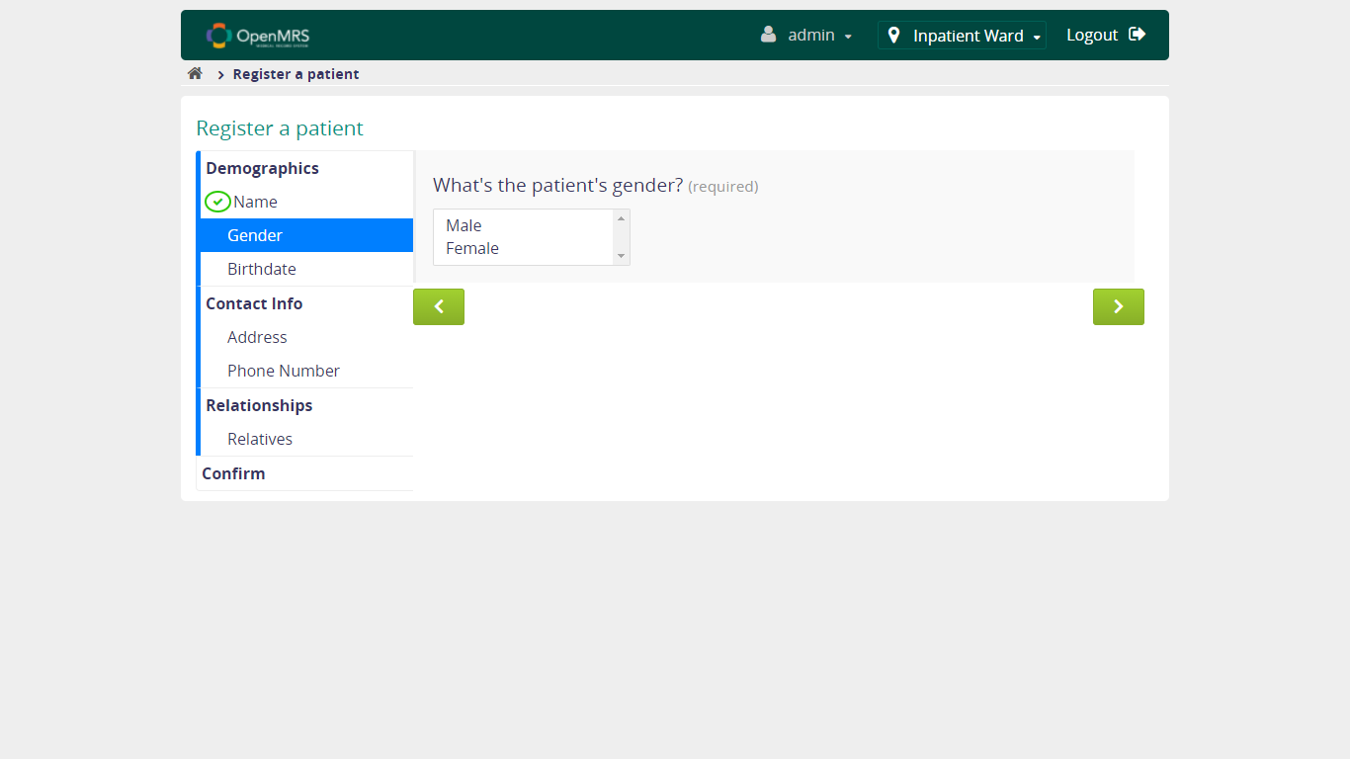

* + 1. **Verify User is able to continue to fill form with FILLED Given name, UNFILLED Middle name, FILLED Family name**

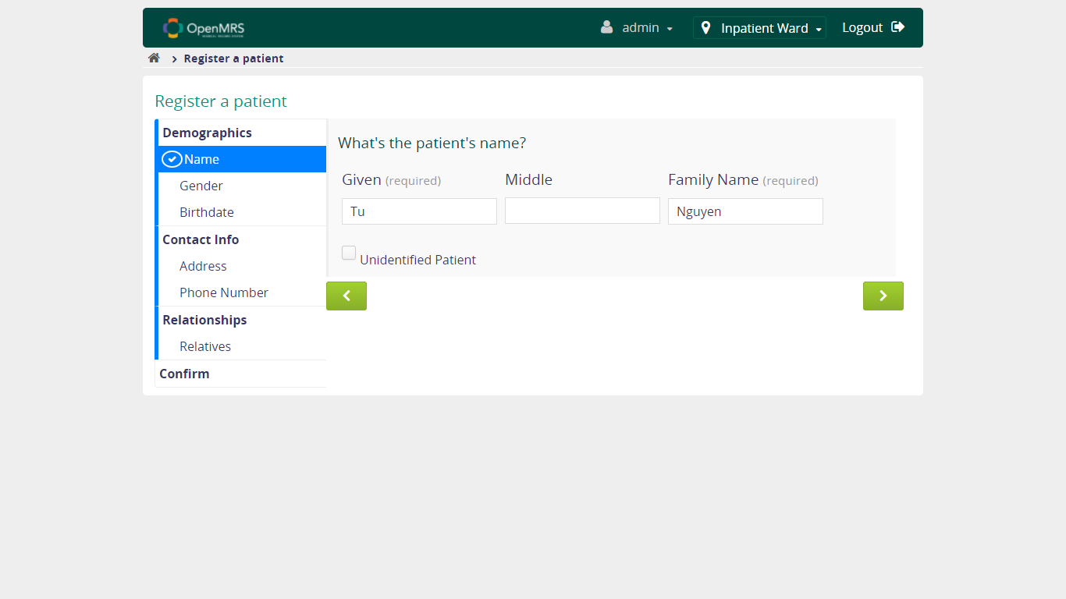

* + 1. **Verify User is able to continue to fill form with FILLED Given name, UNFILLED Middle name, UNFILLED Family name**

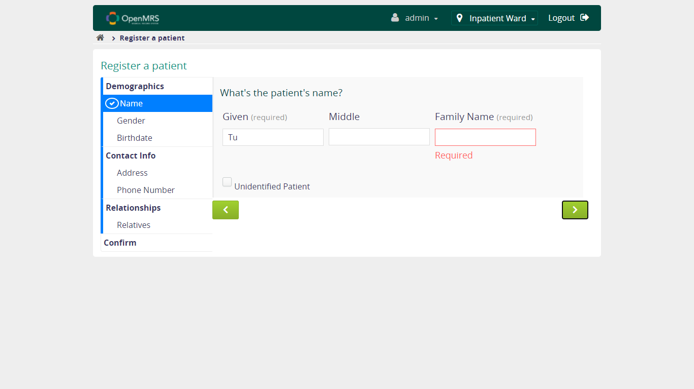

* + 1. **Verify User is able to continue to fill form with FILLED Given name, FILLED Middle name, UNFILLED Family name**

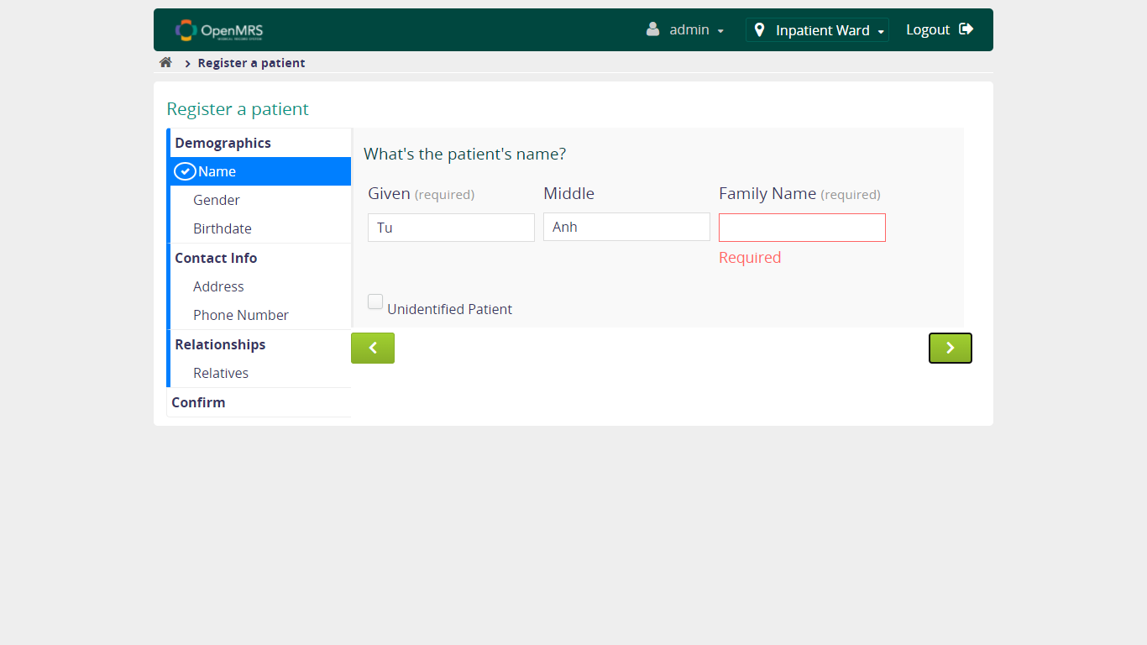

* + 1. **Verify User is able to continue to fill form with UNFILLED Given name, FILLED Middle name, FILLED Family name**

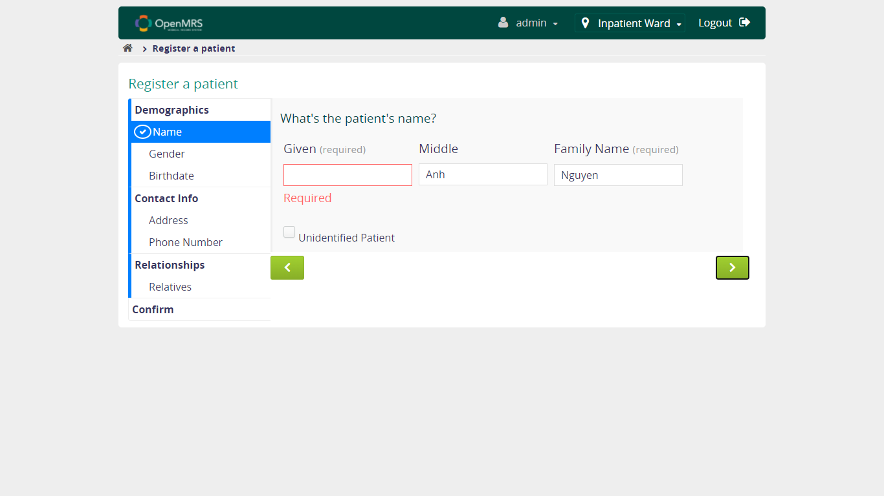

* + 1. **Verify User is able to continue to fill form with UNFILLED Given name, UNFILLED Middle name, FILLED Family name**

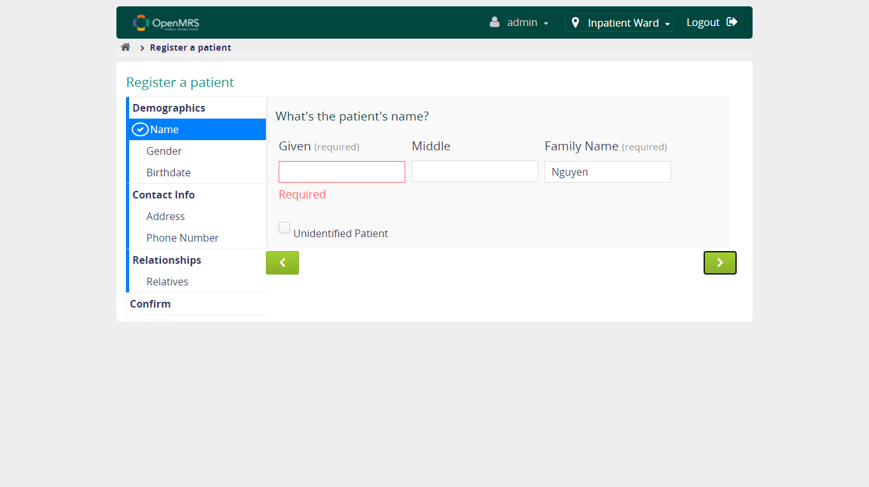

* + 1. **Verify User is able to continue to fill form with UNFILLED Given name, FILLED Middle name, UNFILLED Family name**

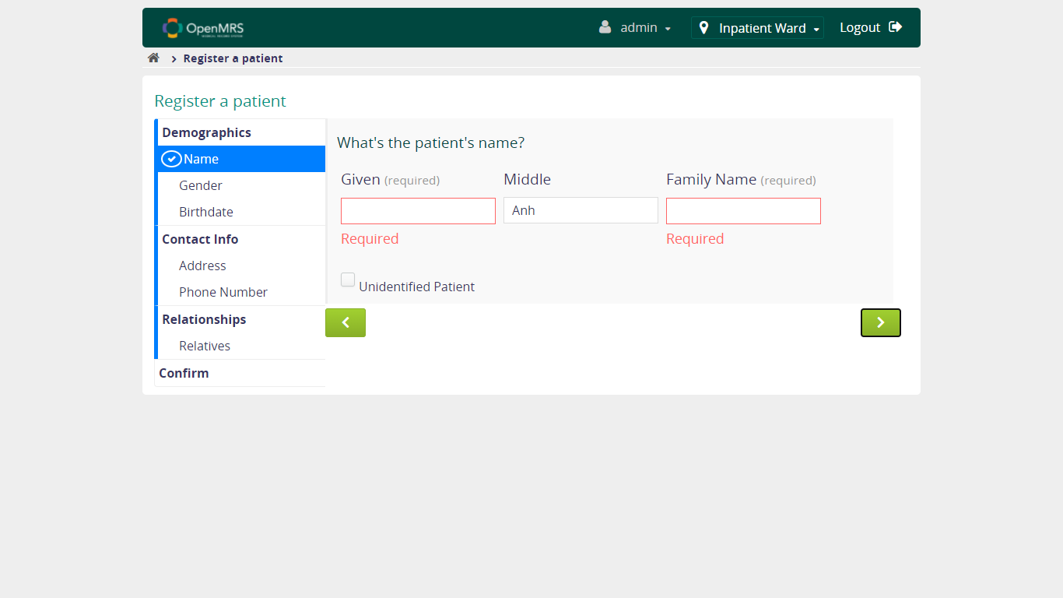

* + 1. **Verify User is able to continue to fill form with Unidentifiled Patient checkbox been CHECKED**

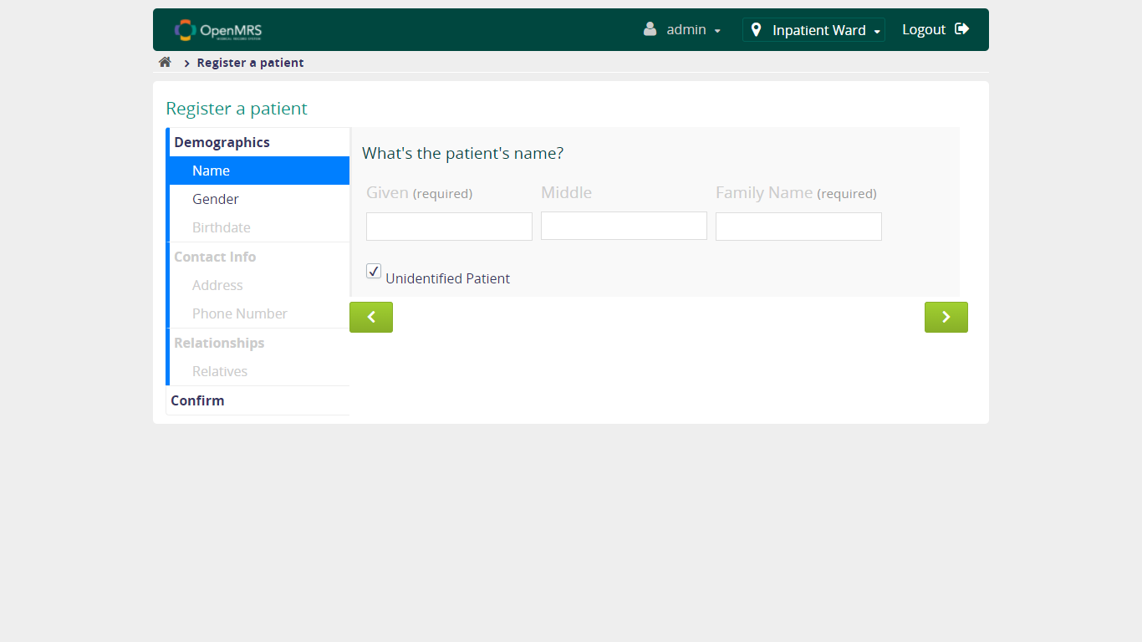

* 1. **Verify Select Patient's Gender Functionality**

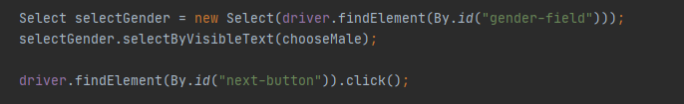

* + 1. **Verify User is able to continue to fill form with NOT SELECT gender**

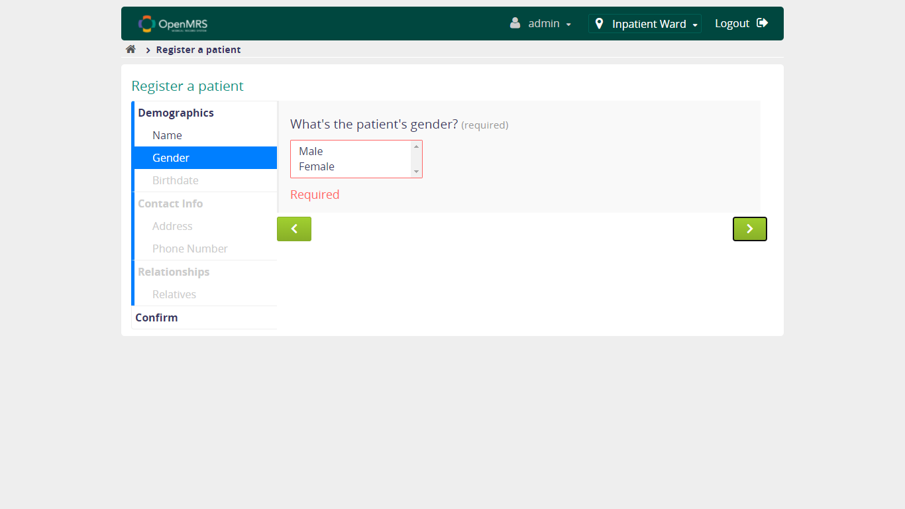

* + 1. **Verify User is able to continue to fill form with MALE gender is SELECTED**

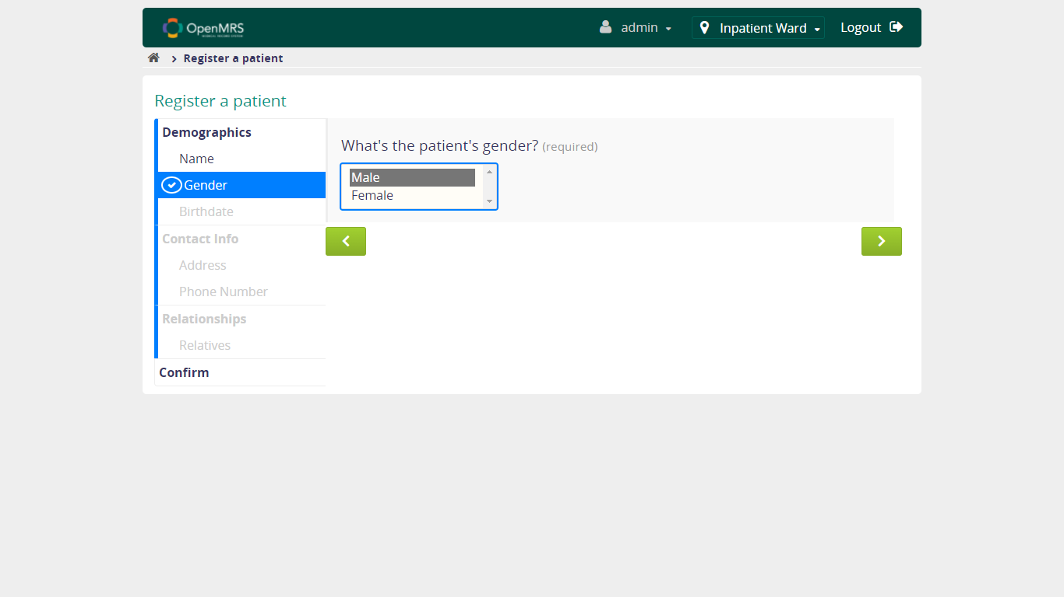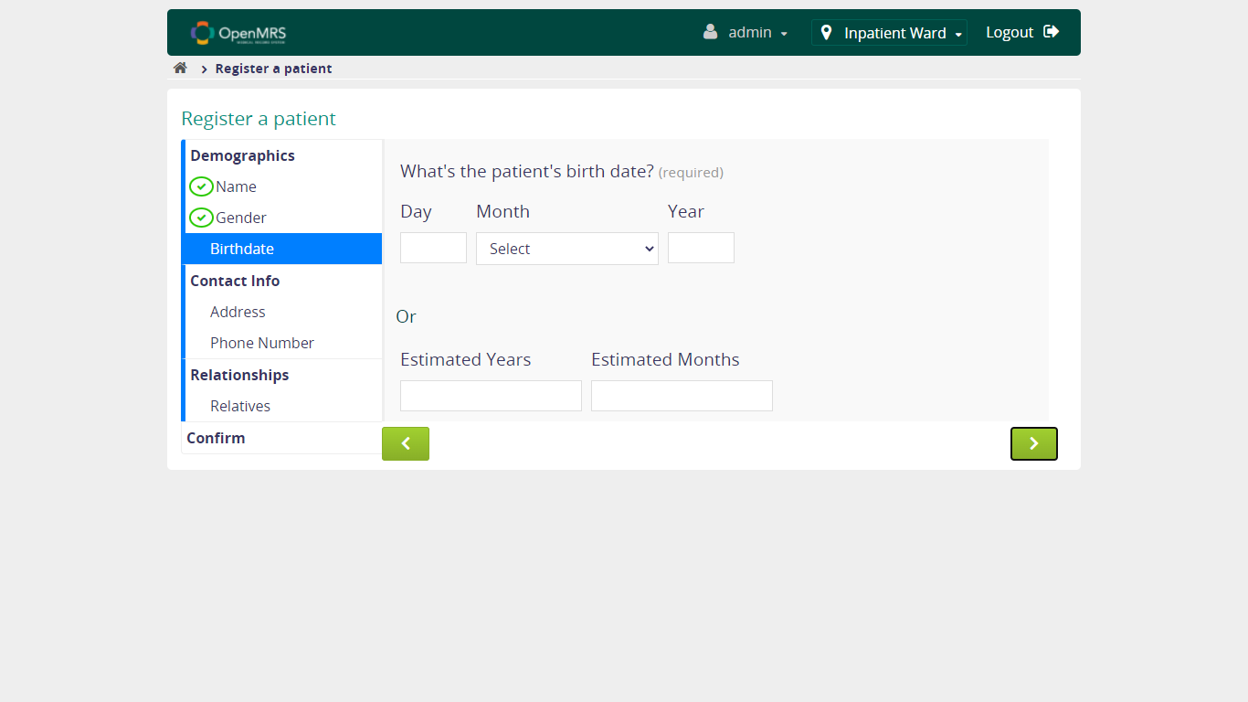

* + 1. **Verify User is able to continue to fill form with FEMALE gender is SELECTED**

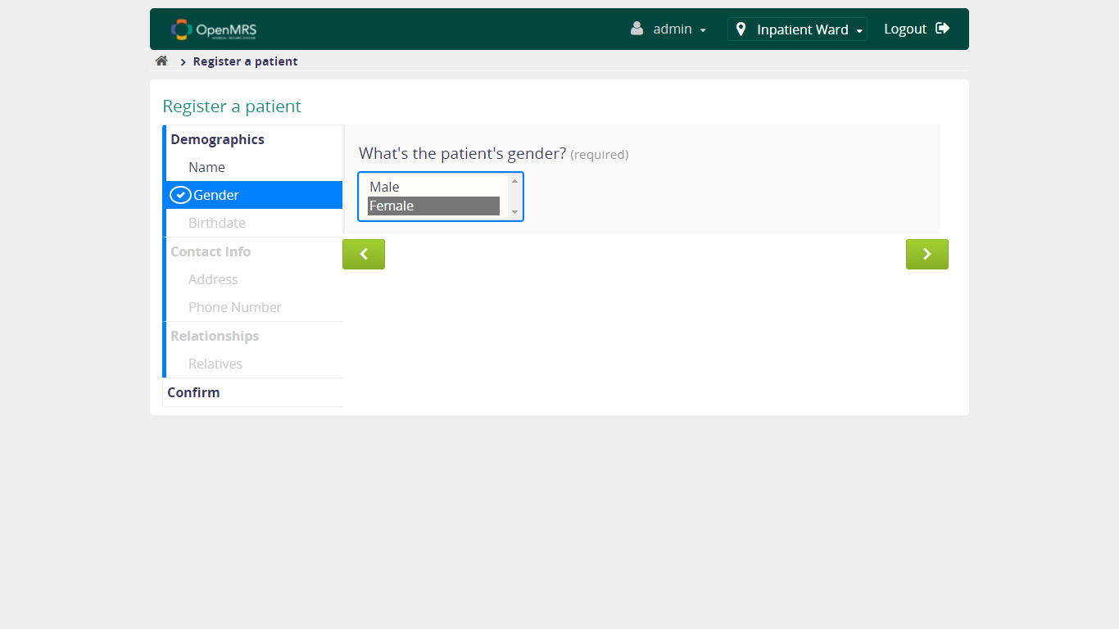

* 1. **Verify Fill in Patient's Birthdate Functionality**

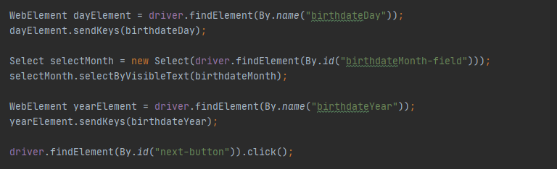

* + 1. **Verify User is able to continue to fill form when fill valid Date, SELECT Month, valid Year**

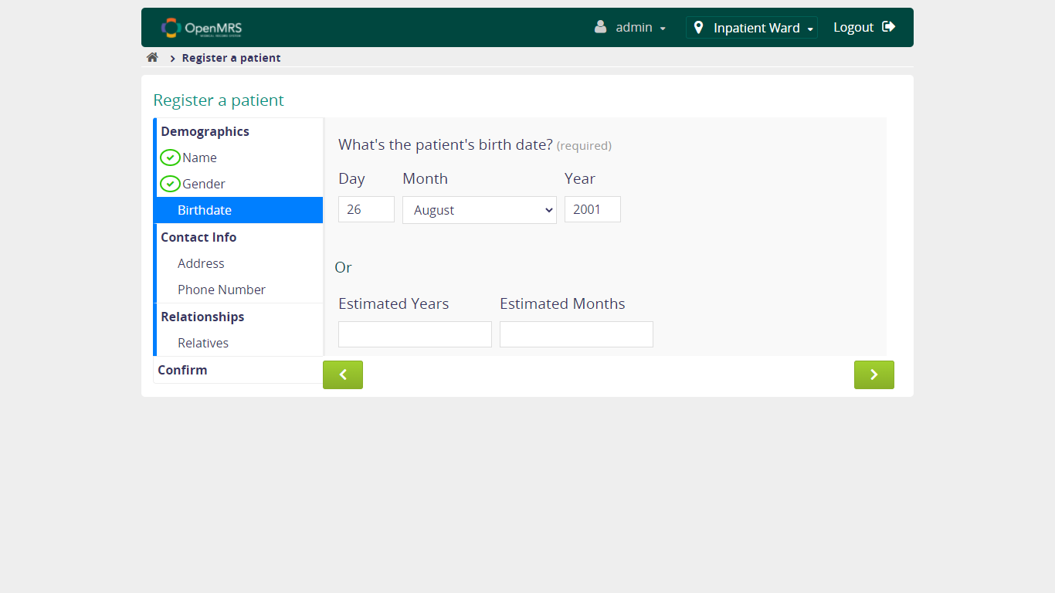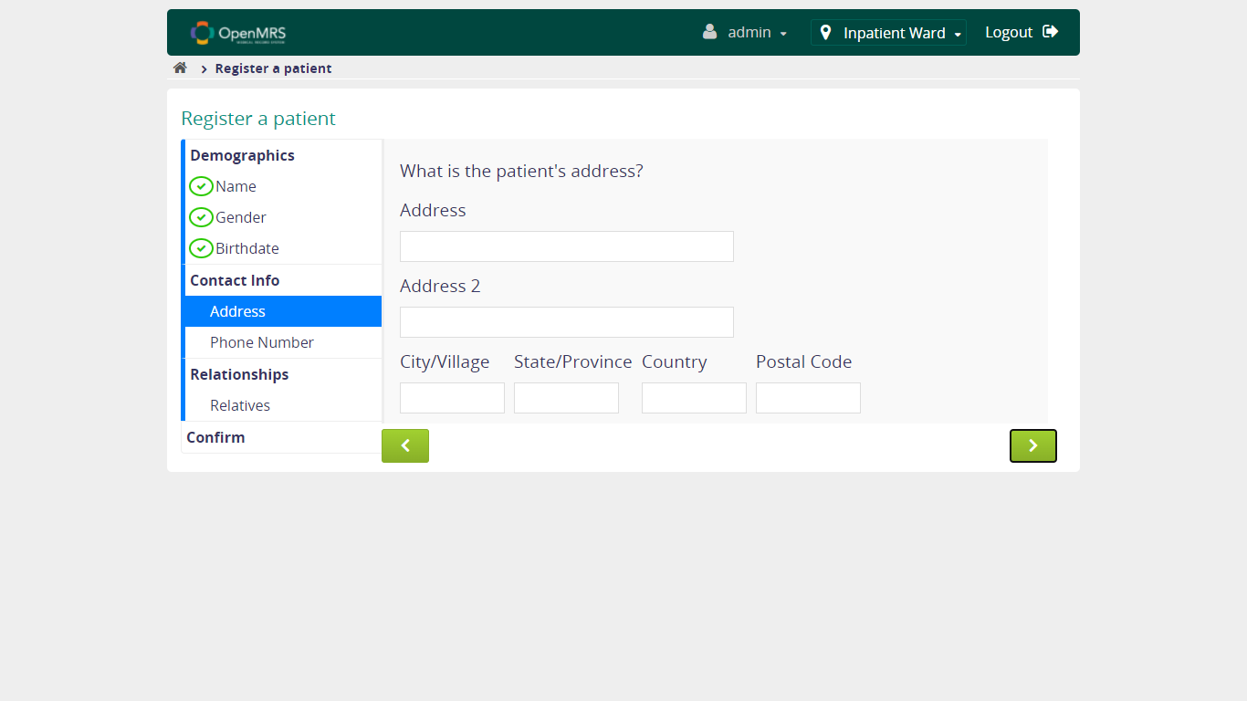

* + 1. **Verify User is able to continue to fill form when fill valid Date, NOT SELECT Month, valid Year**

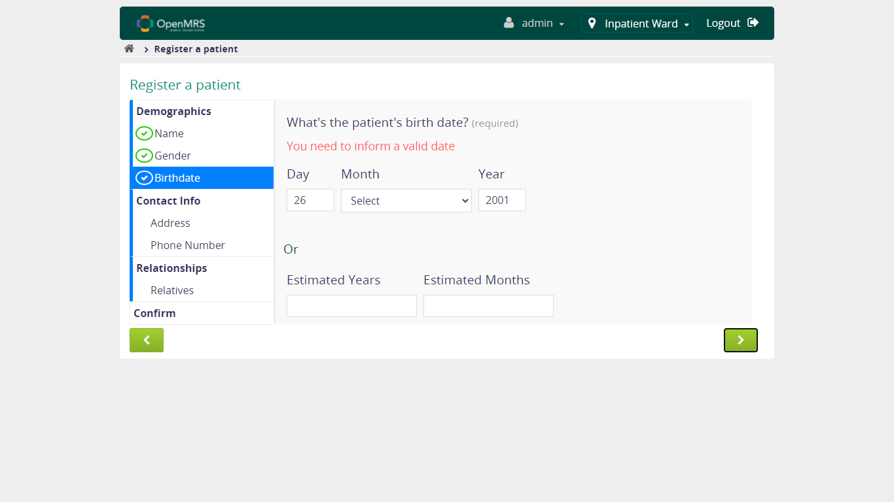

* + 1. **Verify User is able to continue to fill form when fill valid Date, SELECT Month, unvalid Year**

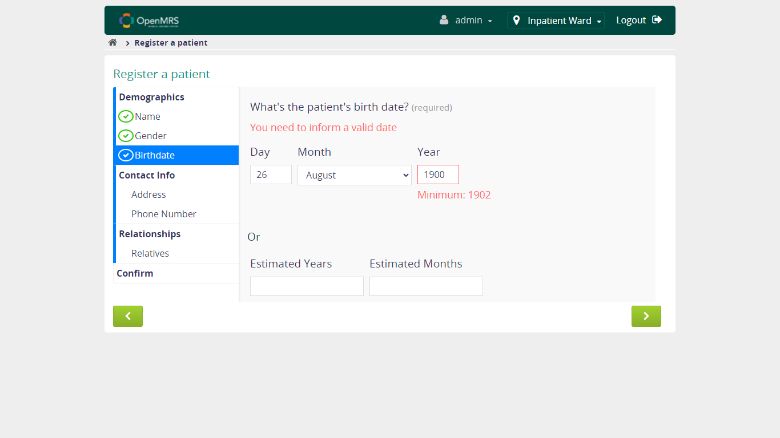

* + 1. **Verify User is able to continue to fill form when fill valid Date, NOT SELECT Month, unvalid Year**

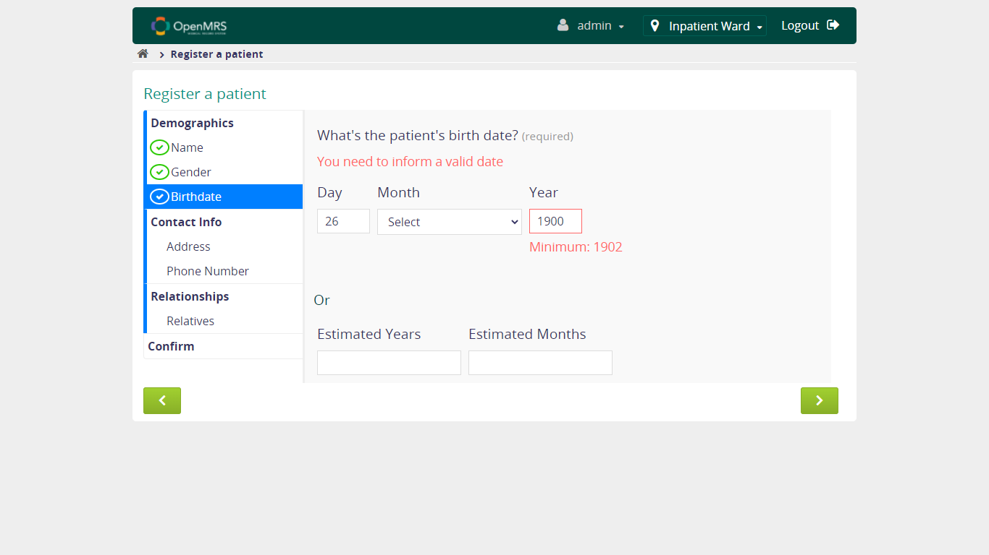

* + 1. **Verify User is able to continue to fill form when fill unvalid Date**

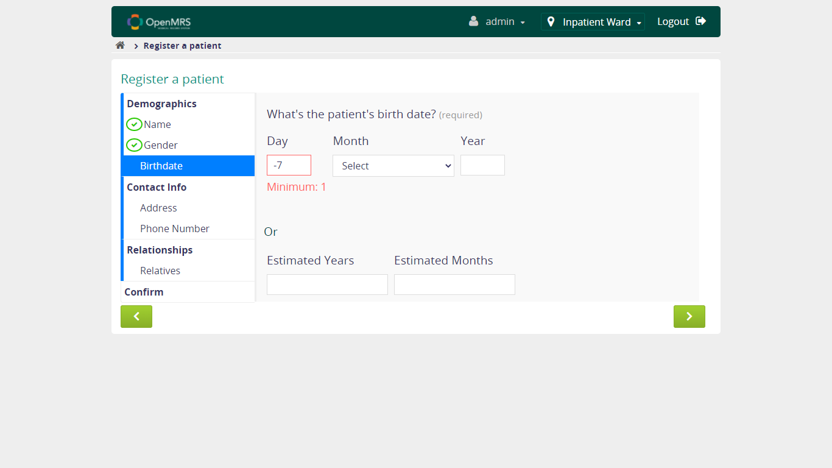

* + 1. **Verify User is able to continue to fill form when fill valid Estimated Years, Estimated Months**

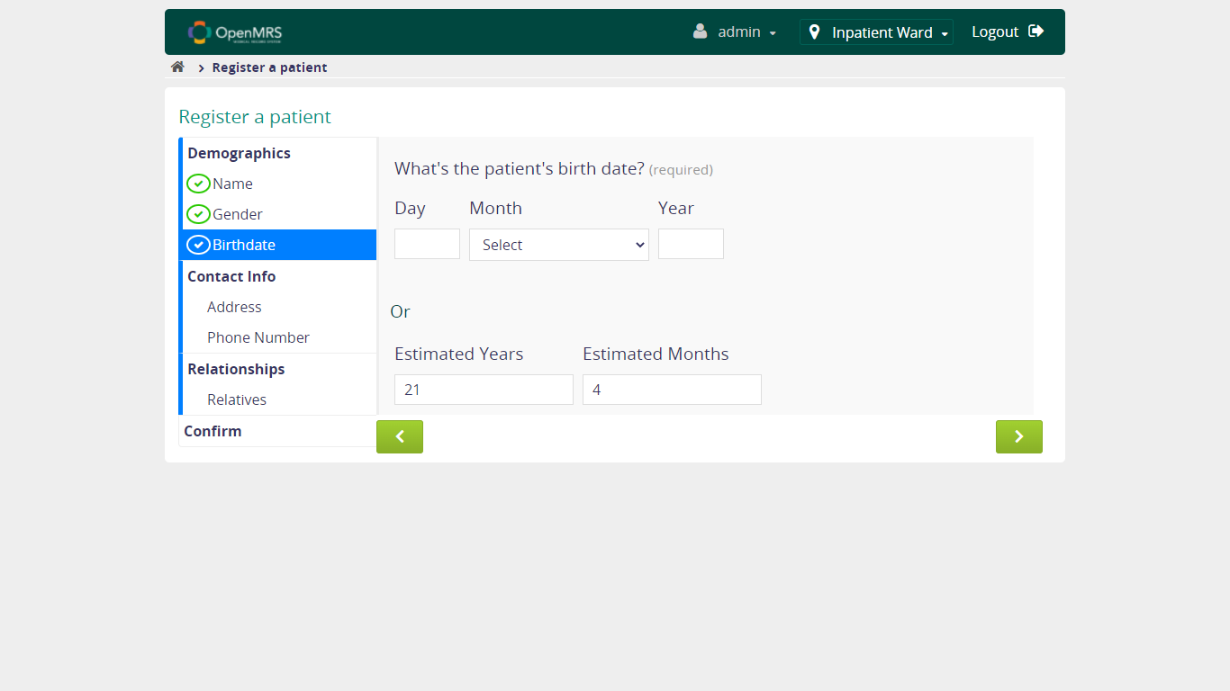

* + 1. **Verify User is able to continue to fill form when fill unvalid Estimated Years, Estimated Months**

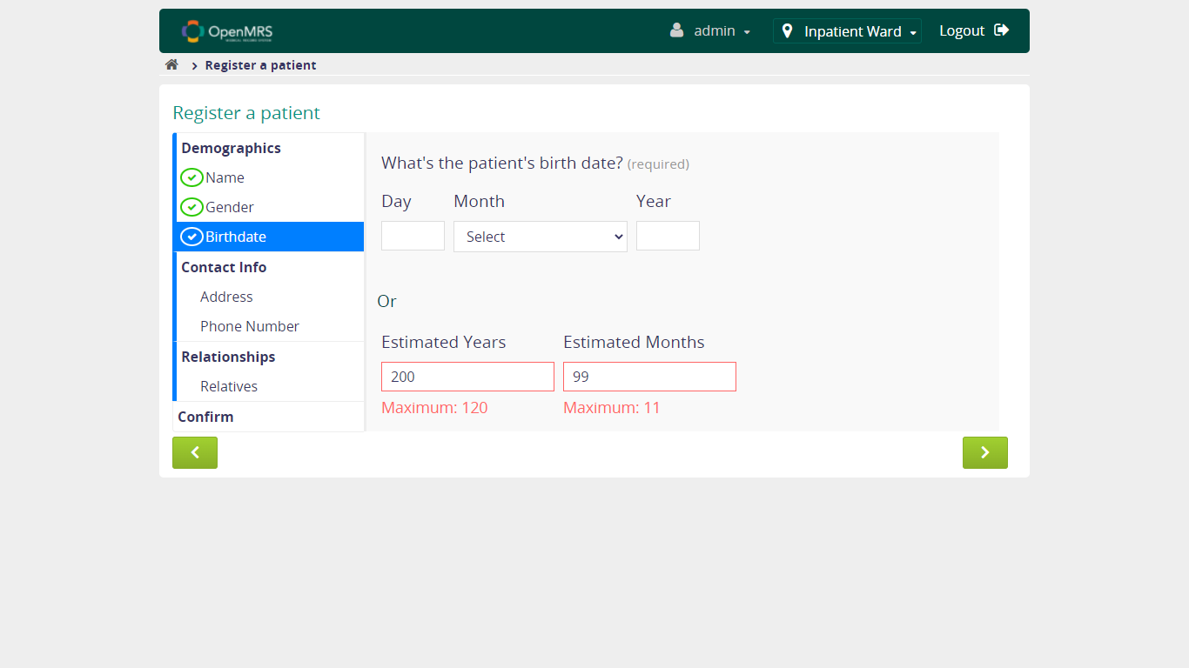

* + 1. **Verify User is able to continue to fill form when fill valid Estimated Years, unvalid Estimated Months**

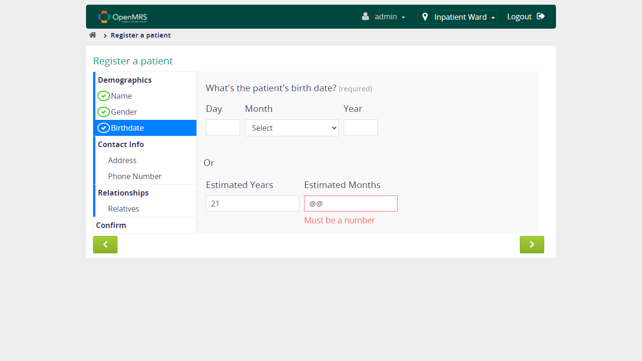

* + 1. **Verify User is able to continue to fill form when fill unvalid Estimated Years, valid Estimated Months**

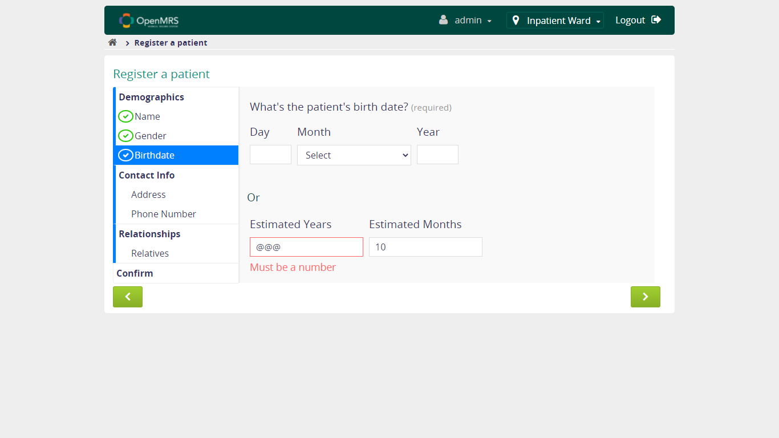

* + 1. **Verify User is able to continue to fill form when NOT fill Estimated Years, fill valid Estimated Months**

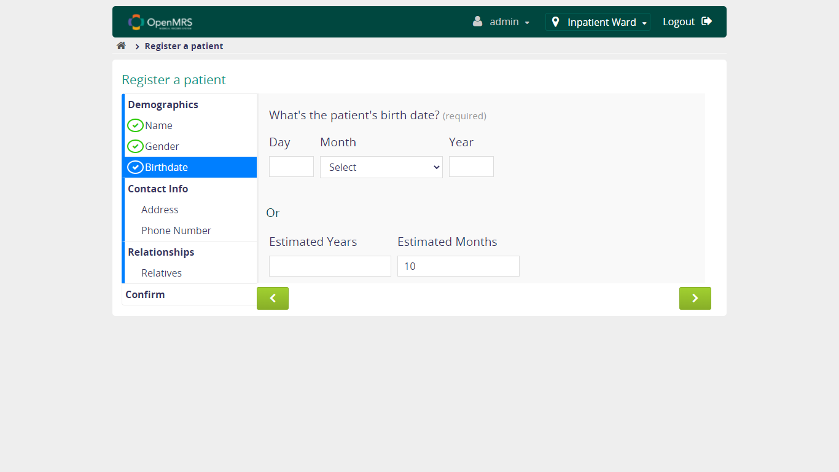

* + 1. **Verify User is able to continue to fill form when fill valid Estimated Years, NOT fill Estimated Months**

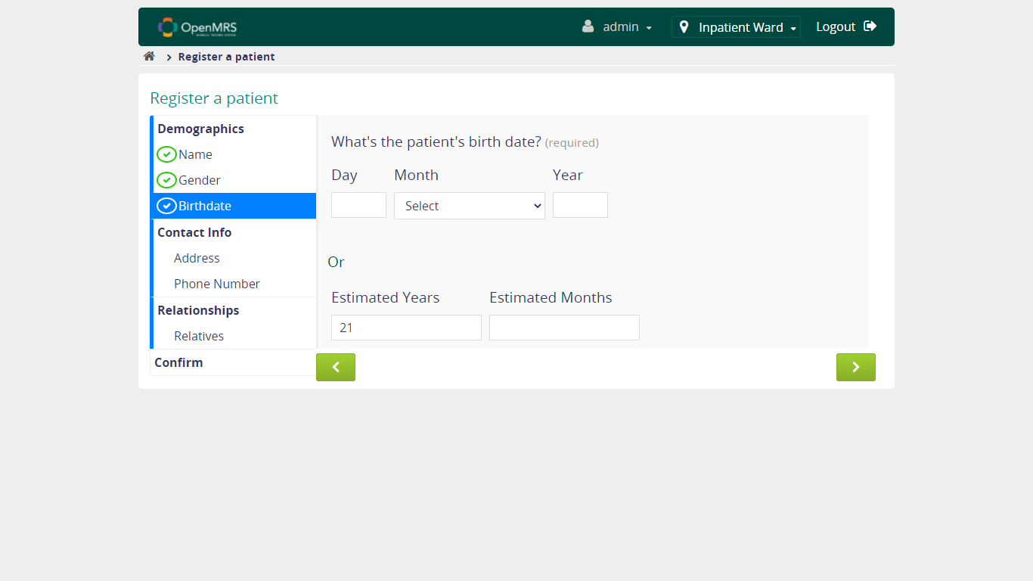

* + 1. **Verify User is able to continue to fill form when NOT fill Estimated Years, NOT fill Estimated Months**

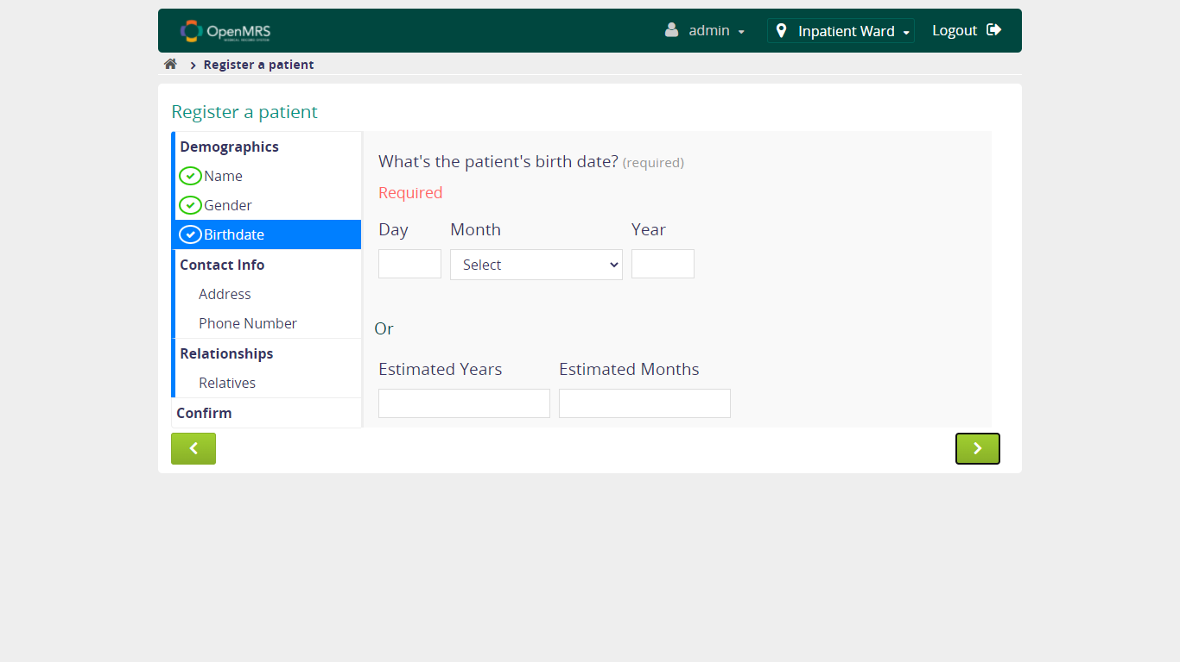

* 1. **Verify Fill in Patient's Address Functionality**

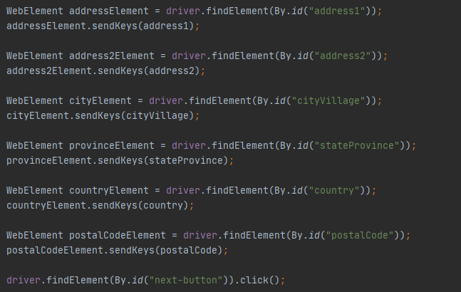

* + 1. **Verify User is able to continue to fill form when fill patient's address**

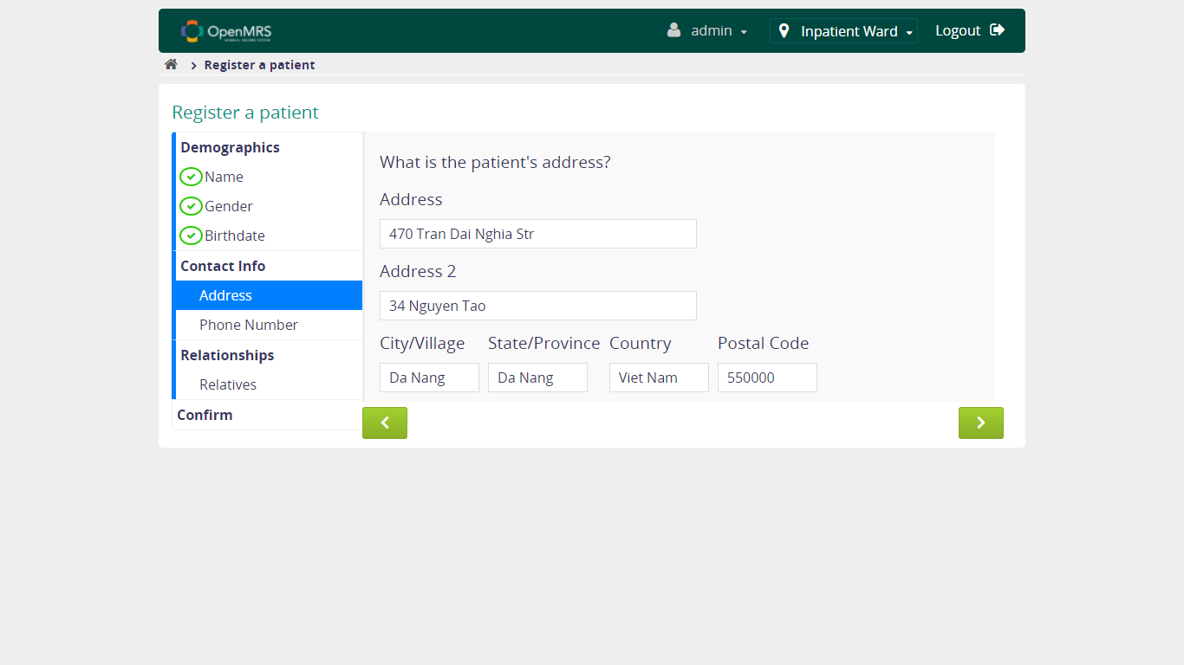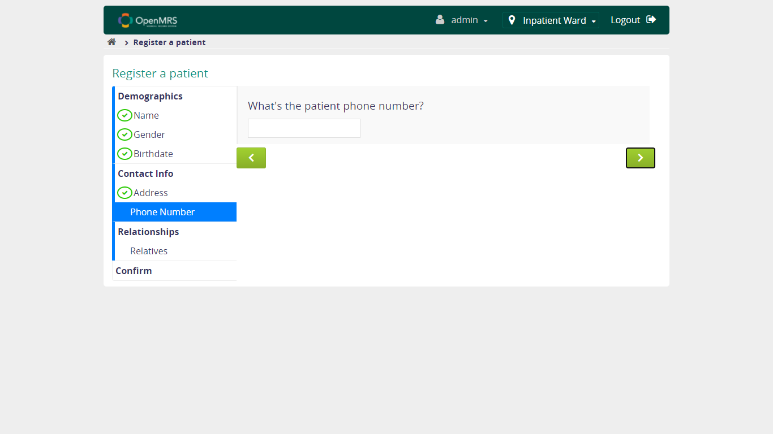

* + 1. **Verify User is able to continue to fill form when NOT fill patient's address**

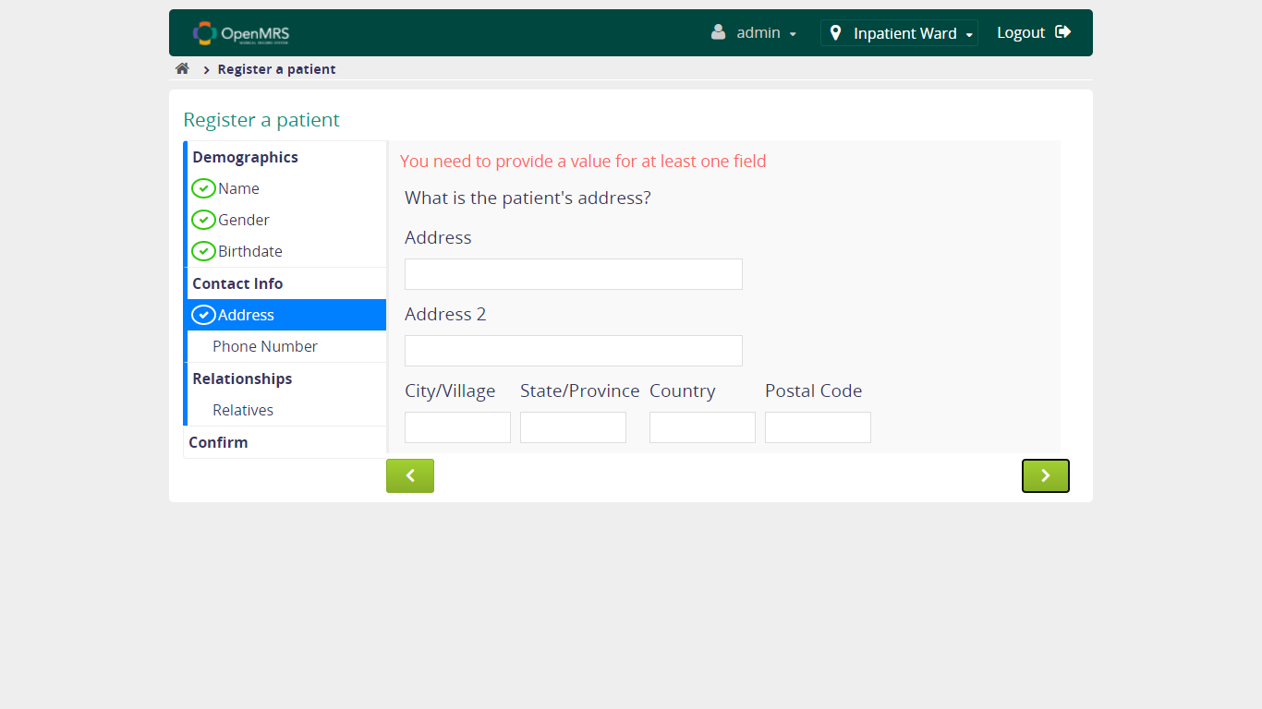

* 1. **Verify Fill in Patient's Phone Number Functionality**

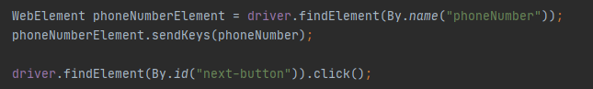

* + 1. **Verify User is able to continue to fill form when fill valid patient's phone number**

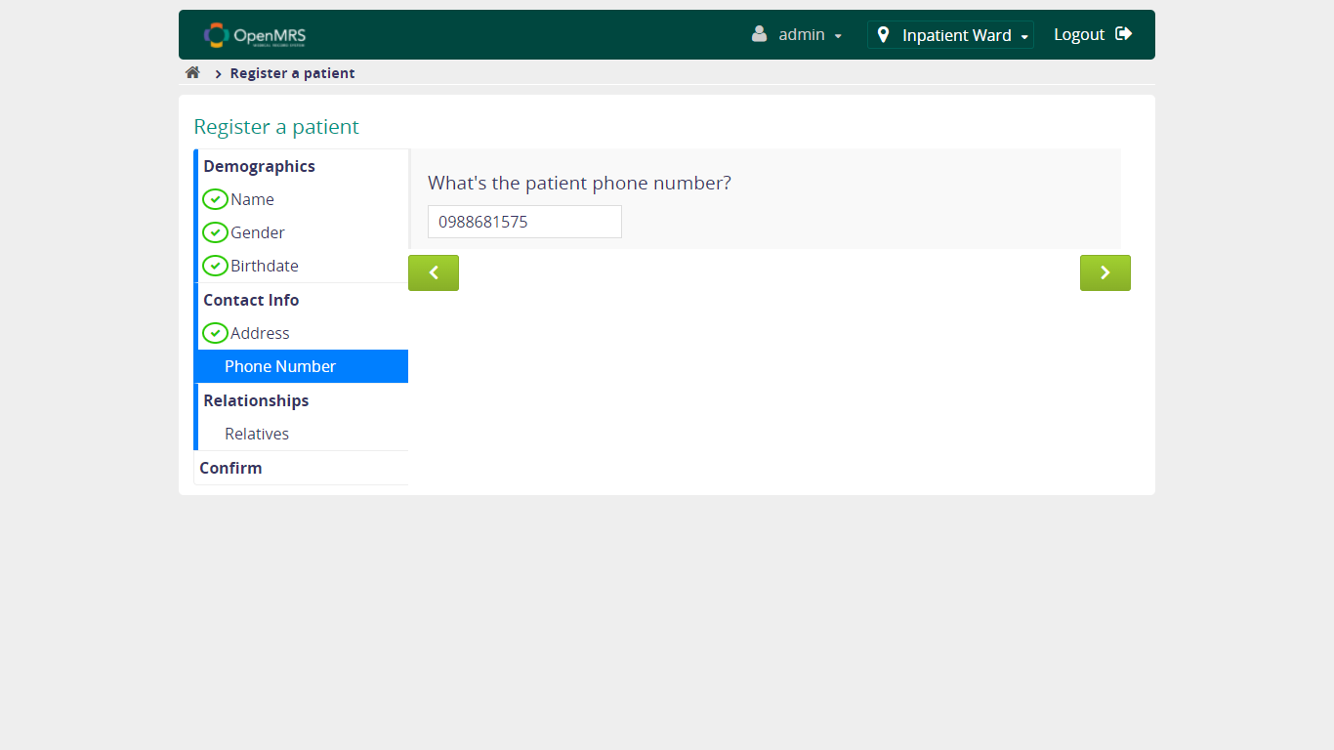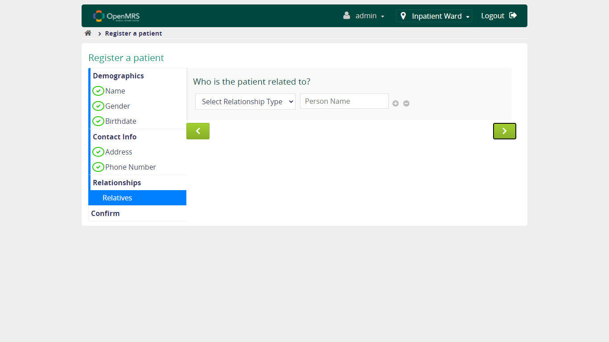

* + 1. **Verify User is able to continue to fill form when fill unvalid patient's phone number**

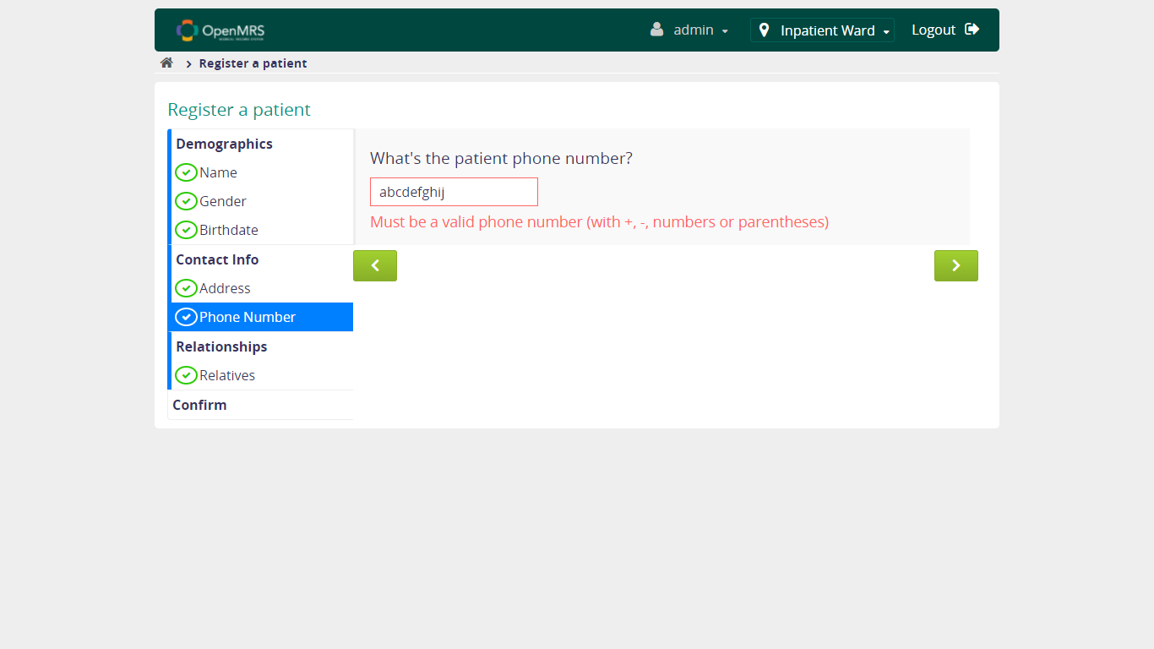

* + 1. **Verify User is able to continue to fill form when NOT fill patient's phone number**

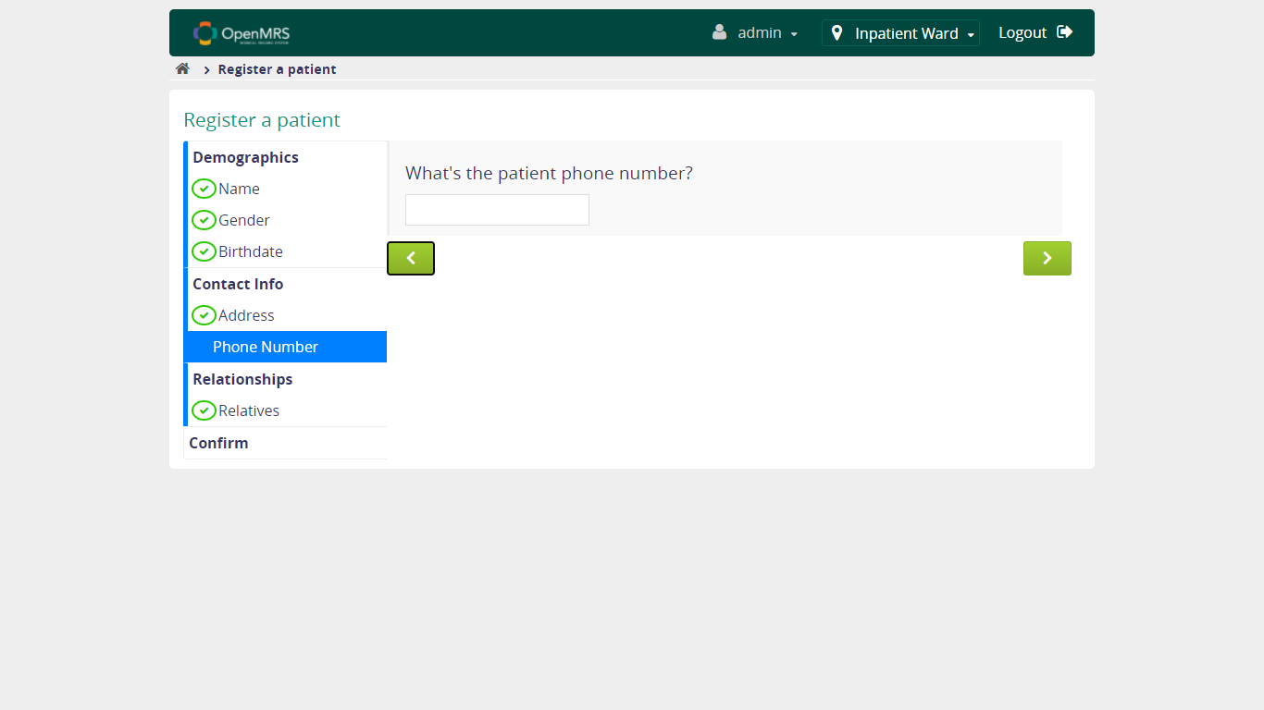

* 1. **Verify Fill in Patient's Relatives Functionality**

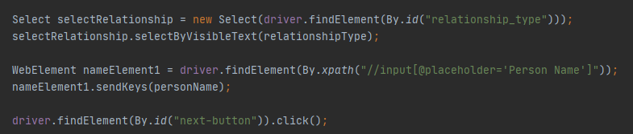

* + 1. **Verify User is able to continue to fill form when fill patient's relatives**

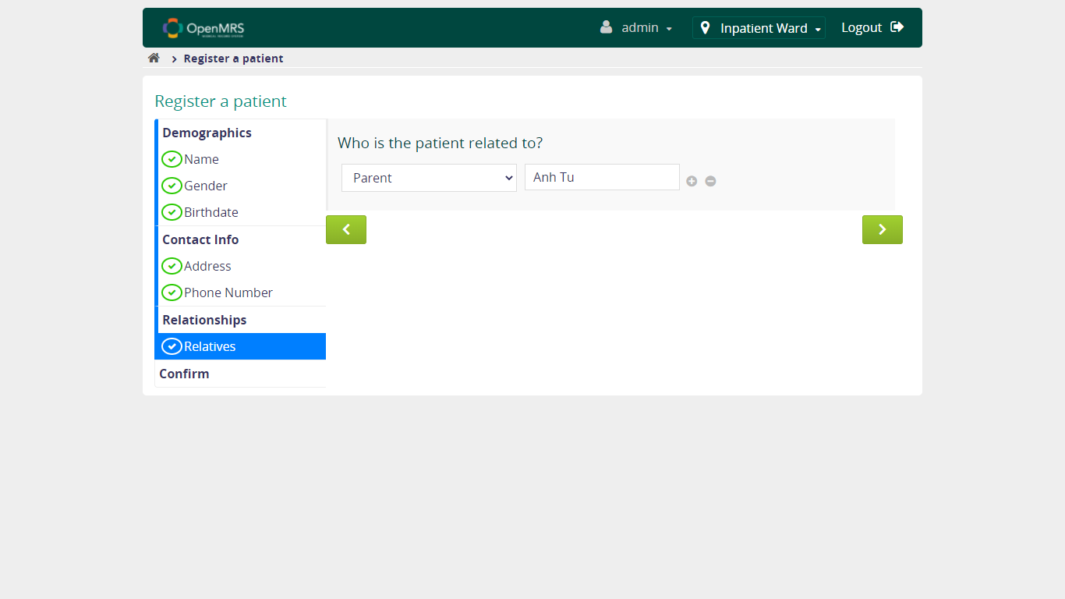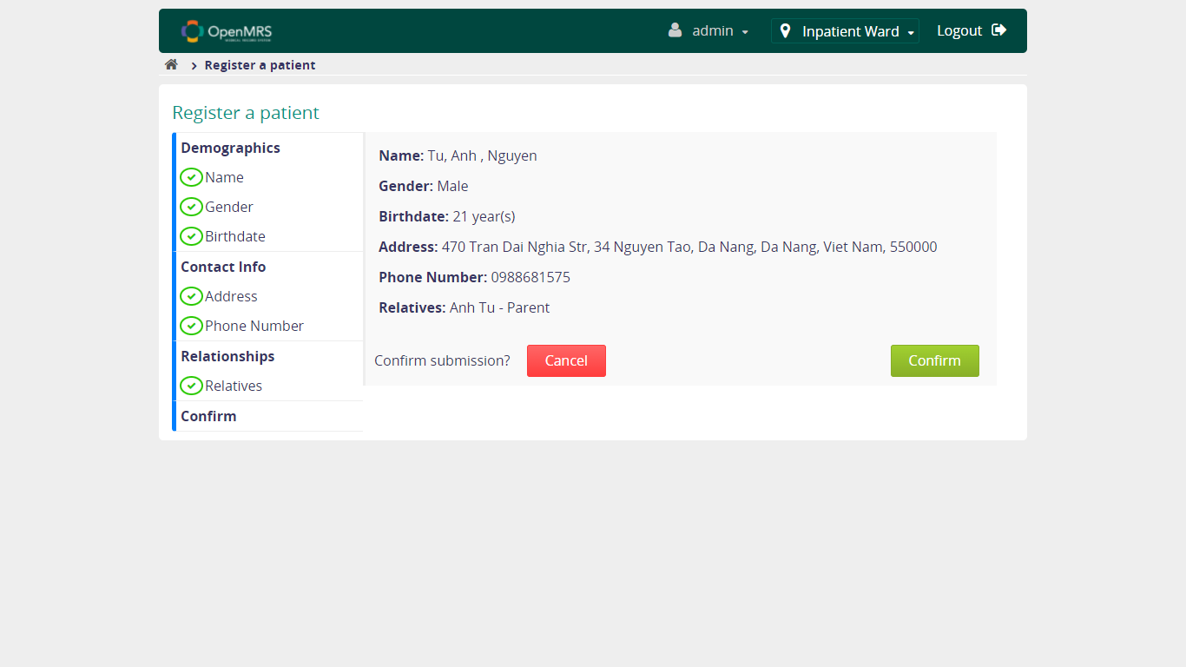

* + 1. **Verify User is able to continue to fill form when NOT fill patient's relatives**

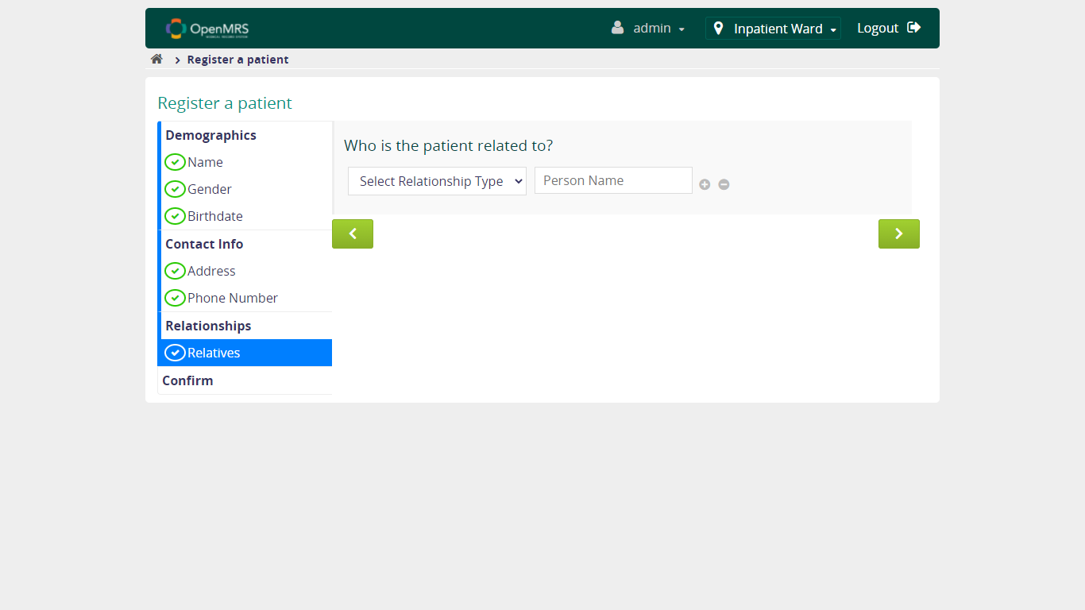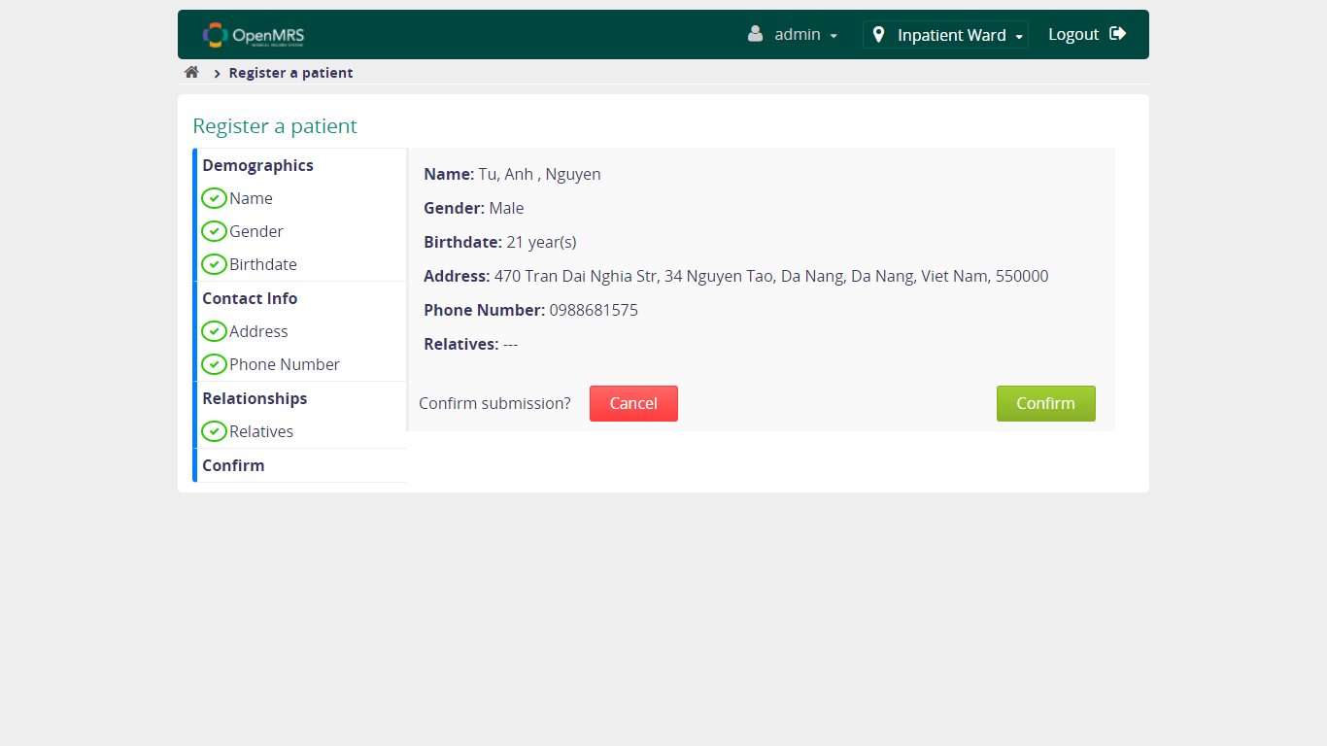

* 1. **Verify Form Confirmation Functionality**

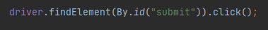

* + 1. **Verify Case happened when click CANCEL button**

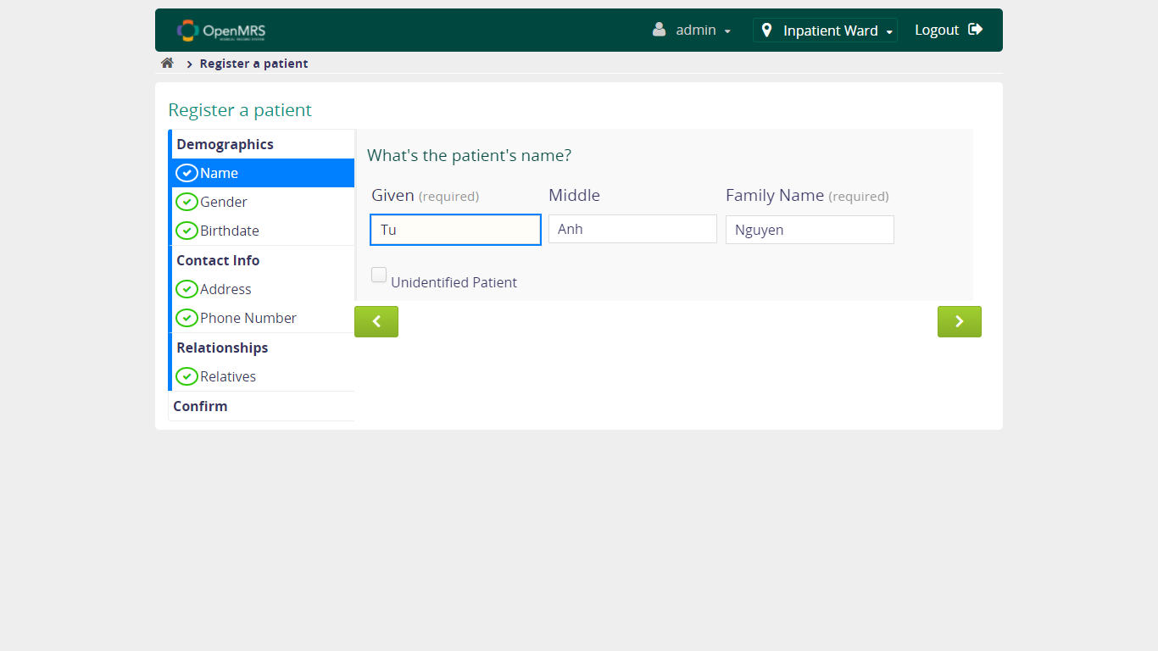

* + 1. **Verify Case happened when click CONFIRM button**

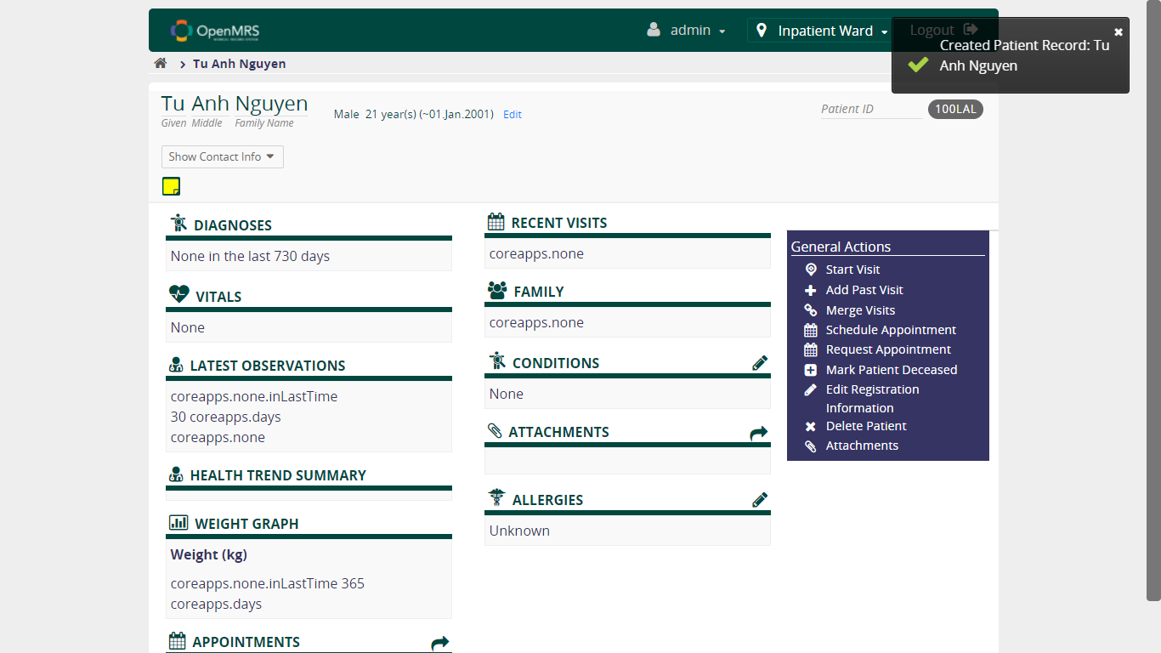

1. **Find Patient Record Module**

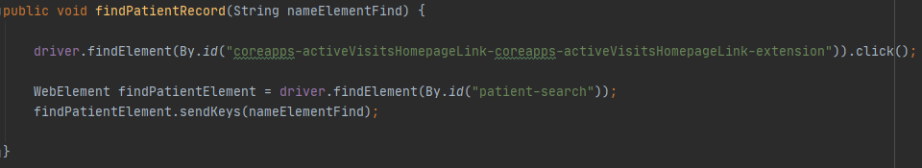

* 1. **Verify Search Functionality**
     1. **Verify if the result is displayed when entering VALID characters**

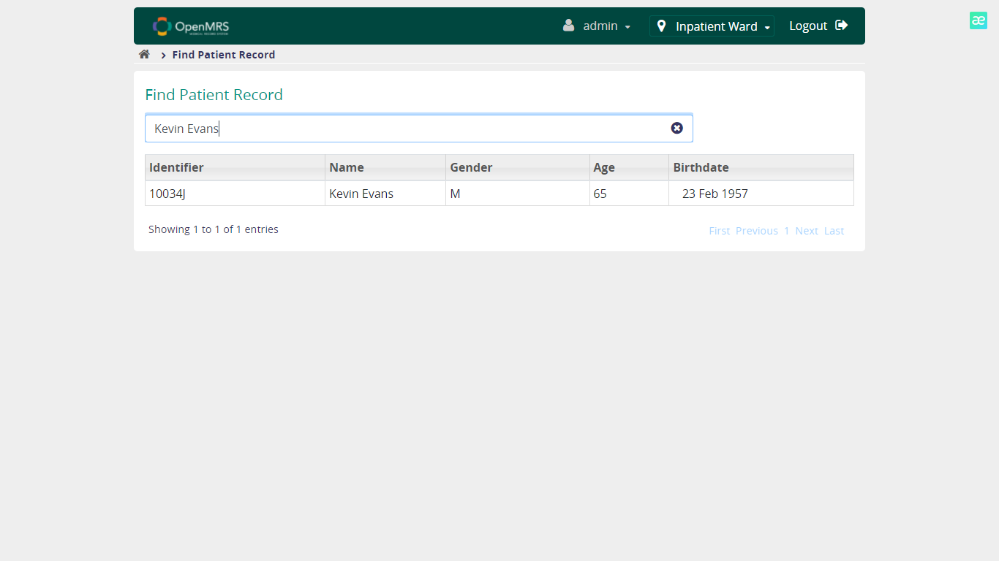

* + 1. **Verify if the result is displayed when entering UNVALID characters**

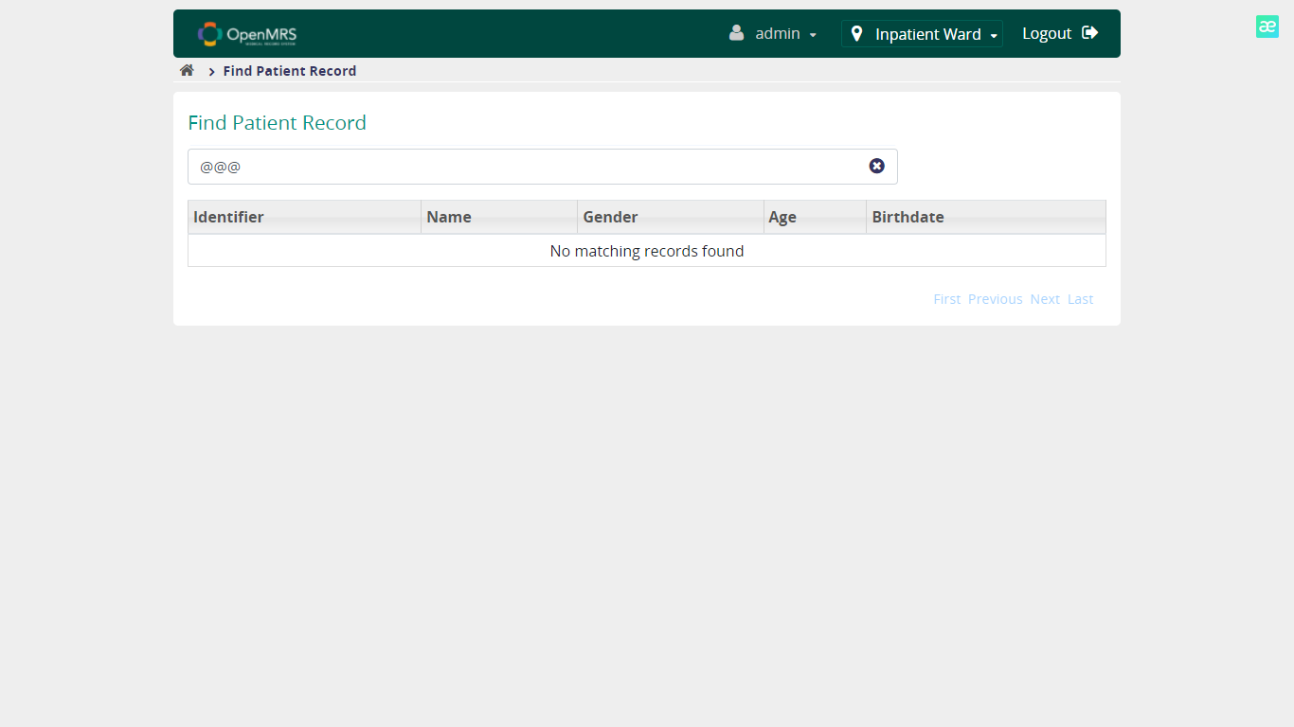

* + 1. **Verify if the result is displayed when left the searchbar EMPTY**

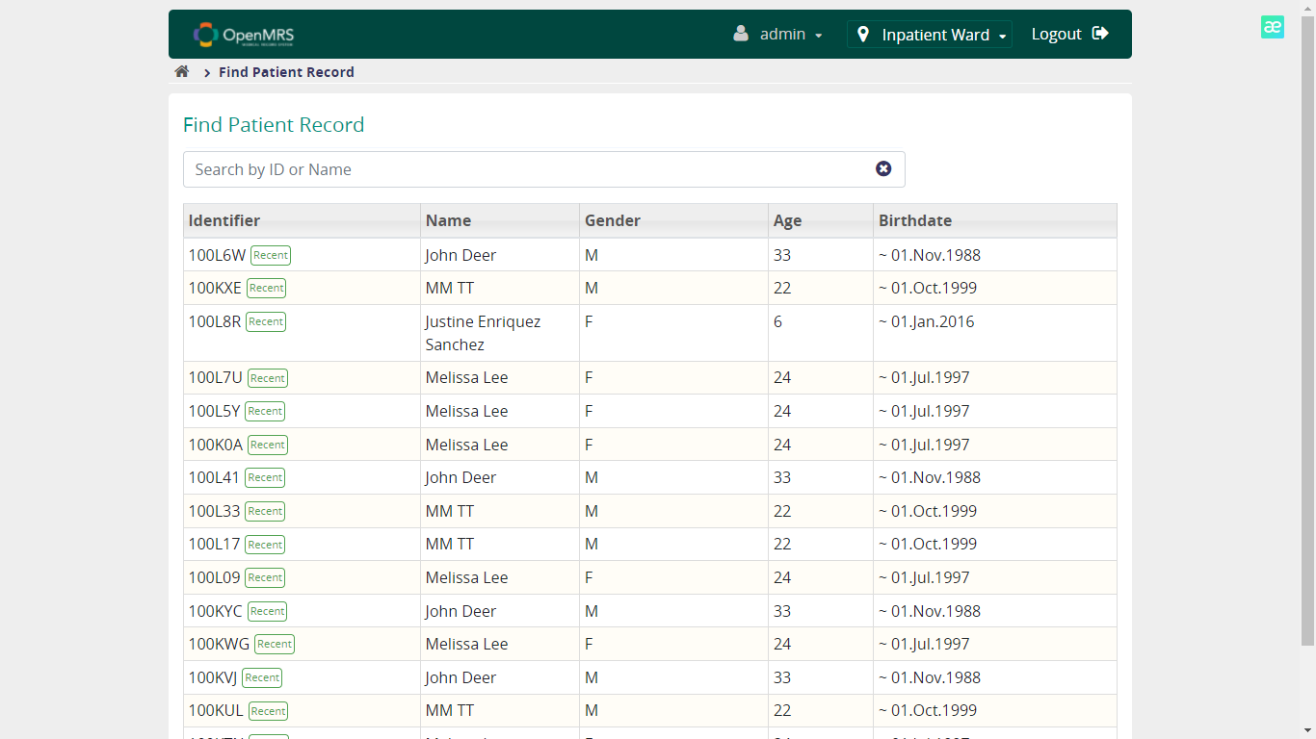

* + 1. **Verify if the result is displayed when entering RELEVANT characters**

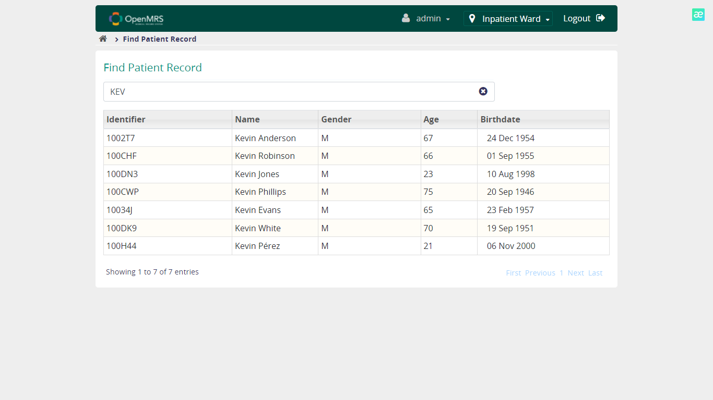

1. **View Patient Module**

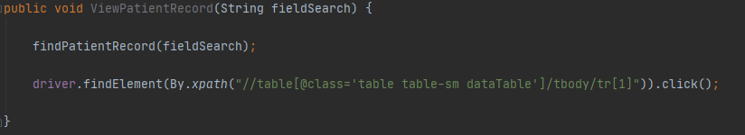

* 1. **Verify View Details Functionality**
     1. **Verify if the patient's details page is displayed when click at the reuslt after search**

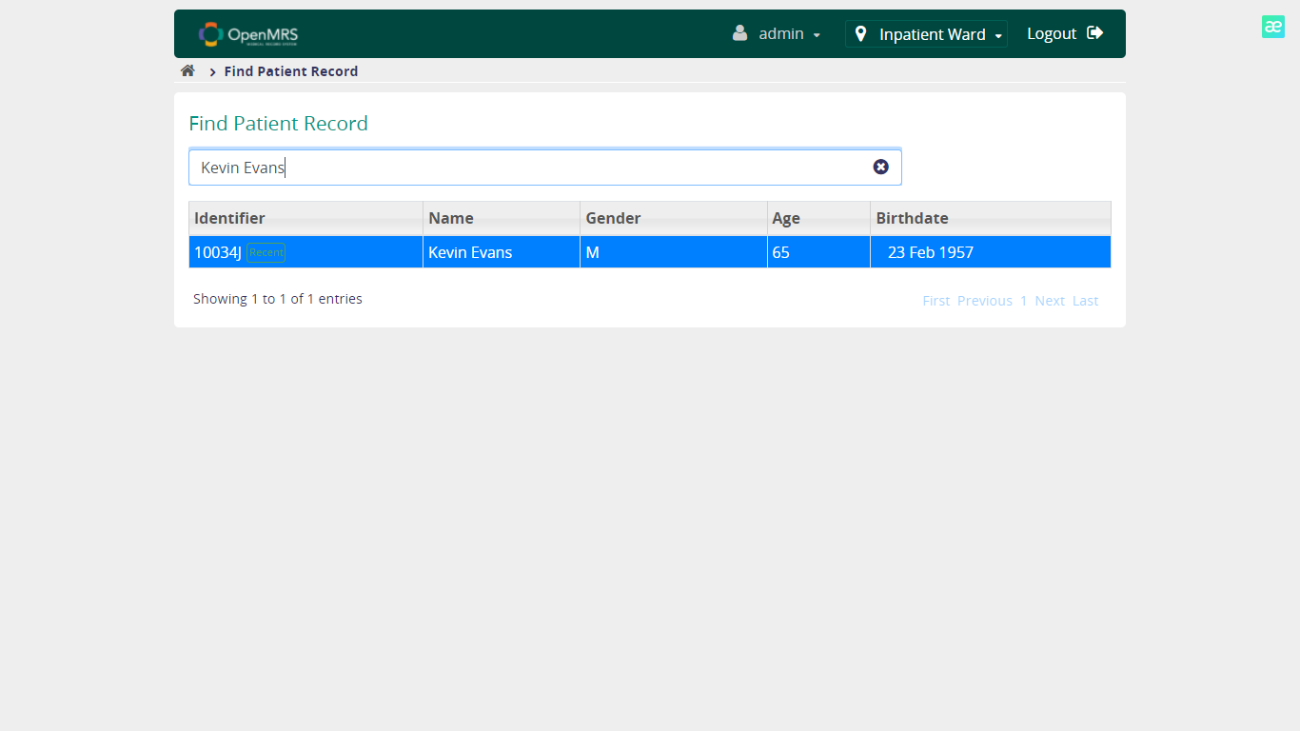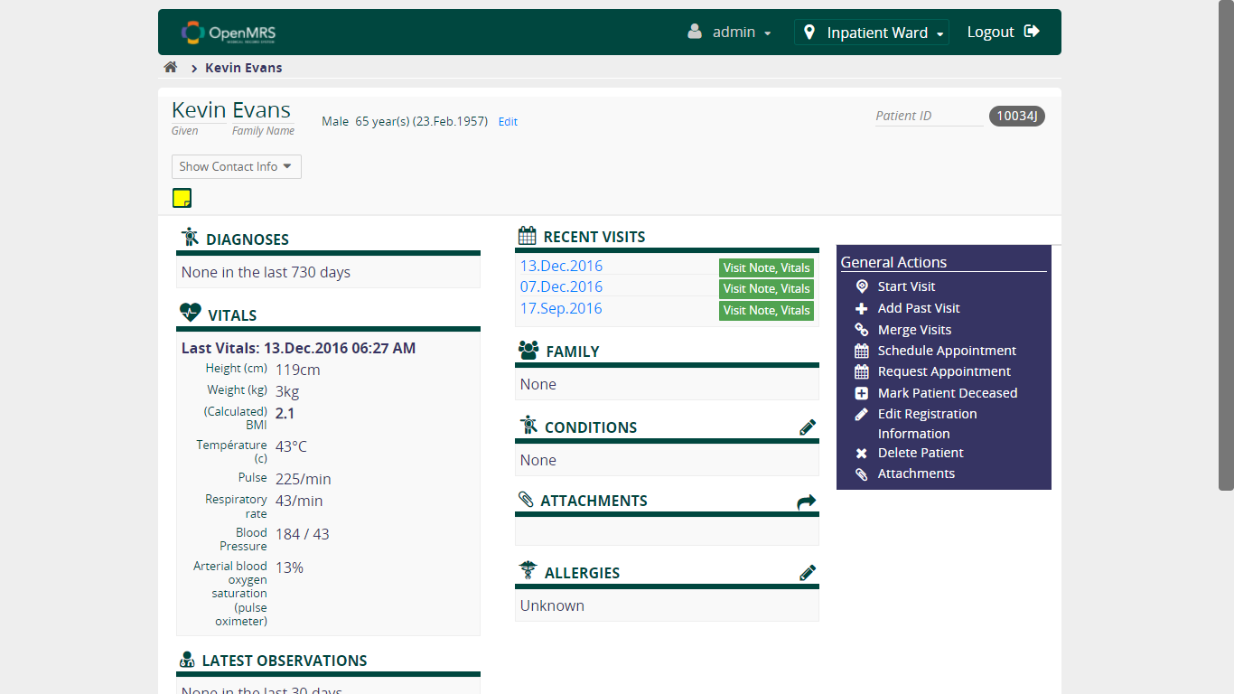

* + 1. **Verify the patient's info shown as patient's details page is CORRECT or NOT**



1. **Book Appointment Module**
   1. **Verify Book an Appointment Functionality**
      1. **Verify if there is any appointment request from patient to book**

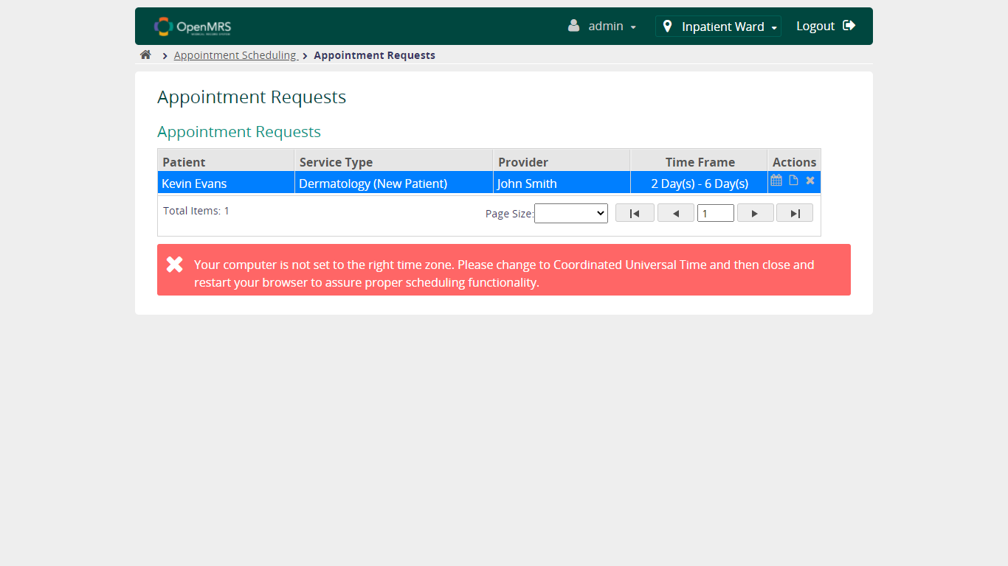

* + 1. **Verify User can continue booking when FILL in Service Type and Timeframe**

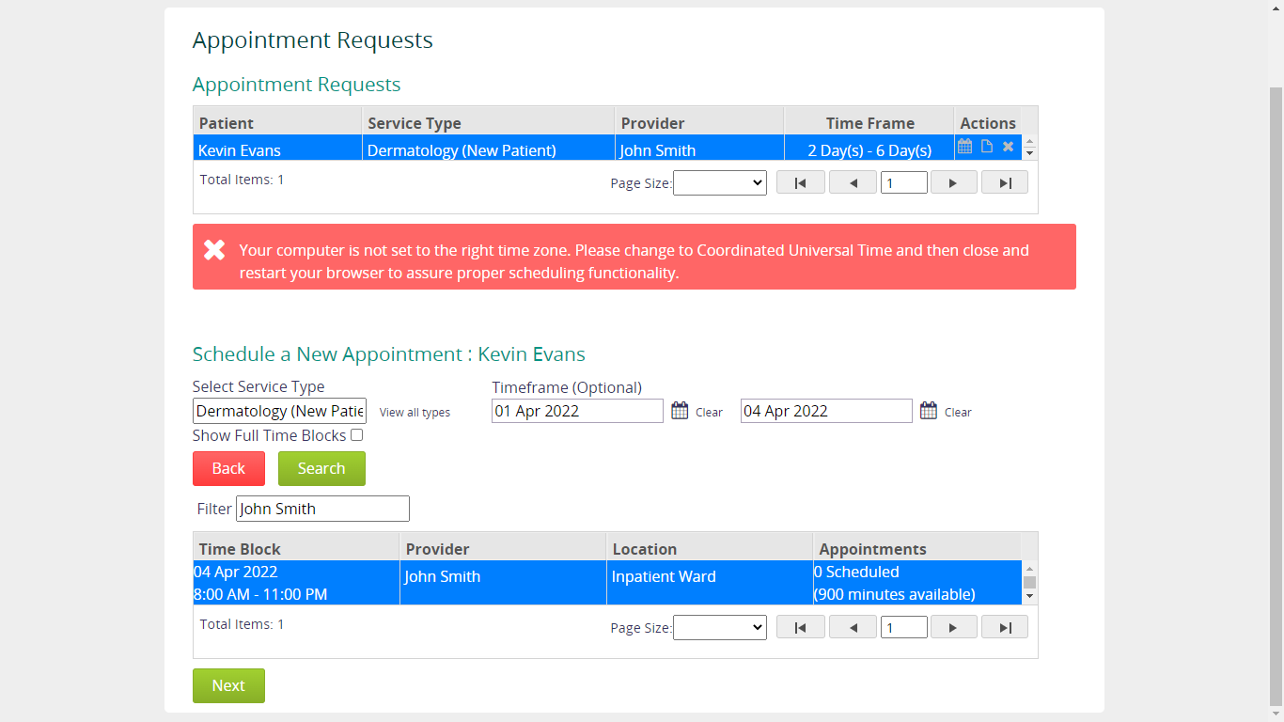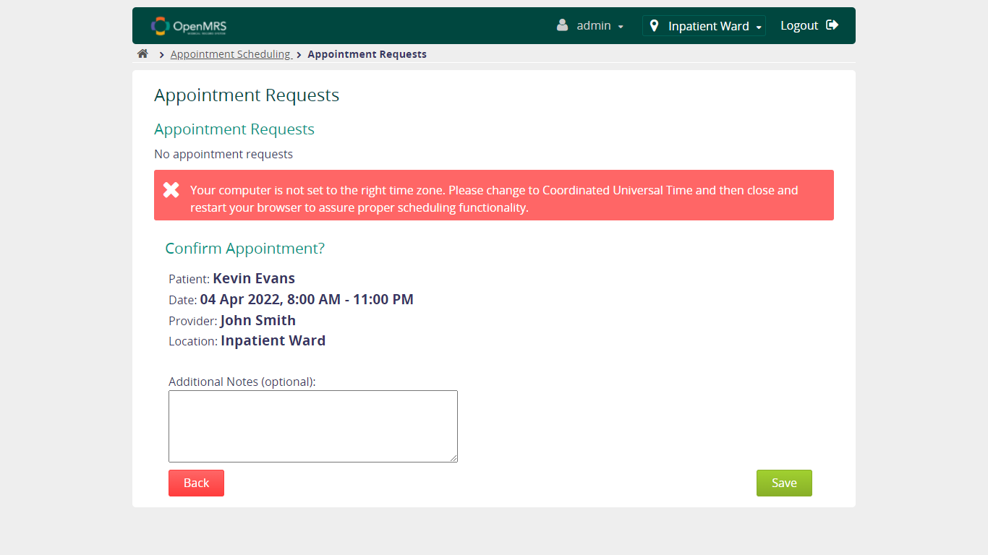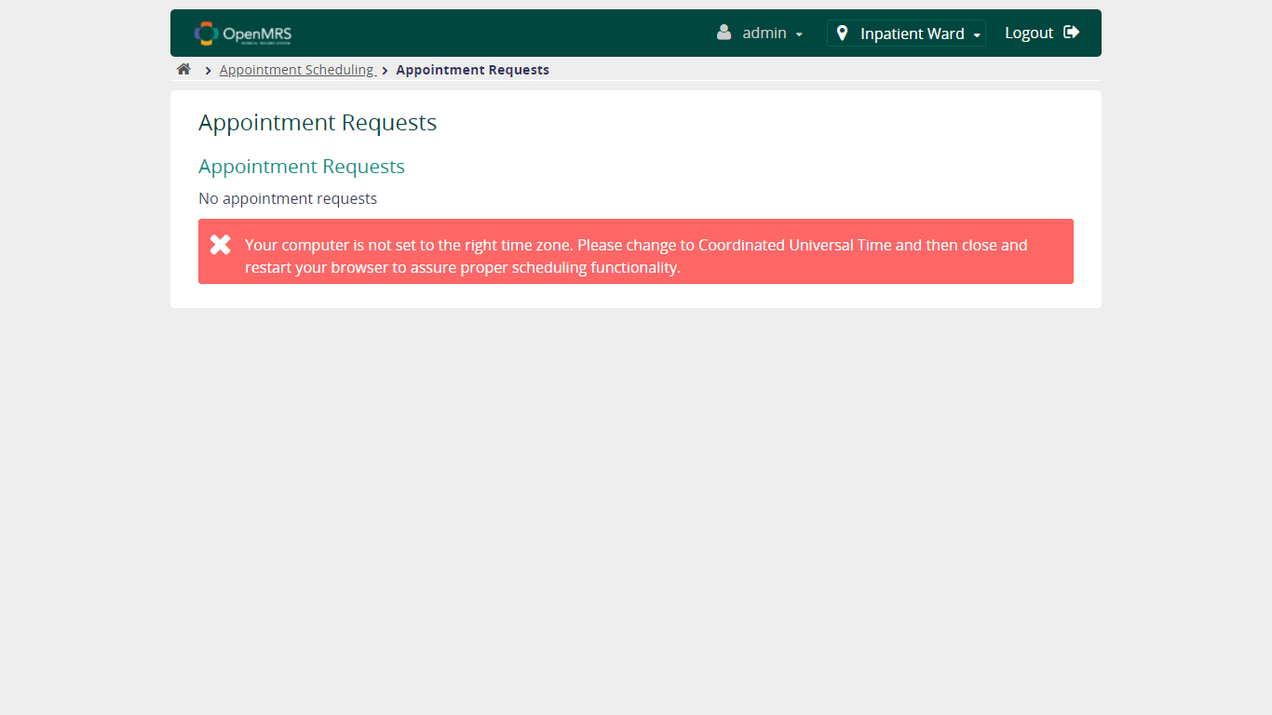

* + 1. **Verify User can continue booking when NOT FILL in Service Type and Timeframe**

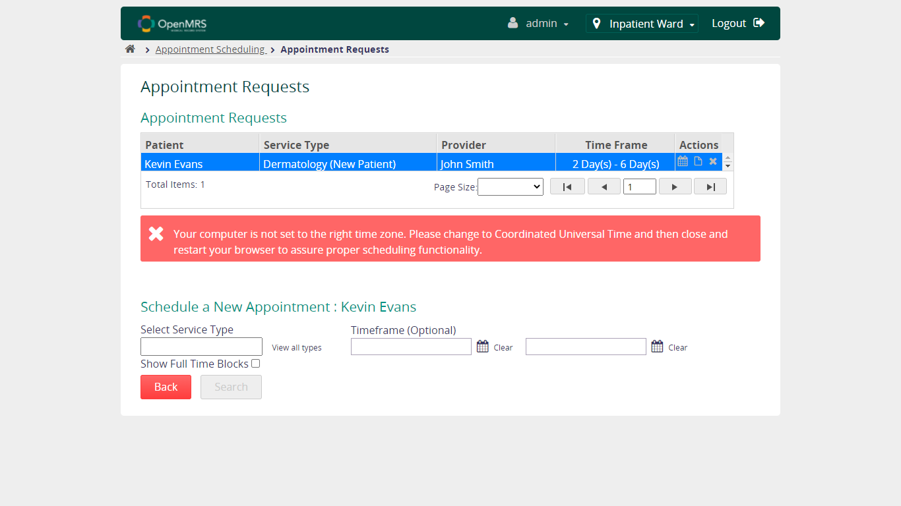

* + 1. **Verify User can continue booking when FILL in Service Type and NOT FILL in Timeframe**

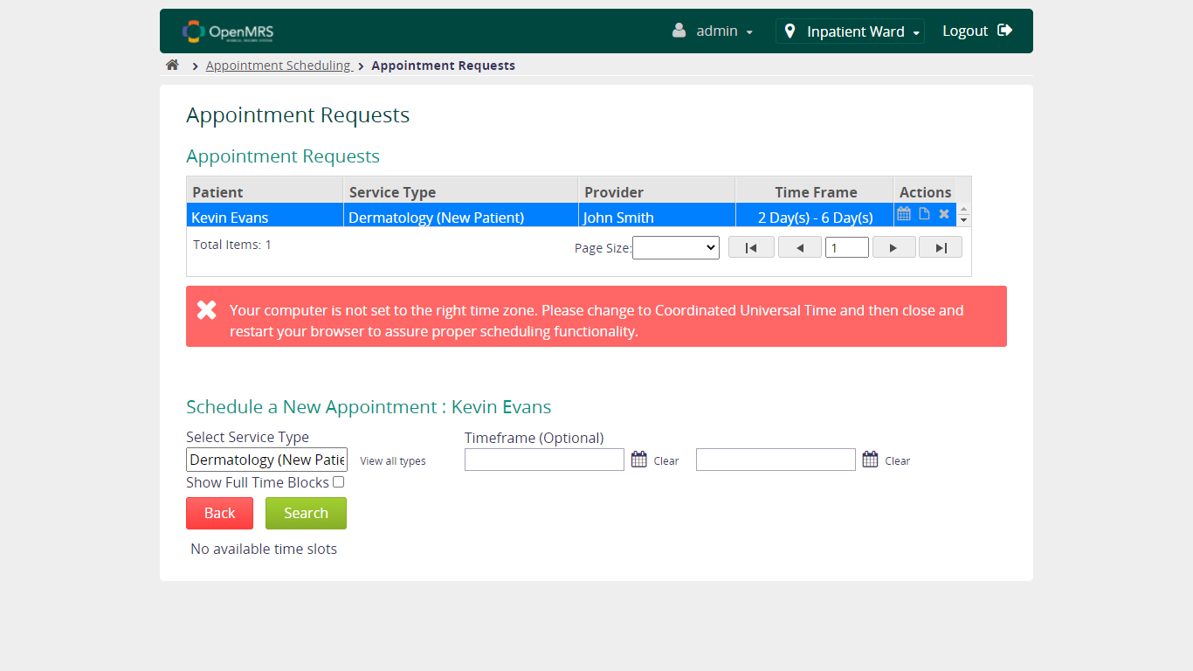

* + 1. **Verify User can continue booking when NOT FILL in Service Type and FILL in Timeframe**

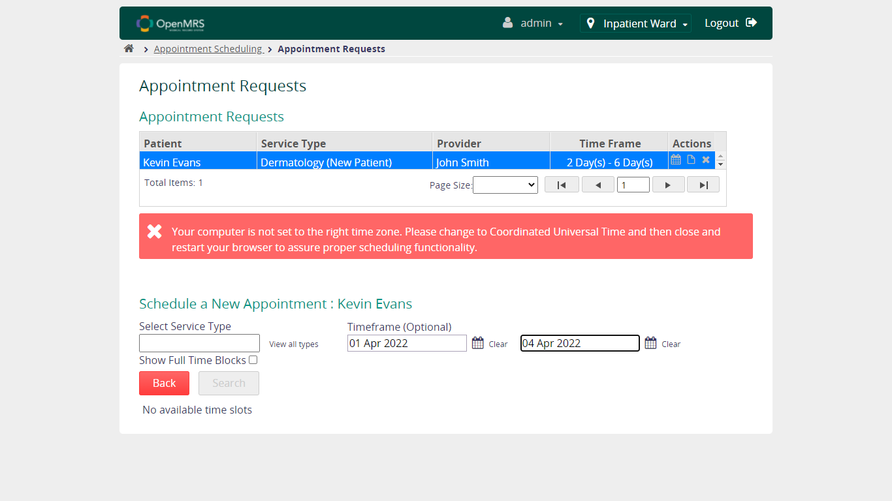

1. **Capture Vitals Module**

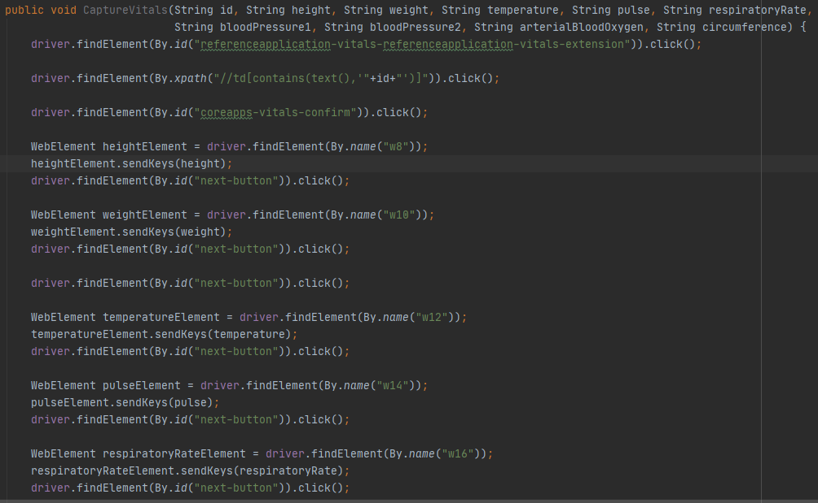 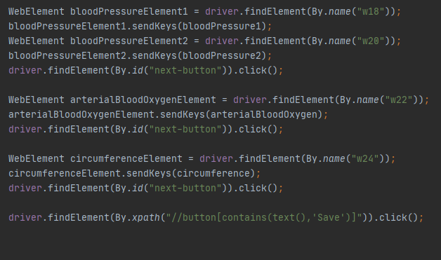

* 1. **Verify Capture Vitals Functionality – Confirmation**

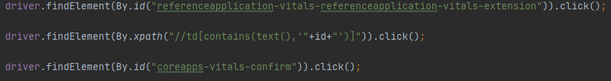

* + 1. **Verify Case happened when click No, Find Another Patient button for "Is this the right patient?"**

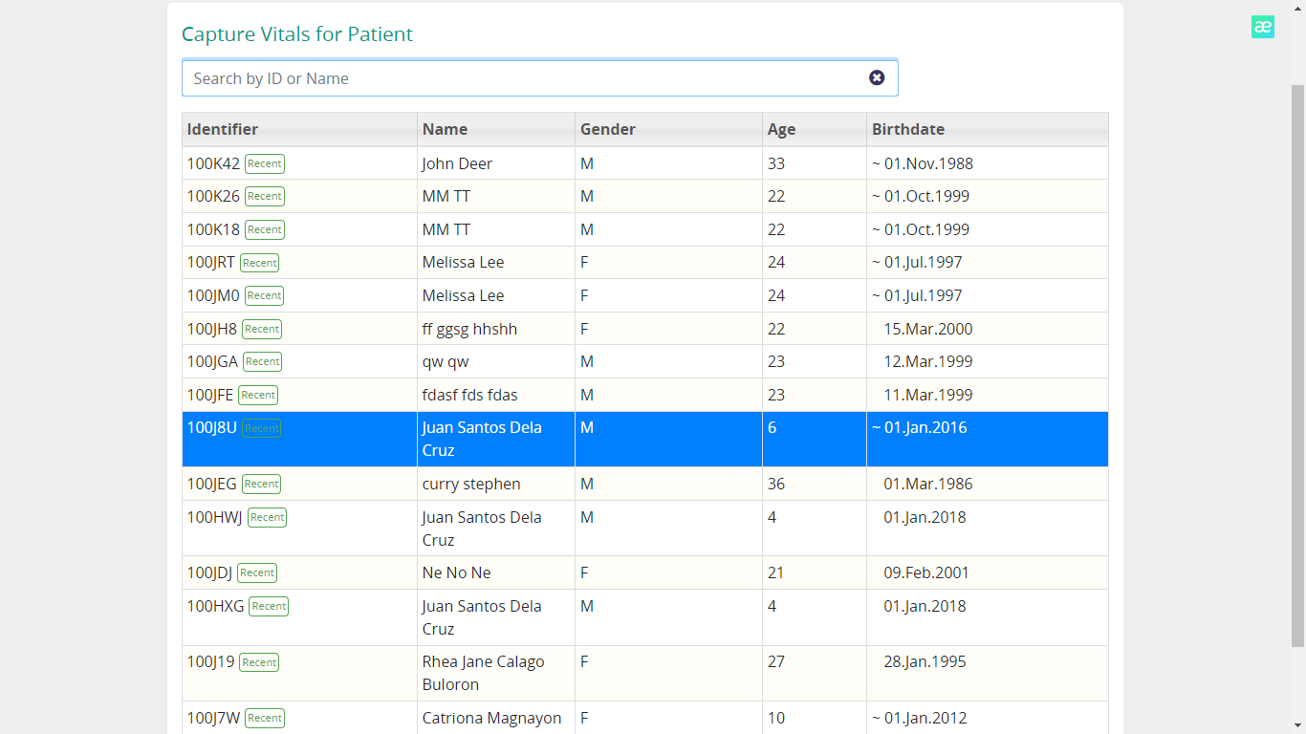

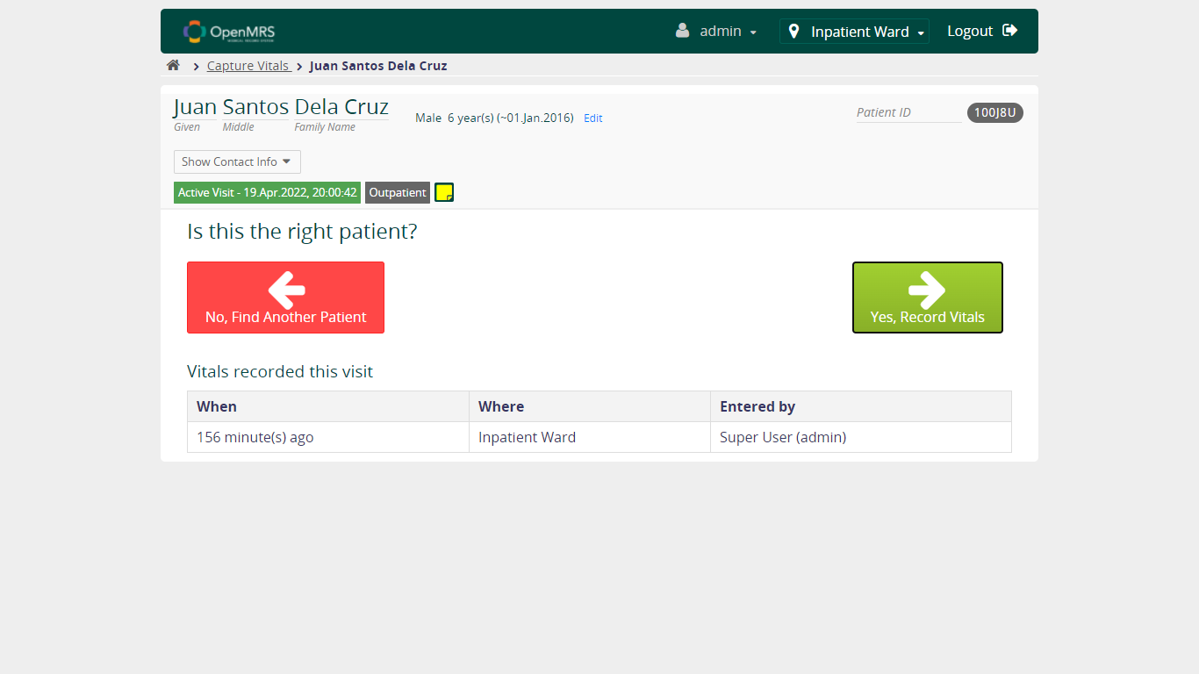 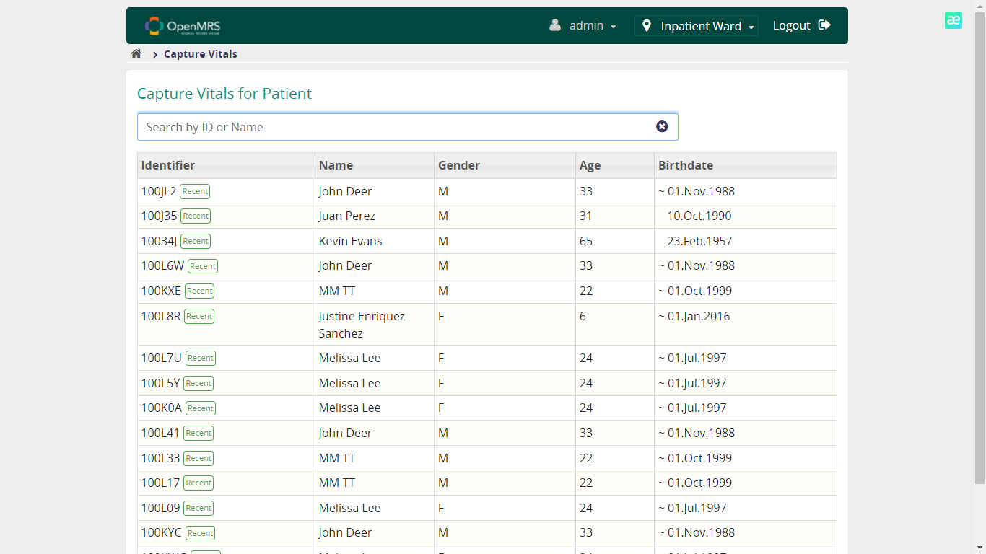

* + 1. **Verify Case happened when click Yes, Record Patient button for "Is this the right patient?"**

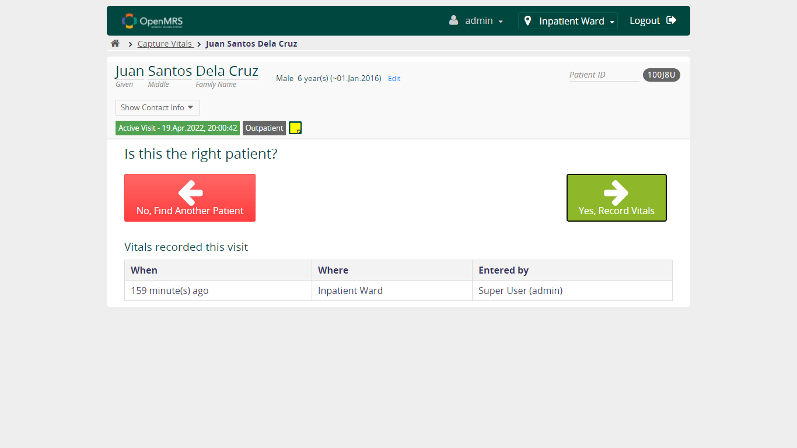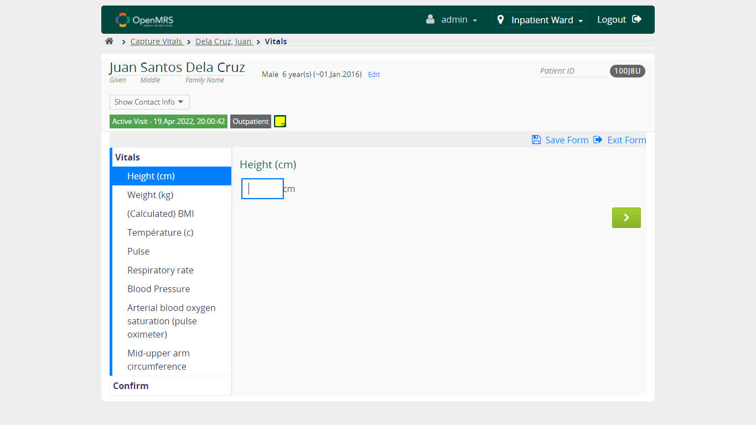

* 1. **Verify Capture Vitals Functionality – Height**

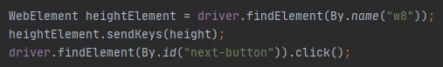

* + 1. **Verify User can continue to fill form when FILL VALID value in Height field**

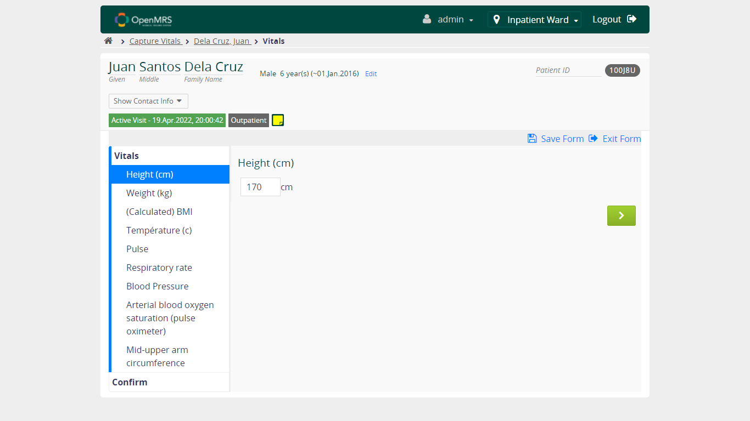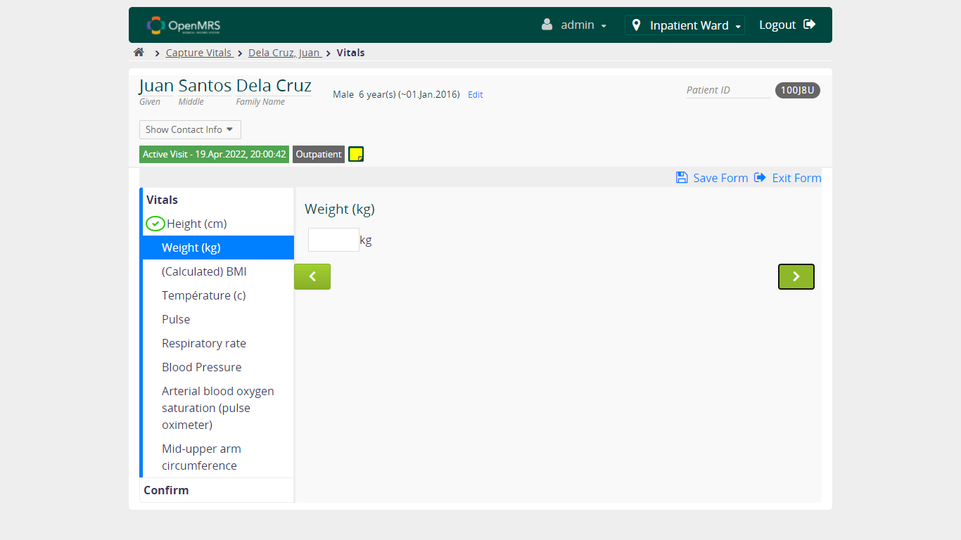

* + 1. **Verify User can continue to fill form when FILL UNVALID value in Height field**

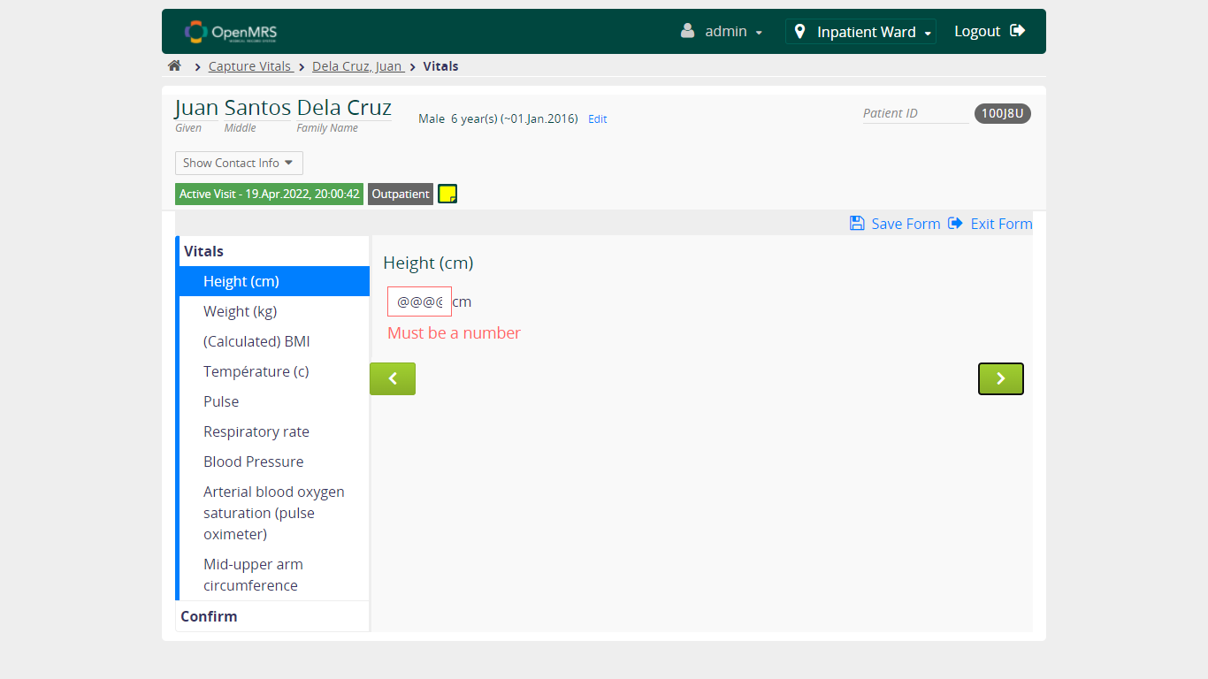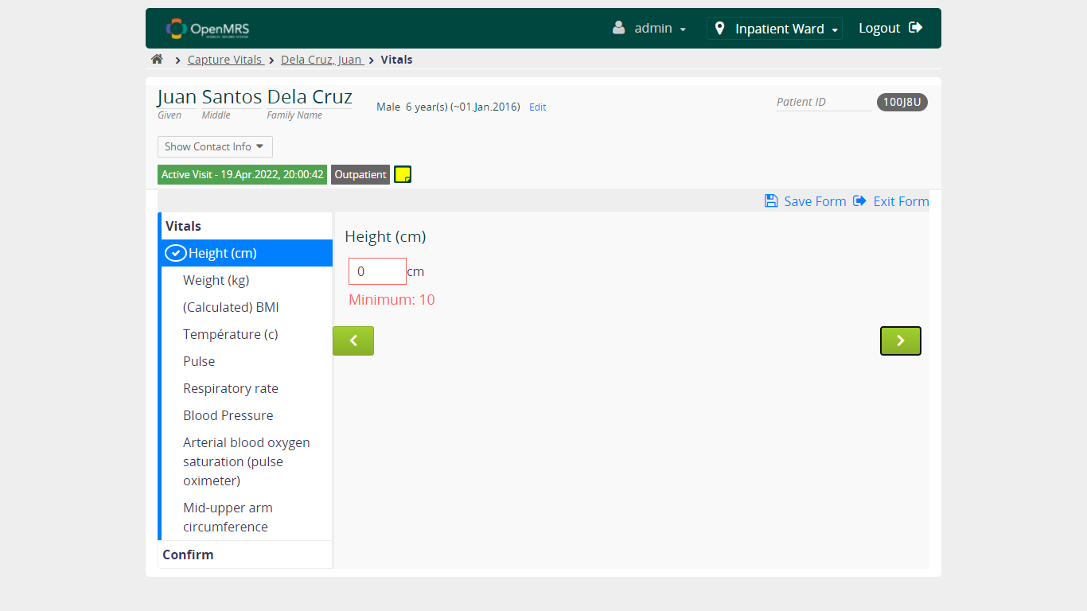

* + 1. **Verify User can continue to fill form when NOT FILL value in Height field**

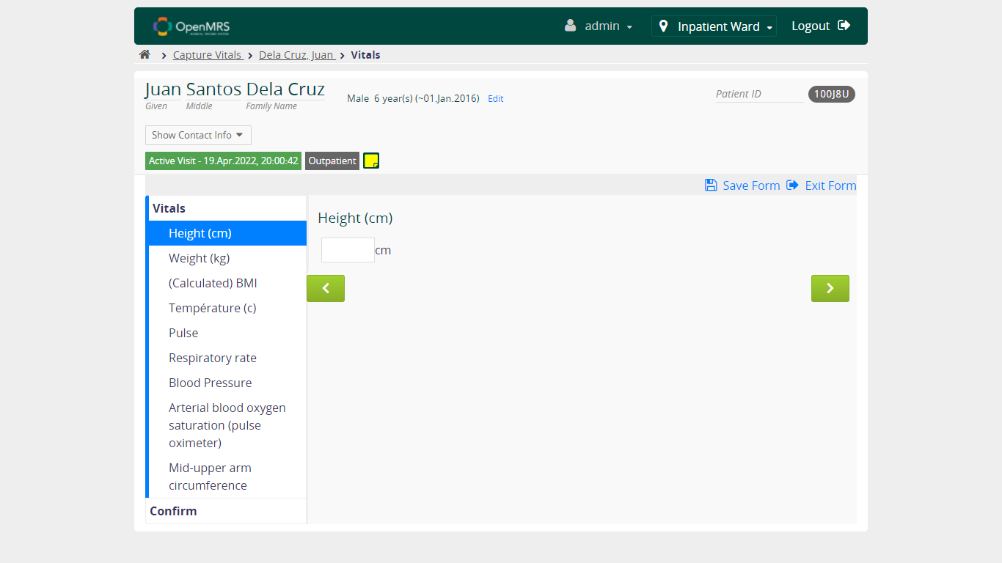

* 1. **Verify Capture Vitals Functionality – Weight**

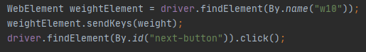

* + 1. **Verify User can continue to fill form when FILL VALID value in Weight field**

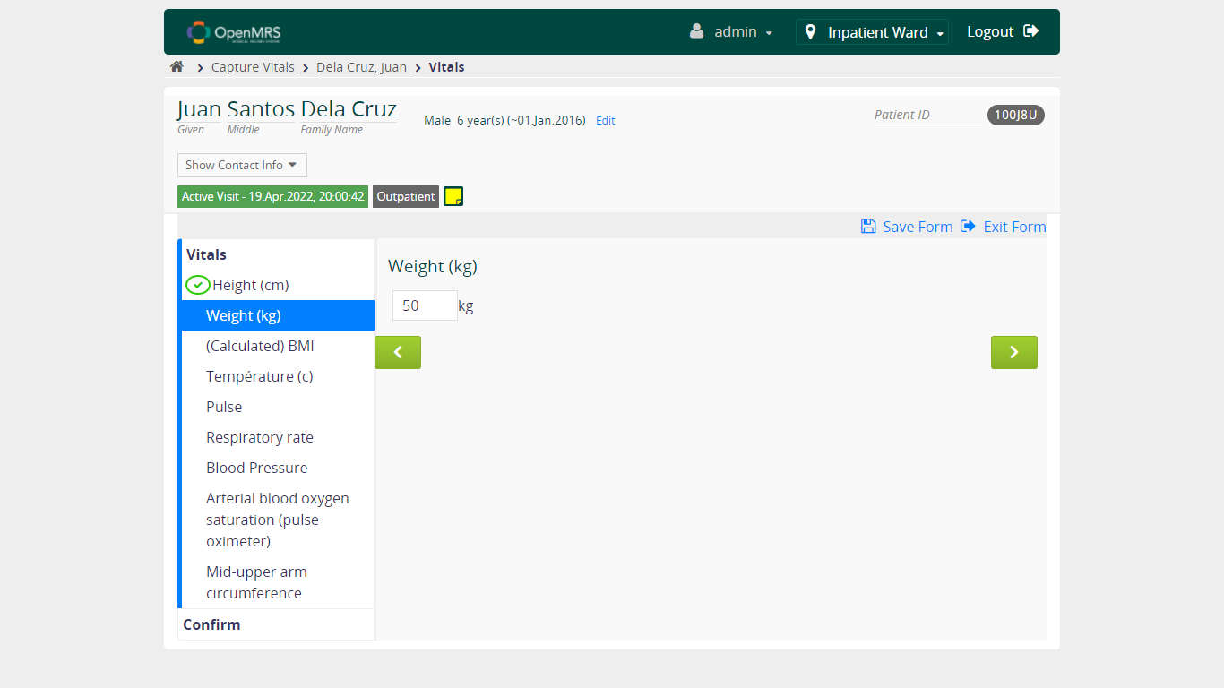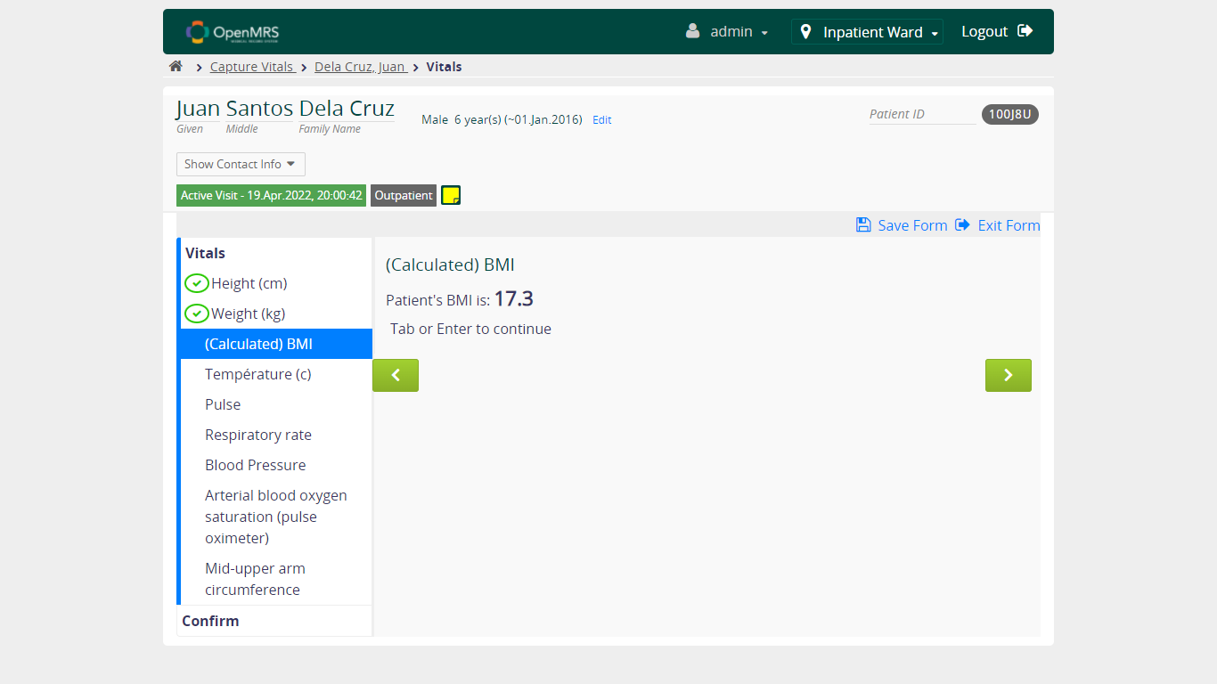

* + 1. **Verify User can continue to fill form when FILL UNVALID value in Weight field**

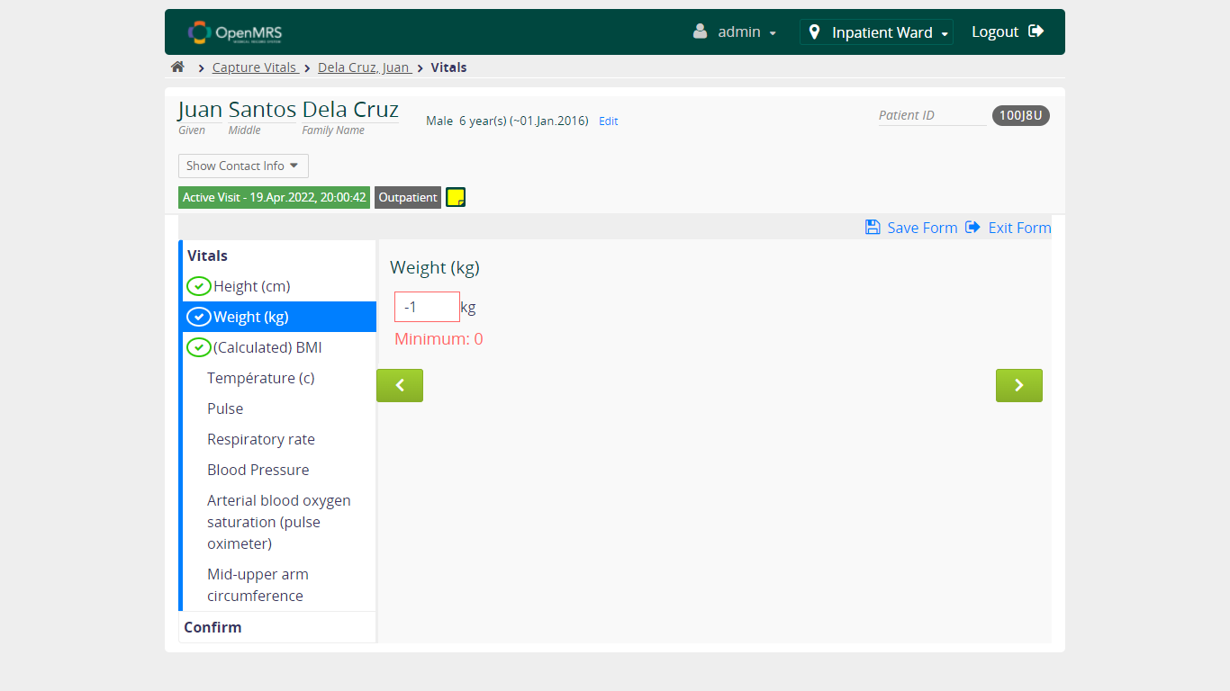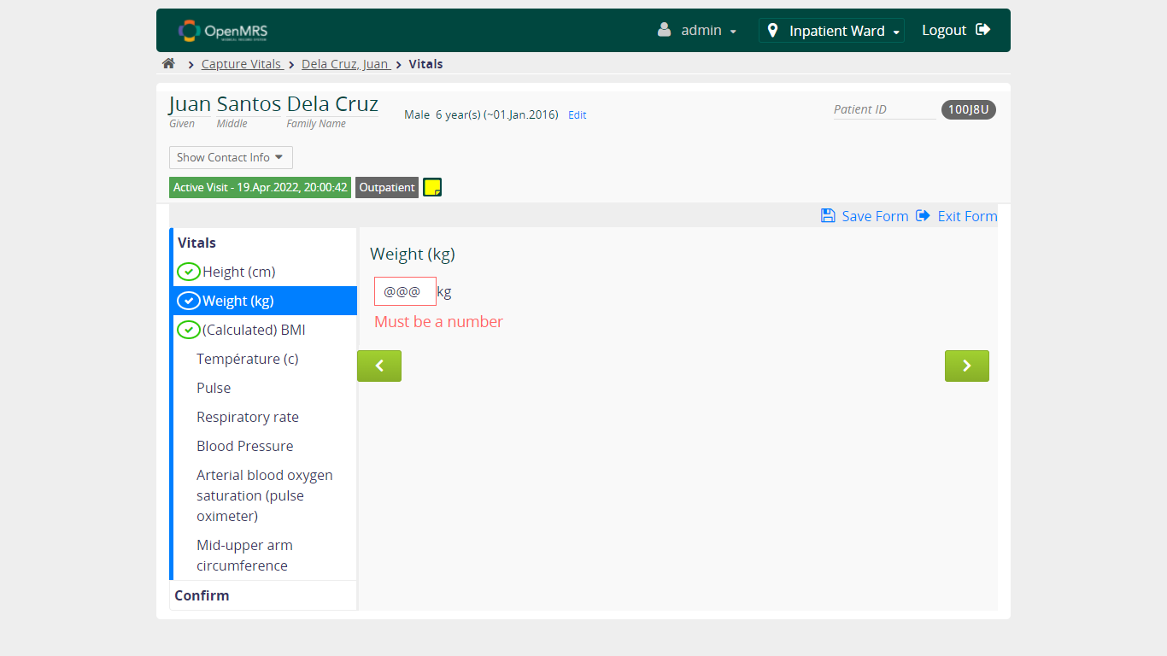

* + 1. **Verify User can continue to fill form when NOT FILL value in Weight field**

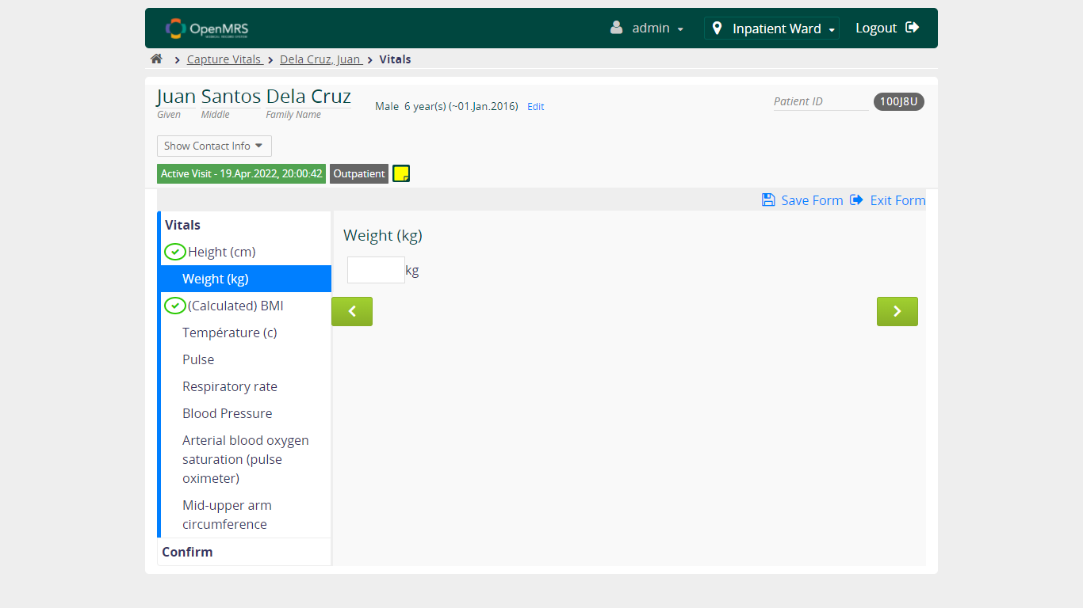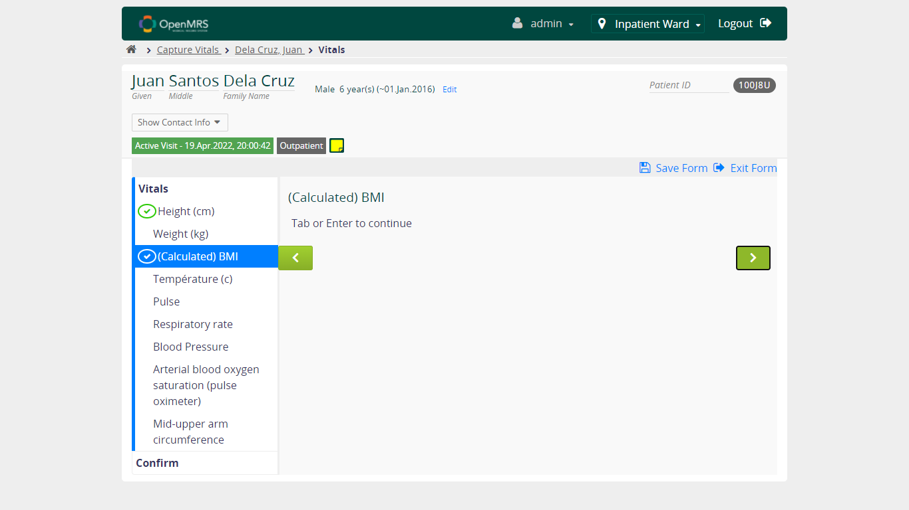

* 1. **Verify Capture Vitals Functionality – Temperature**

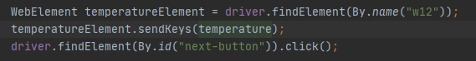

* + 1. **Verify User can continue to fill form when FILL VALID value in Temperature field**

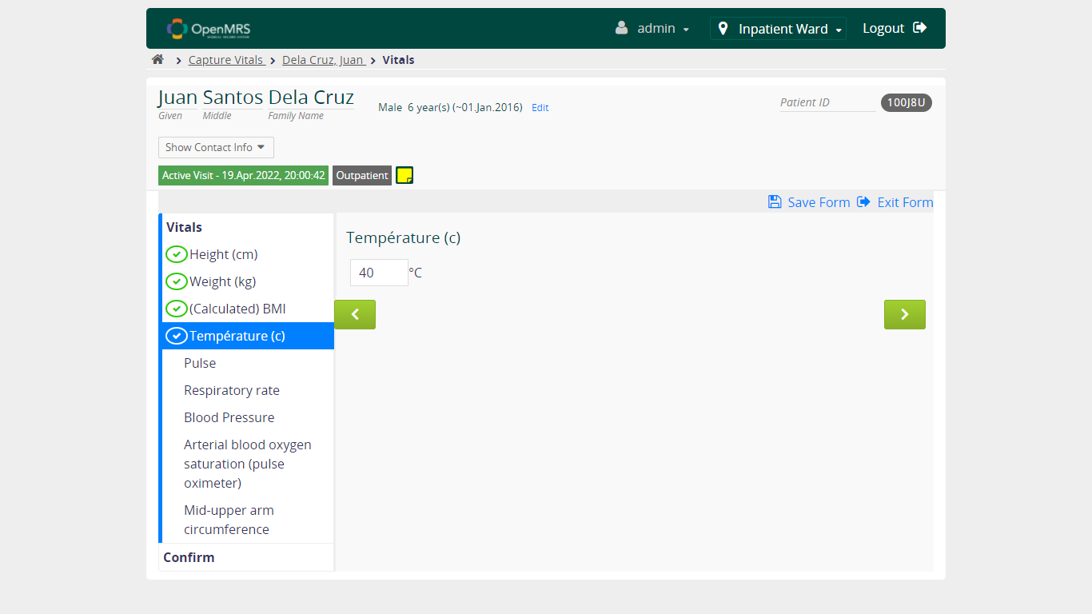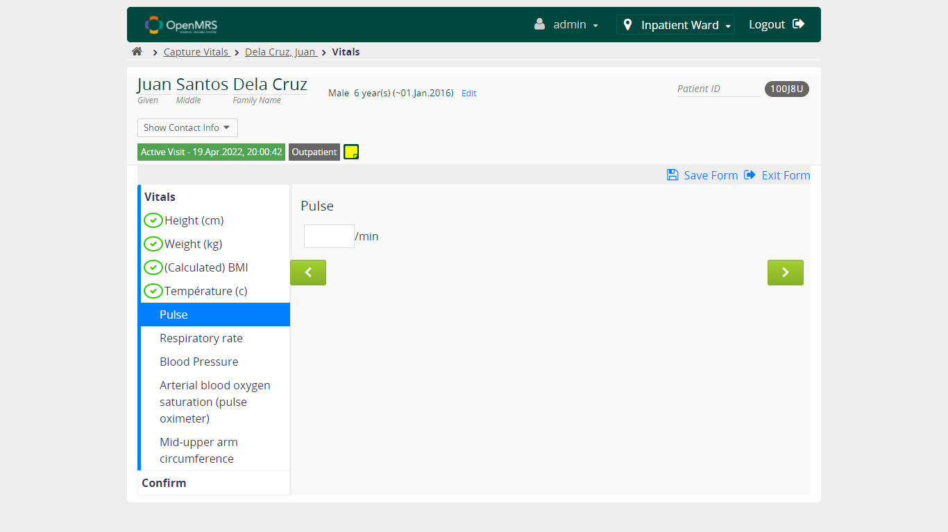

* + 1. **Verify User can continue to fill form when FILL UNVALID value in Temperature field**

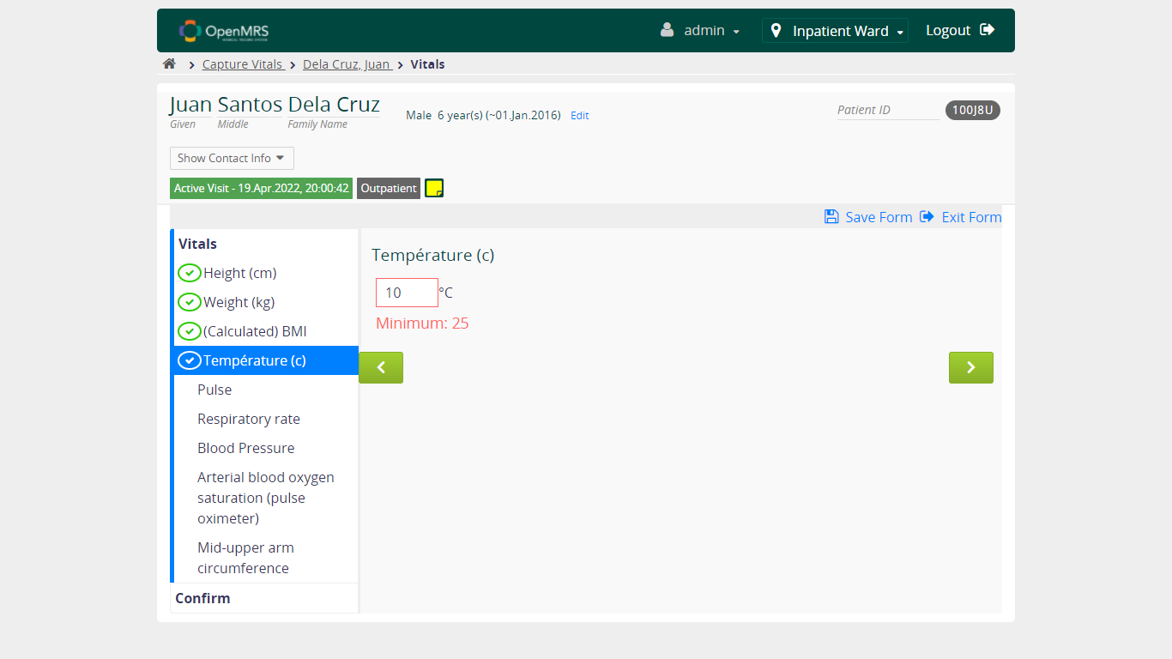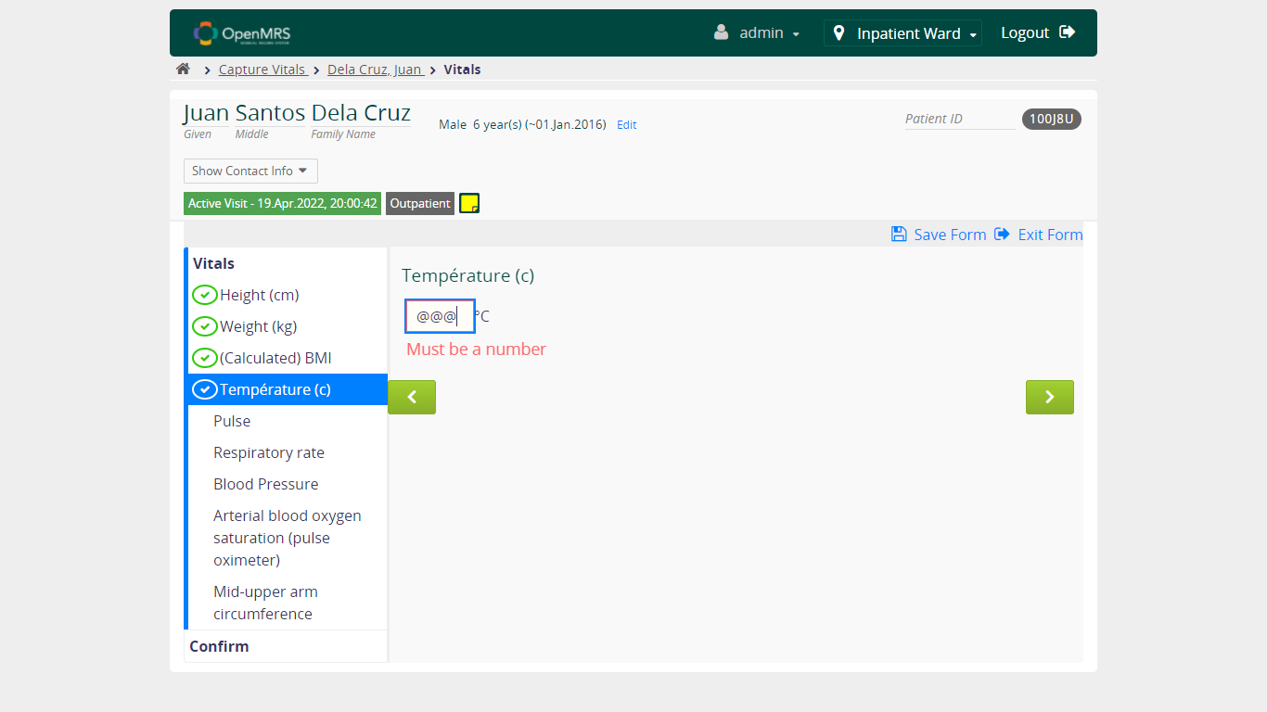

* + 1. **Verify User can continue to fill form when NOT FILL value in Temperature field**

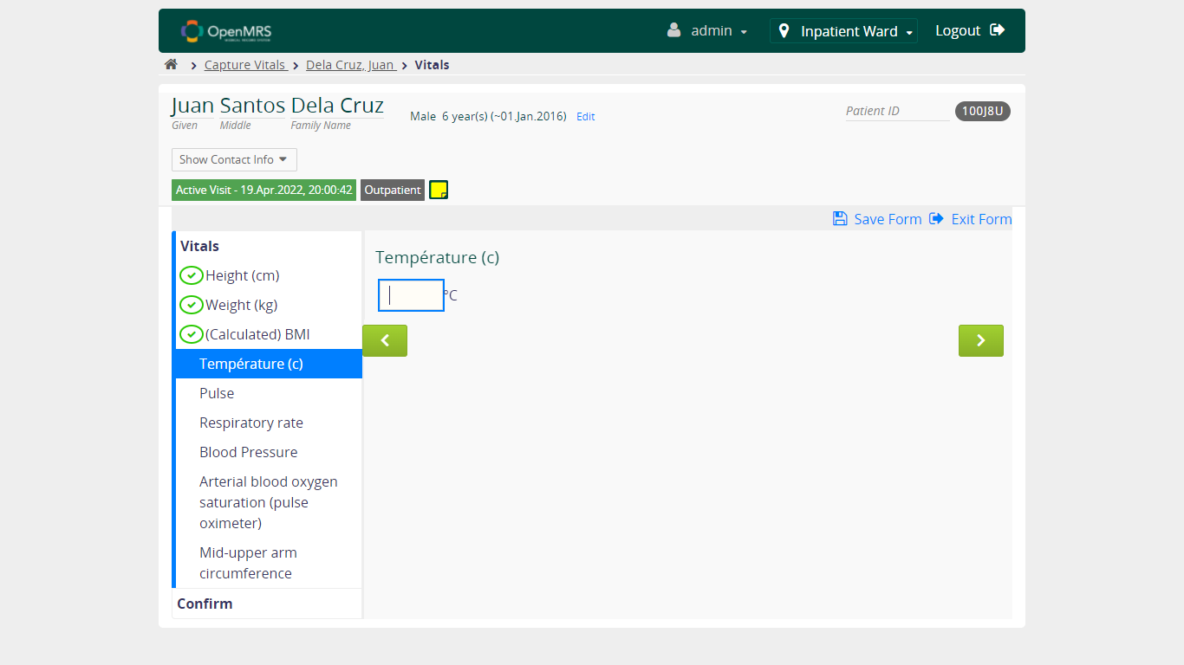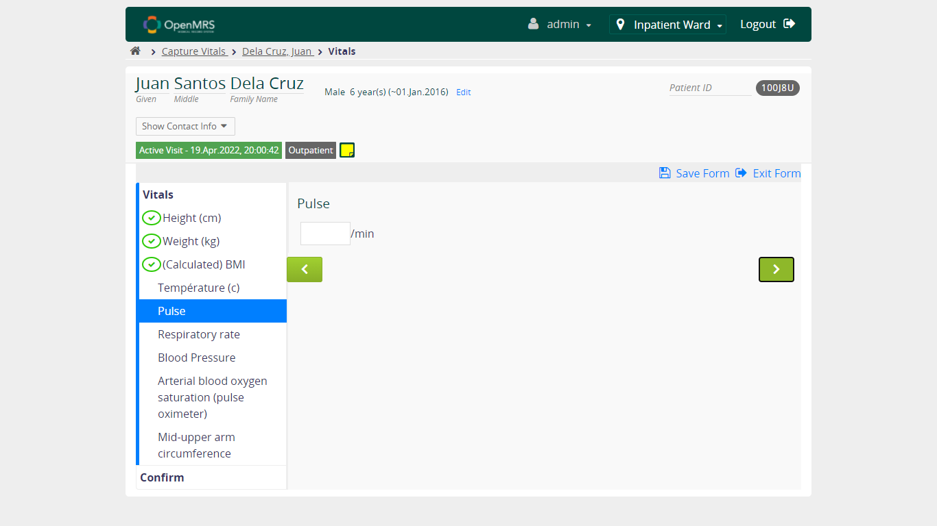

* 1. **Verify Capture Vitals Functionality – Pulse**

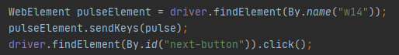

* + 1. **Verify User can continue to fill form when FILL VALID value in Pulse field**

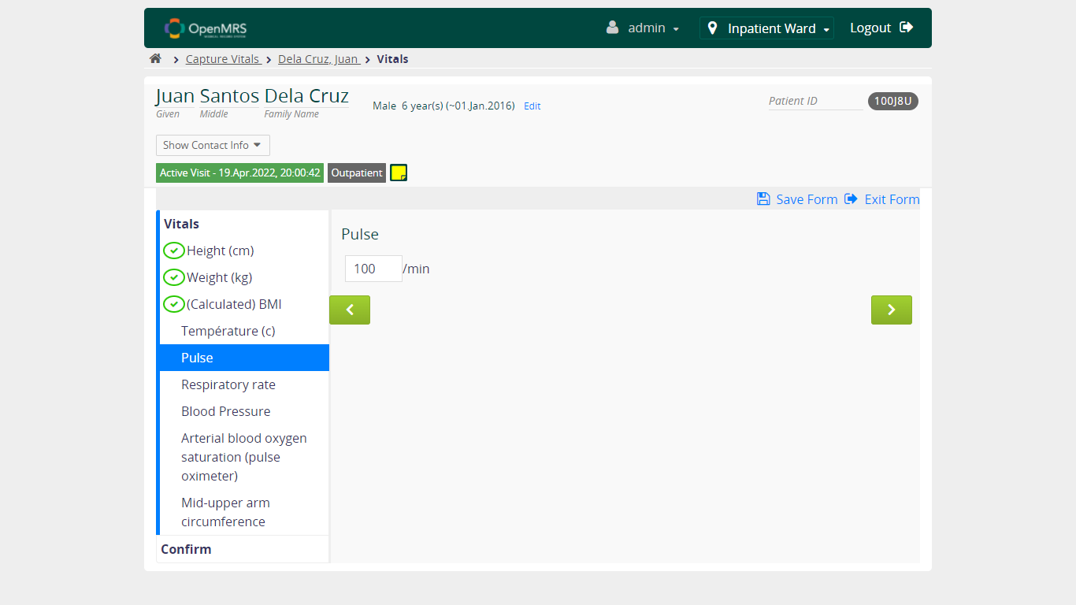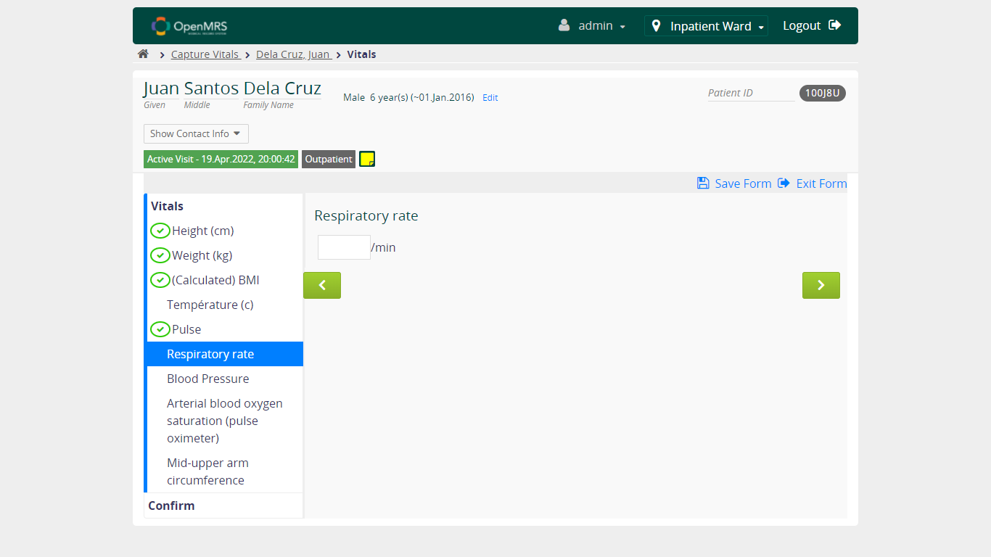

* + 1. **Verify User can continue to fill form when FILL UNVALID value in Pulse field**

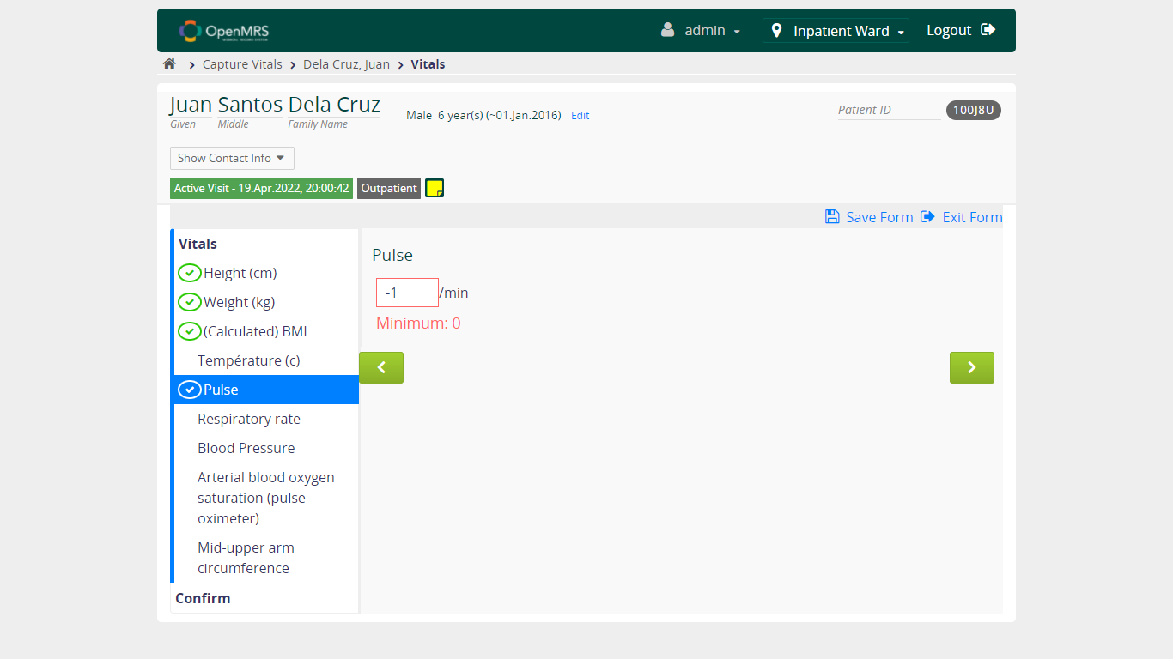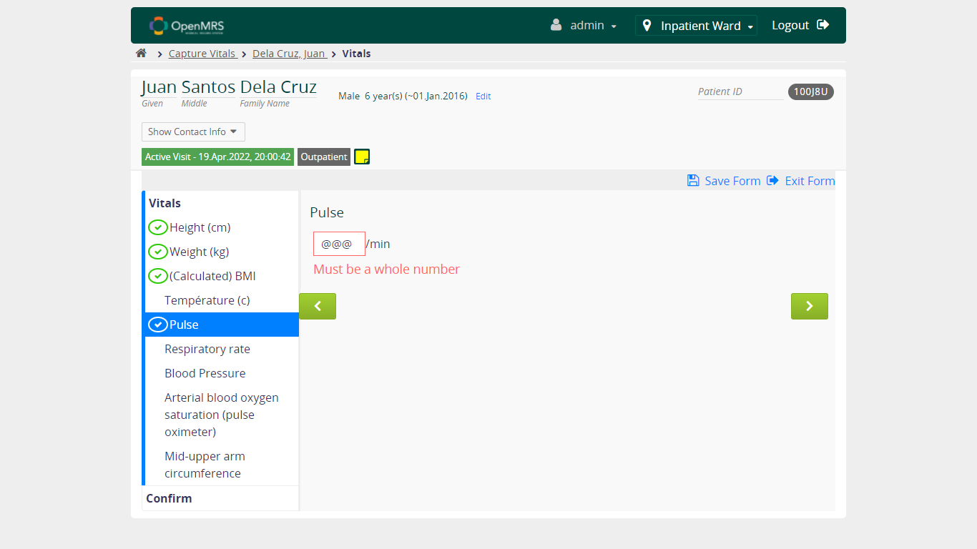

* + 1. **Verify User can continue to fill form when NOT FILL value in Pulse field**

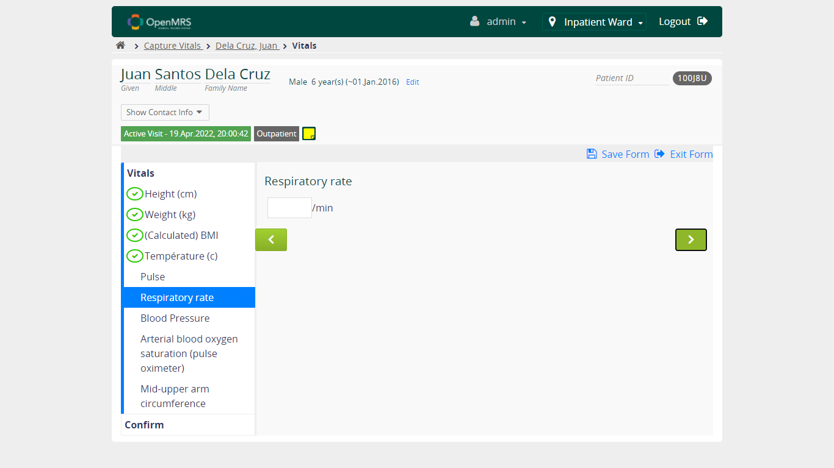

* 1. **Verify Capture Vitals Functionality - Respiratory Rate**

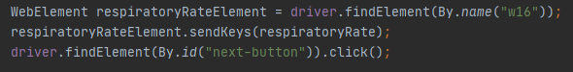

* + 1. **Verify User can continue to fill form when FILL VALID value in Respiratory Rate field**

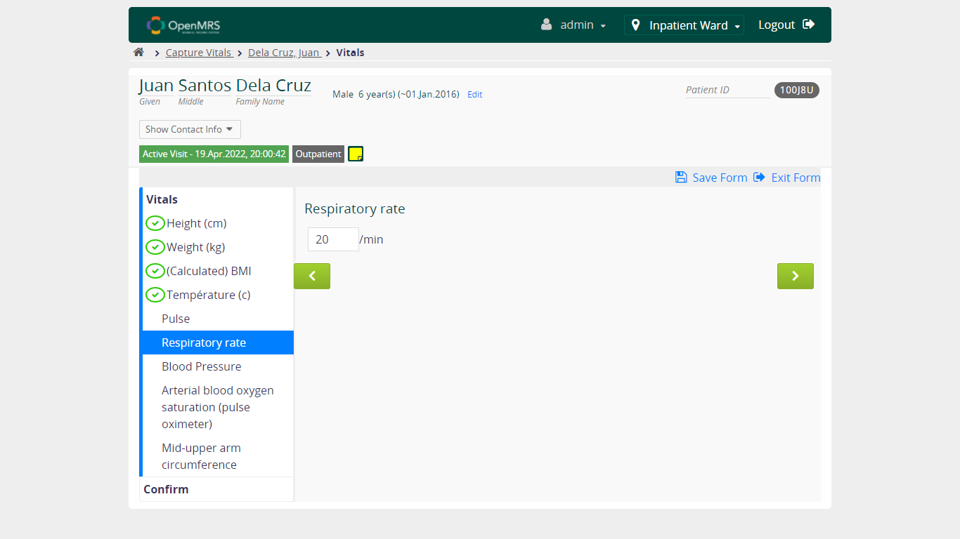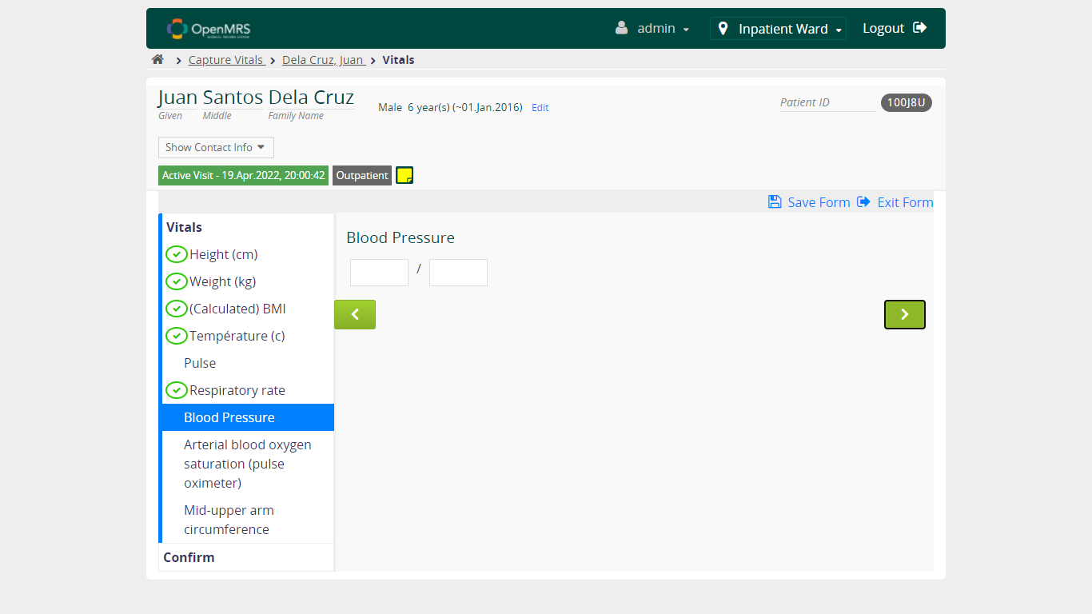

* + 1. **Verify User can continue to fill form when FILL UNVALID value in Respiratory Rate field**

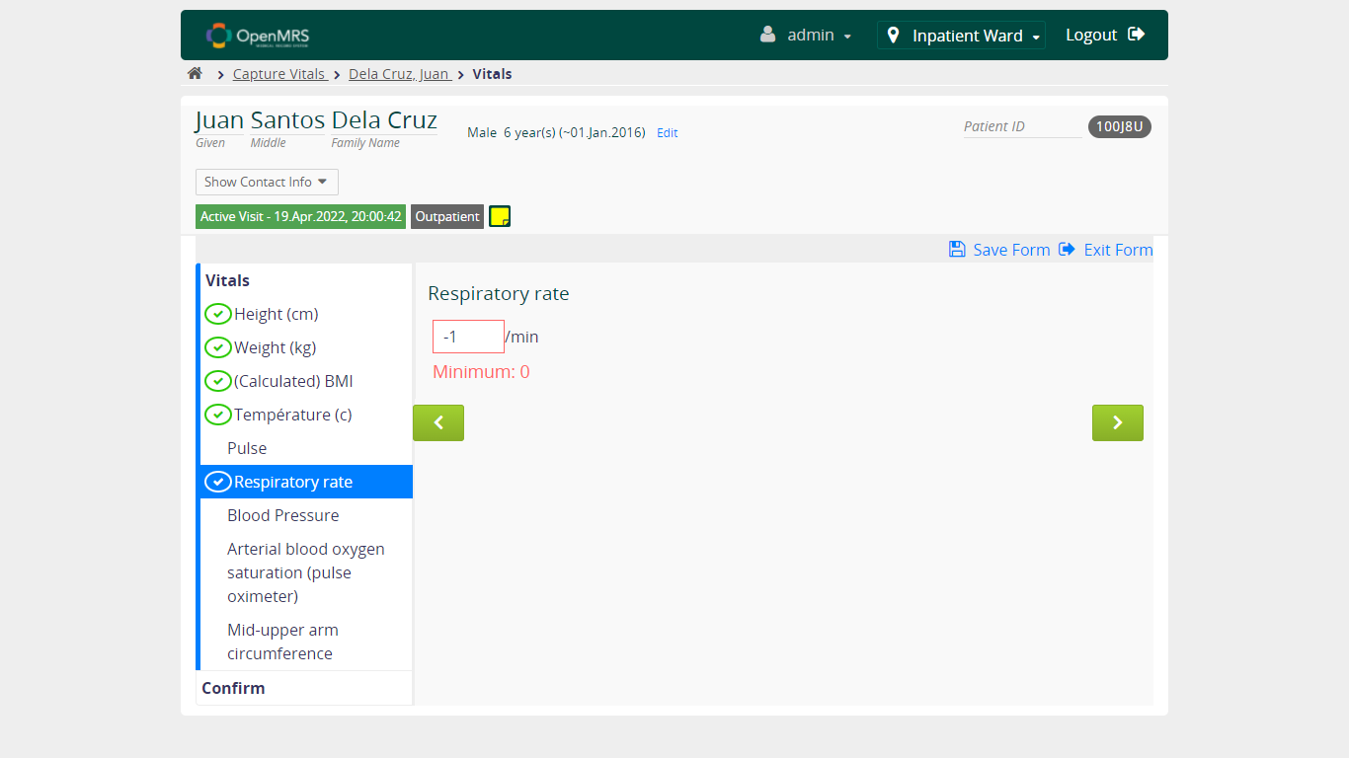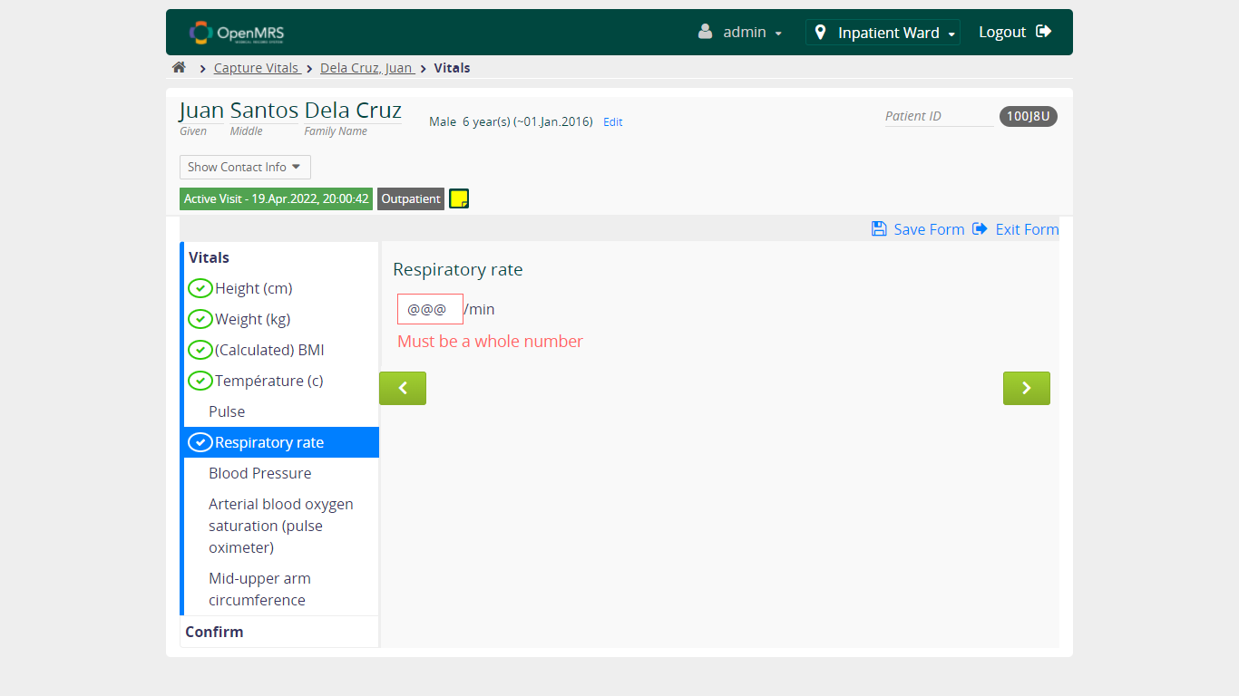

* + 1. **Verify User can continue to fill form when NOT FILL value in Respiratory Rate field**

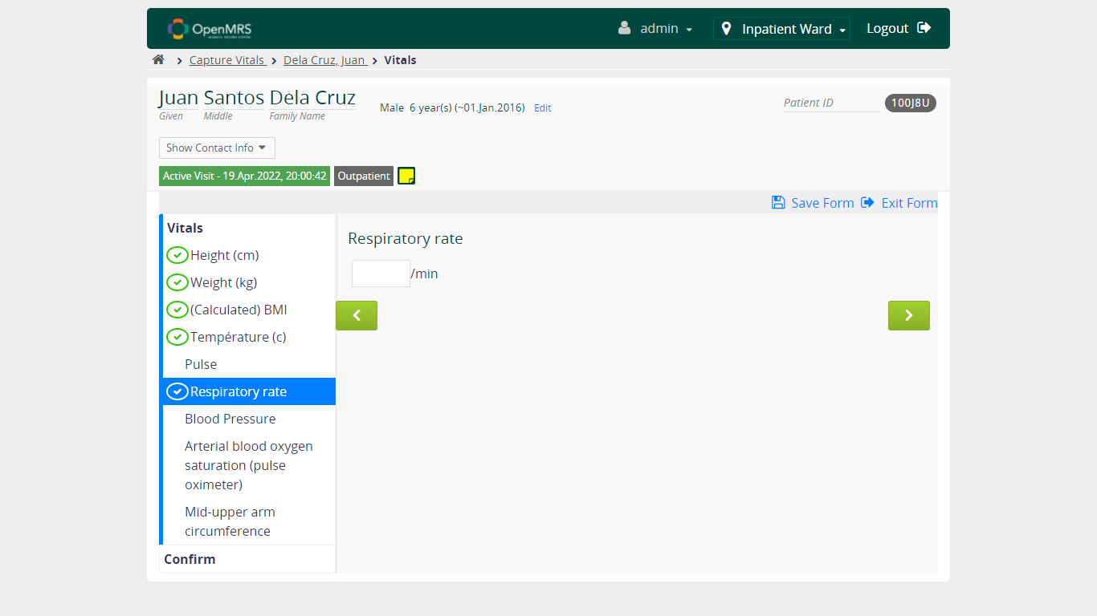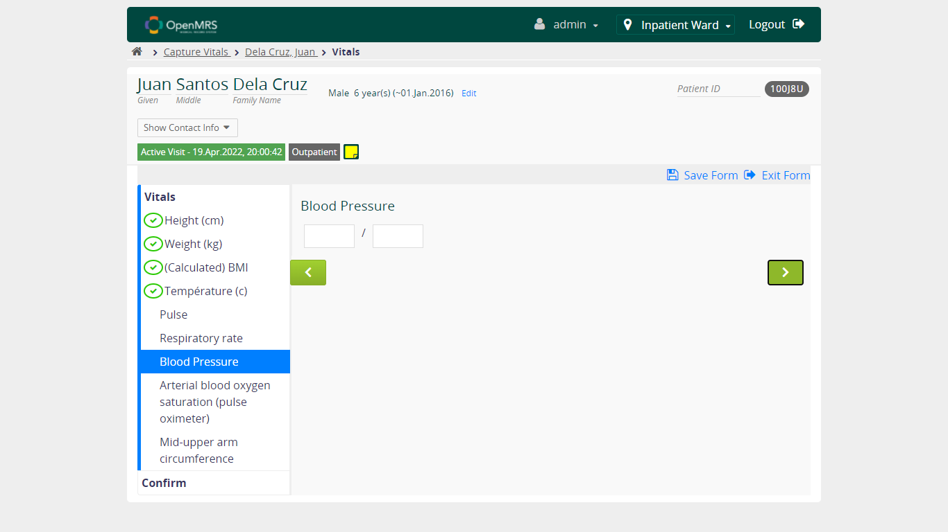

* 1. **Verify Capture Vitals Functionality - Blood Pressure**

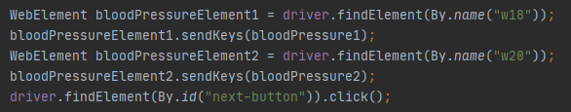

* + 1. **Verify User can continue to fill form when FILL VALID value in Blood Pressure field**

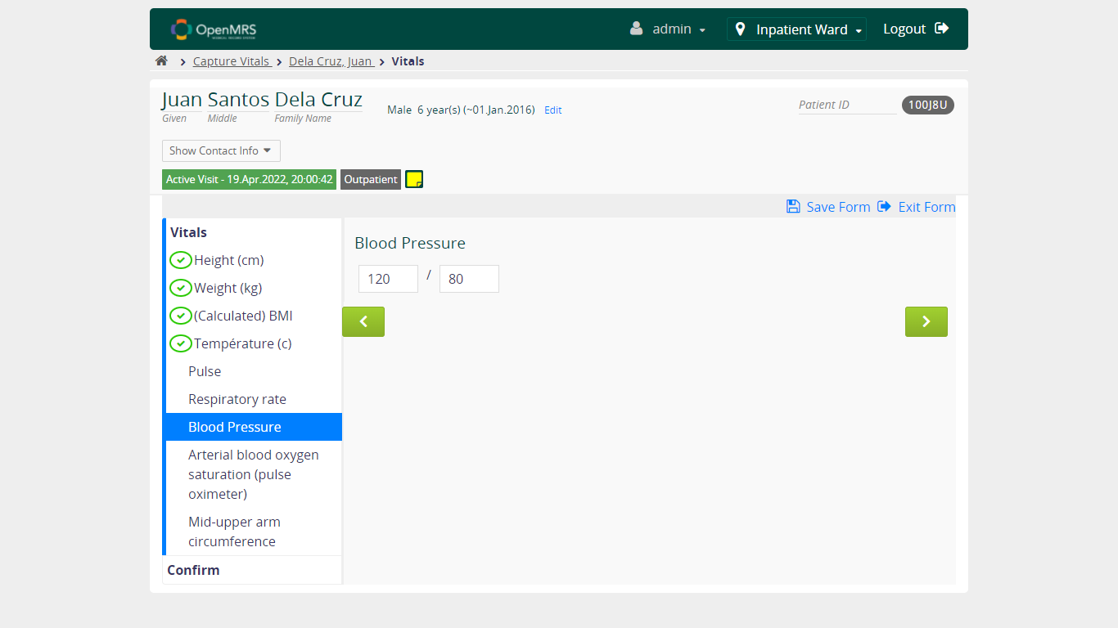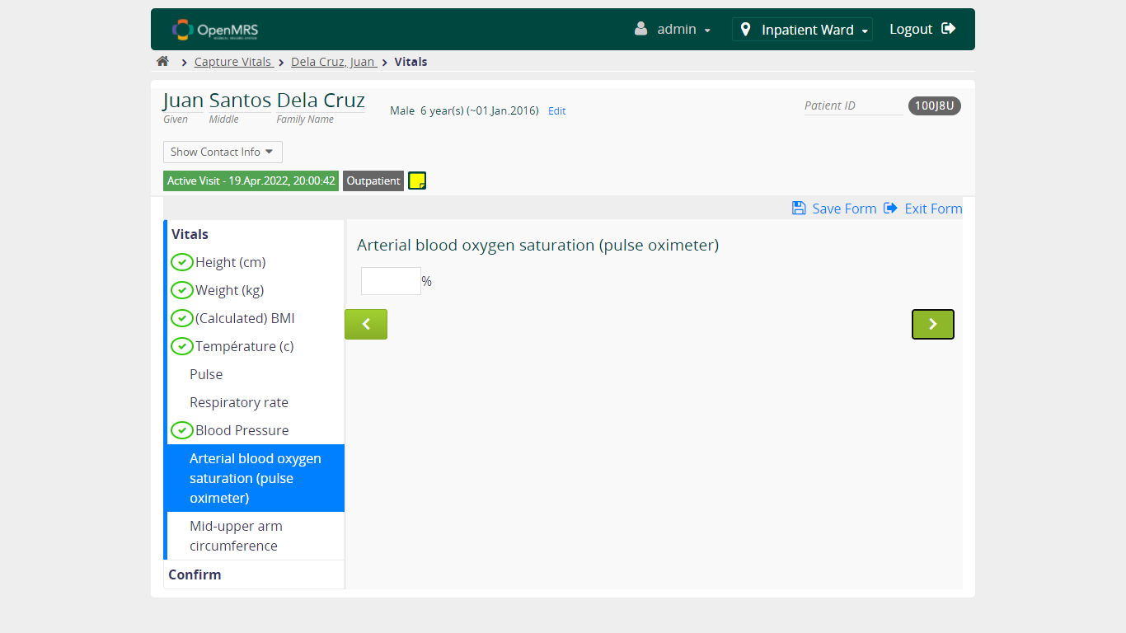

* + 1. **Verify User can continue to fill form when FILL UNVALID value in Blood Pressure field**

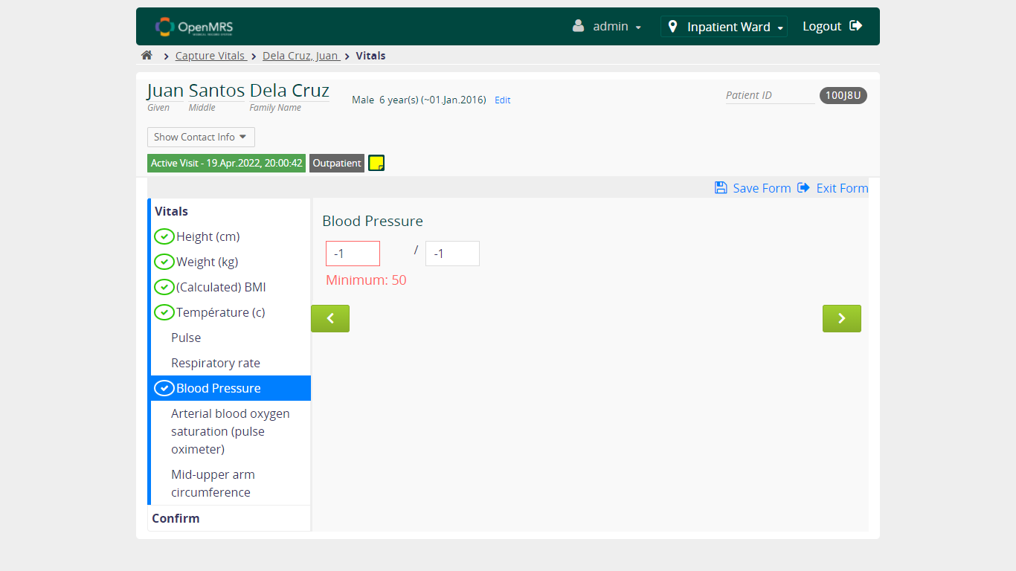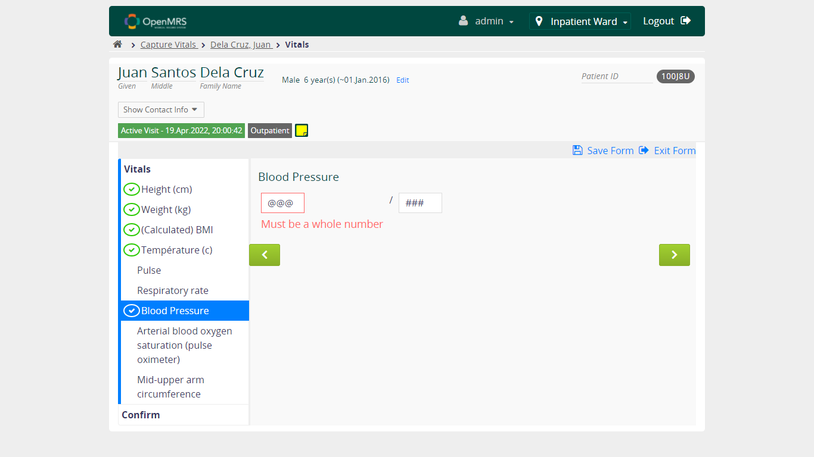

* + 1. **Verify User can continue to fill form when NOT FILL value in Blood Pressure field**



* 1. **Verify Capture Vitals Functionality - Arterial blood oxygen saturation (pulse oximeter)**

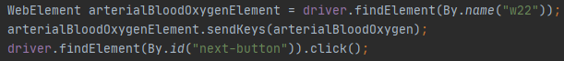

* + 1. **Verify User can continue to fill form when FILL VALID value in Arterial blood oxygen saturation (pulse oximeter) field**

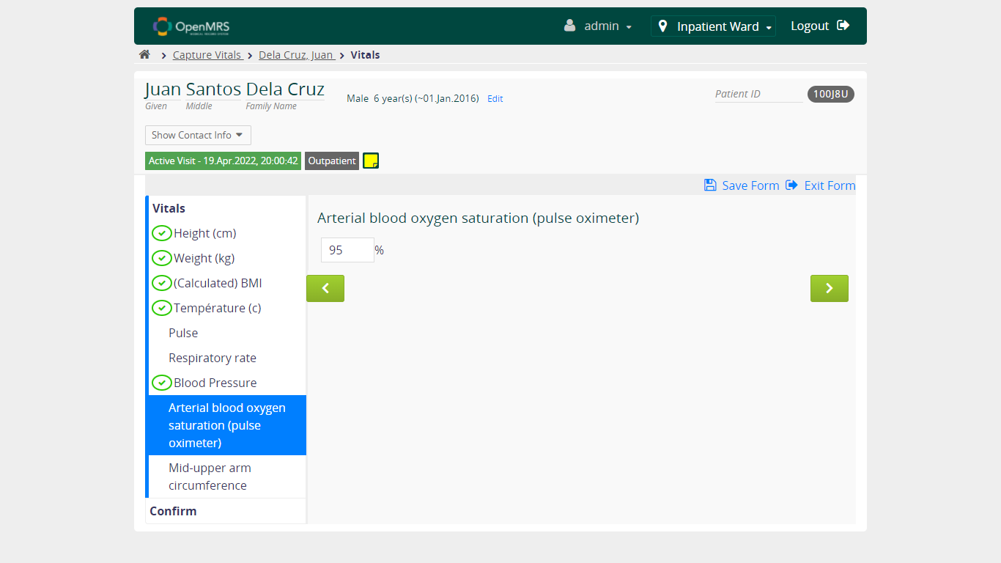

* + 1. **Verify User can continue to fill form when FILL UNVALID value in Arterial blood oxygen saturation (pulse oximeter) field**

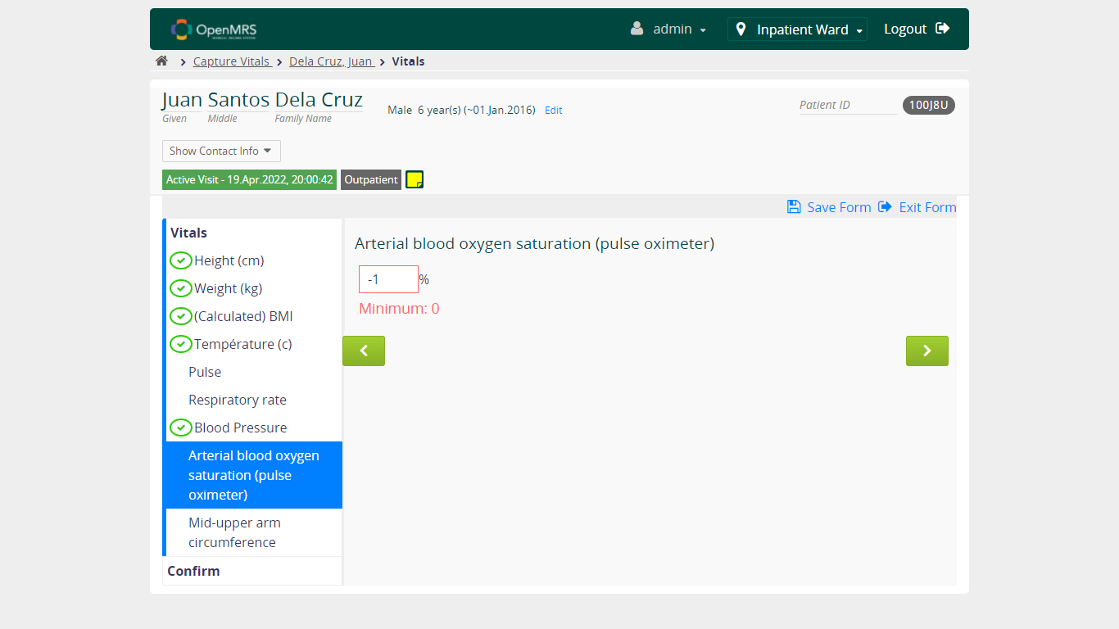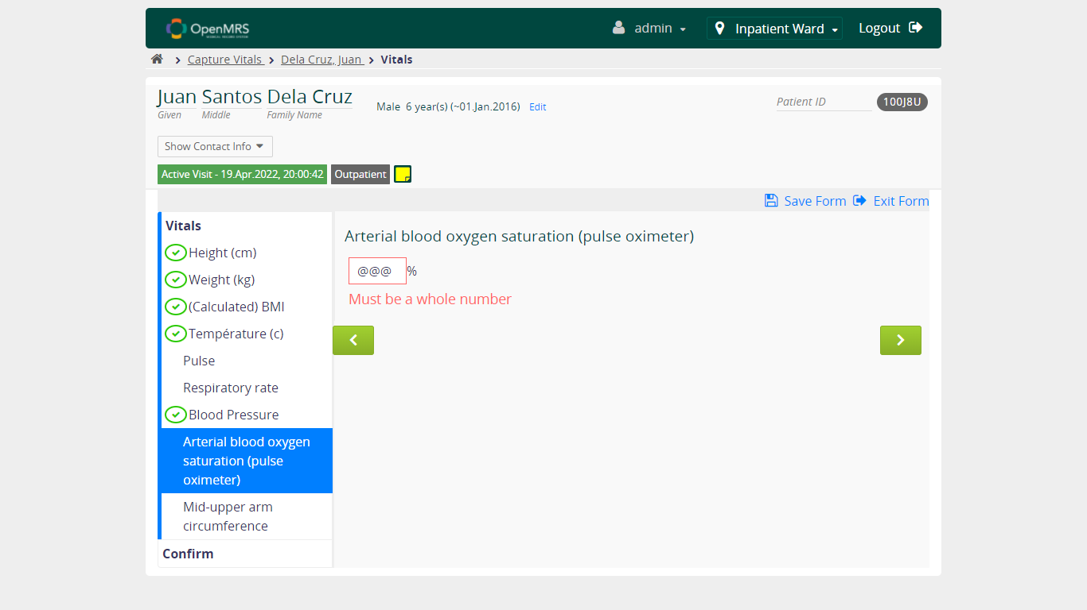

* + 1. **Verify User can continue to fill form when NOT FILL value in Arterial blood oxygen saturation (pulse oximeter) field**

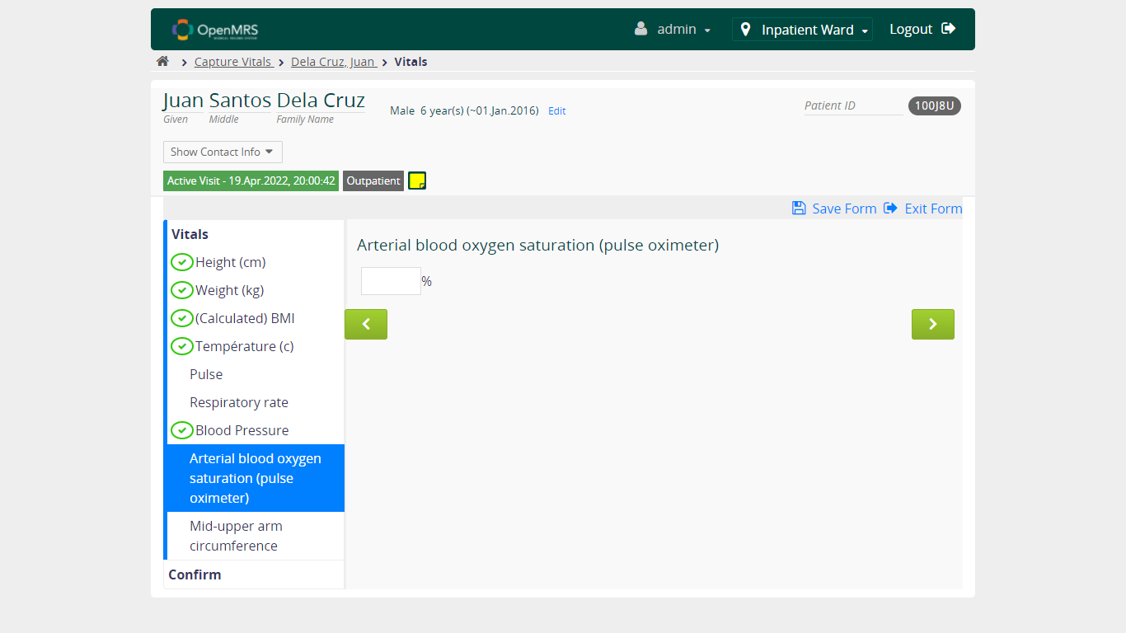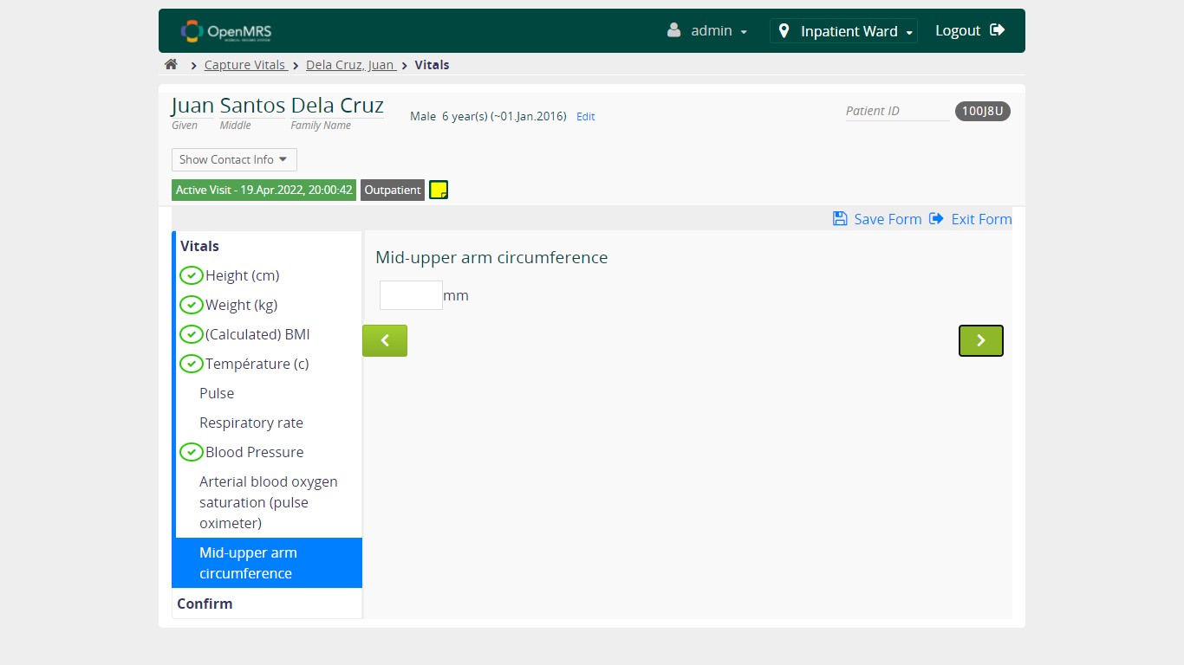

* 1. **Verify Capture Vitals Functionality - Mid-upper arm circumference**

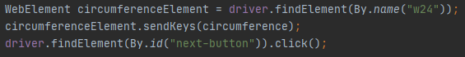

* + 1. **Verify User can continue to fill form when FILL VALID value in Mid-upper arm circumference field**

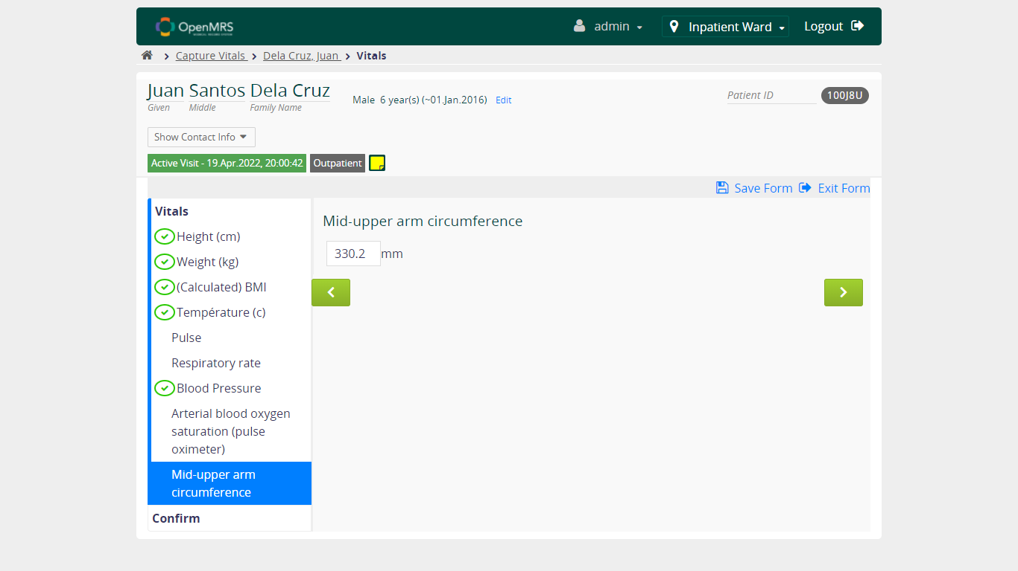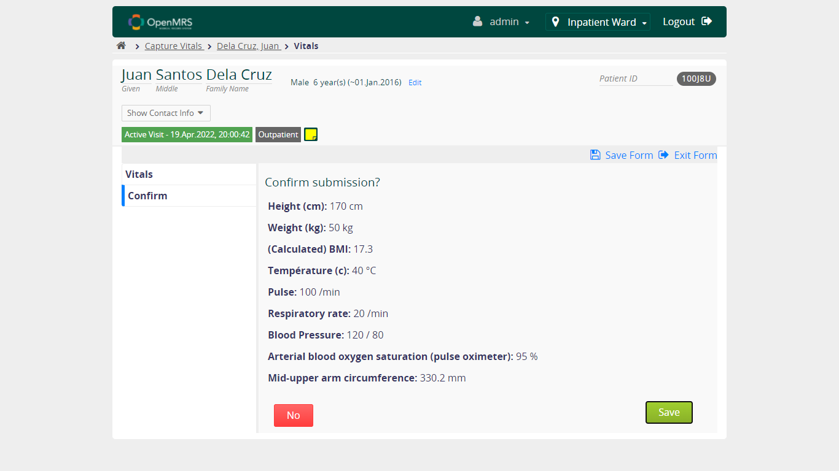

* + 1. **Verify User can continue to fill form when FILL UNVALID value in Mid-upper arm circumference field**

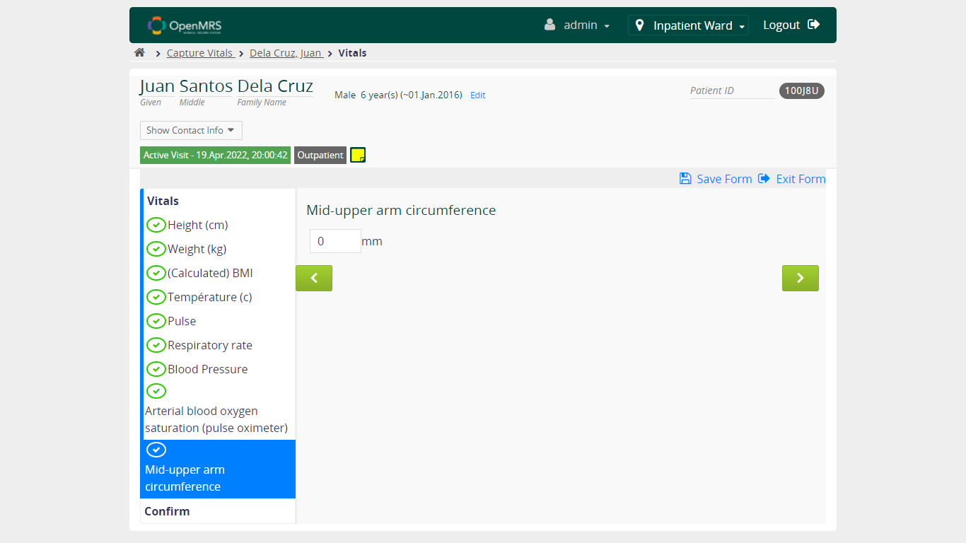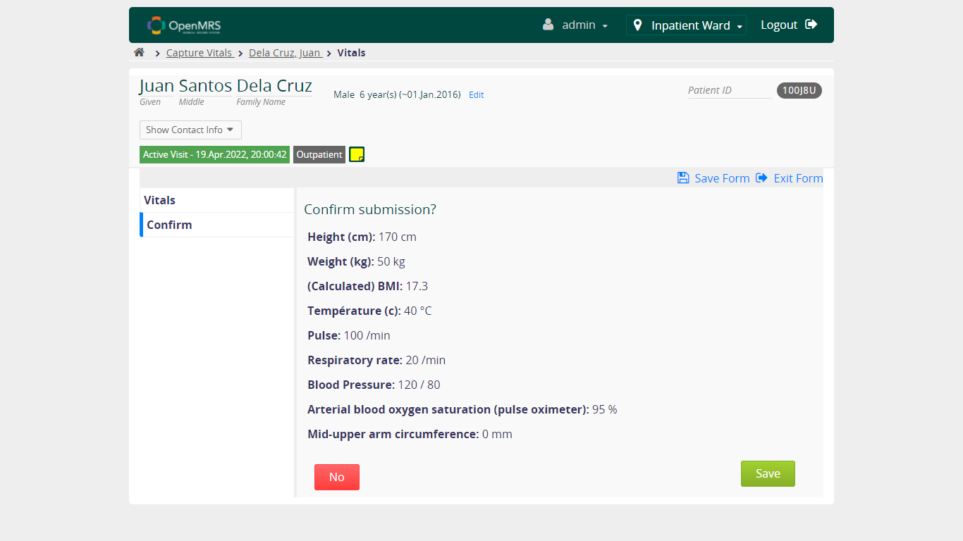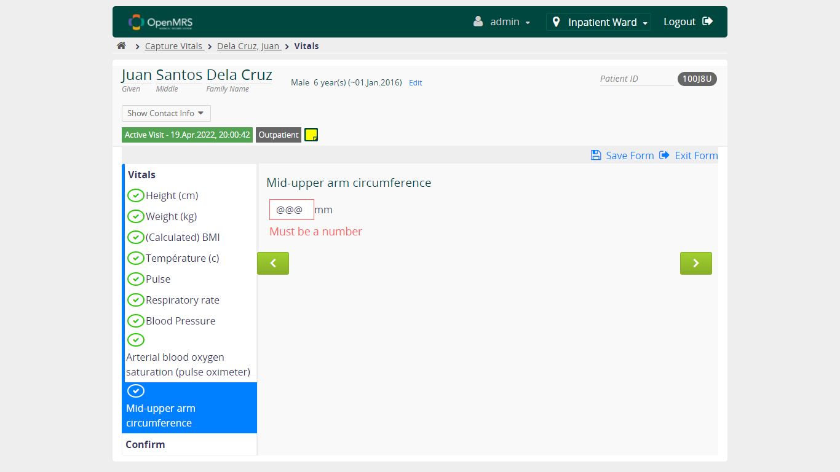

* + 1. **Verify User can continue to fill form when NOT FILL value in Mid-upper arm circumference field**

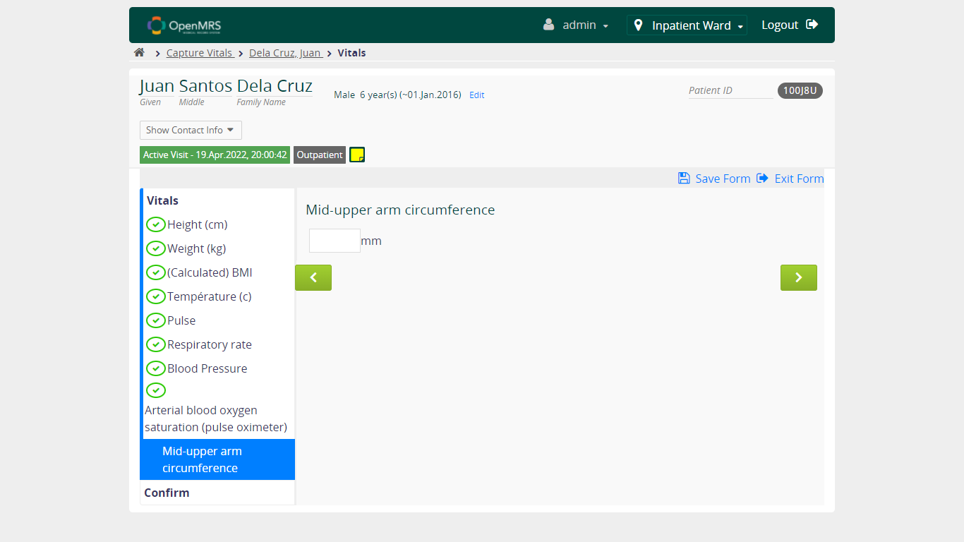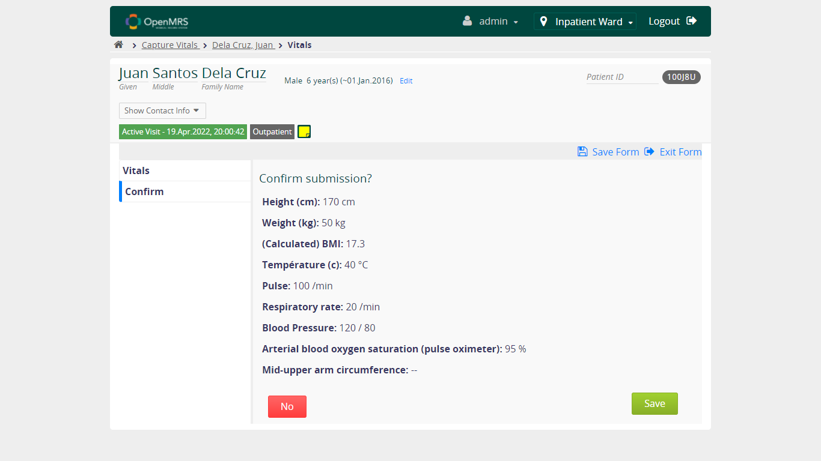

* 1. **Verify Capture Vitals Functionality - Confirm Submission**



* + 1. **Verify Case happened when click NO at Confirm submission page**

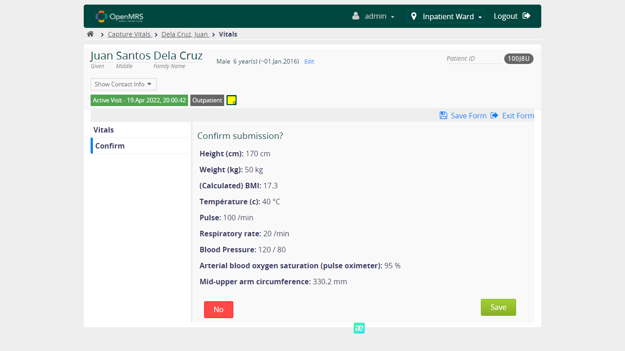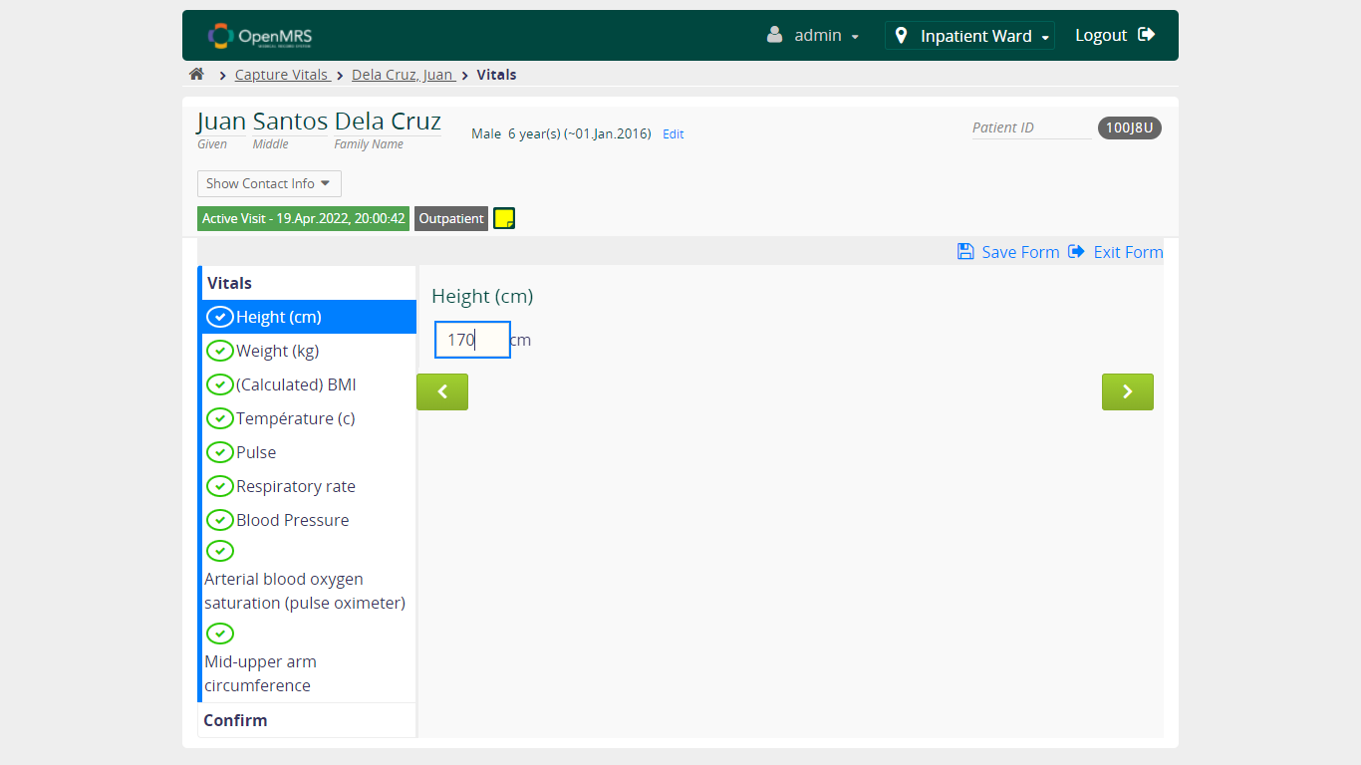

* + 1. **Verify Case happened when click SAVE at Confirm submission page**

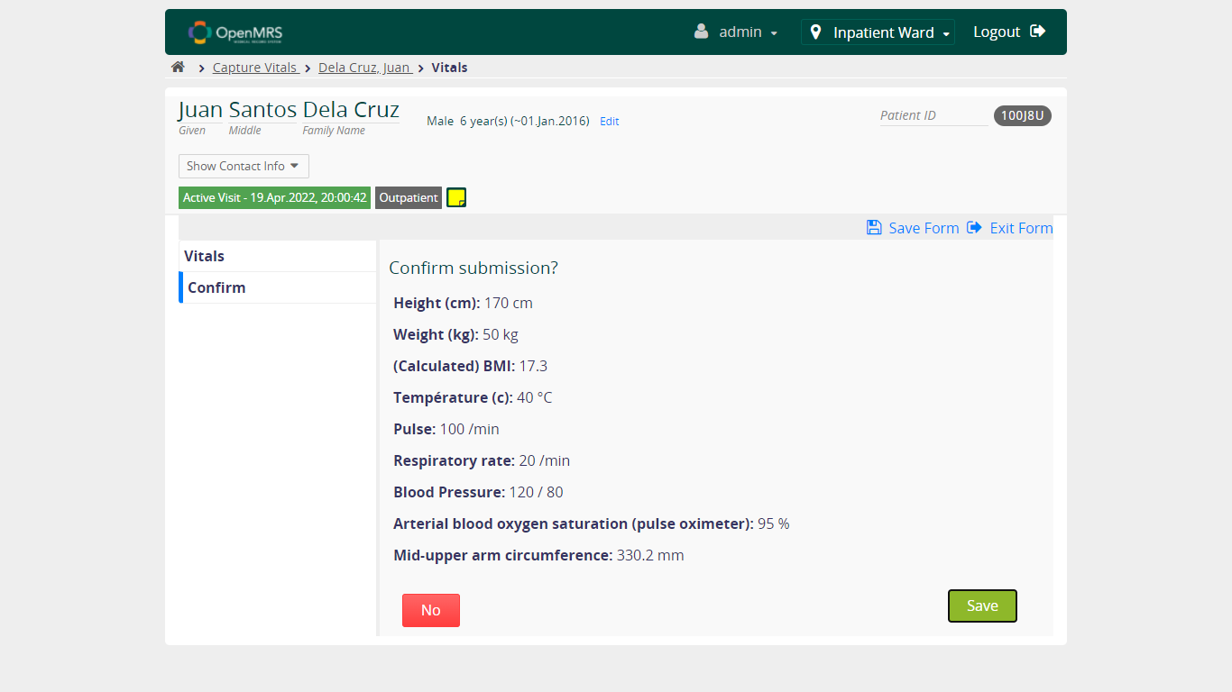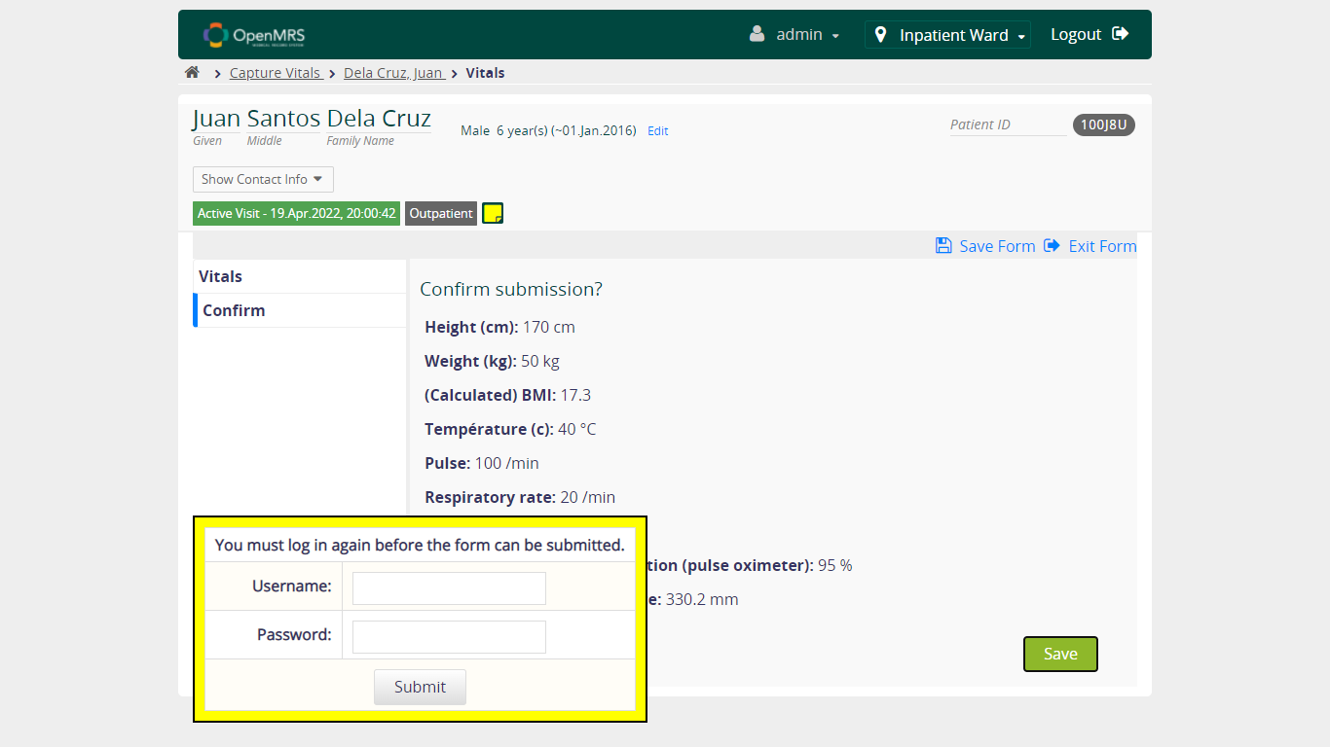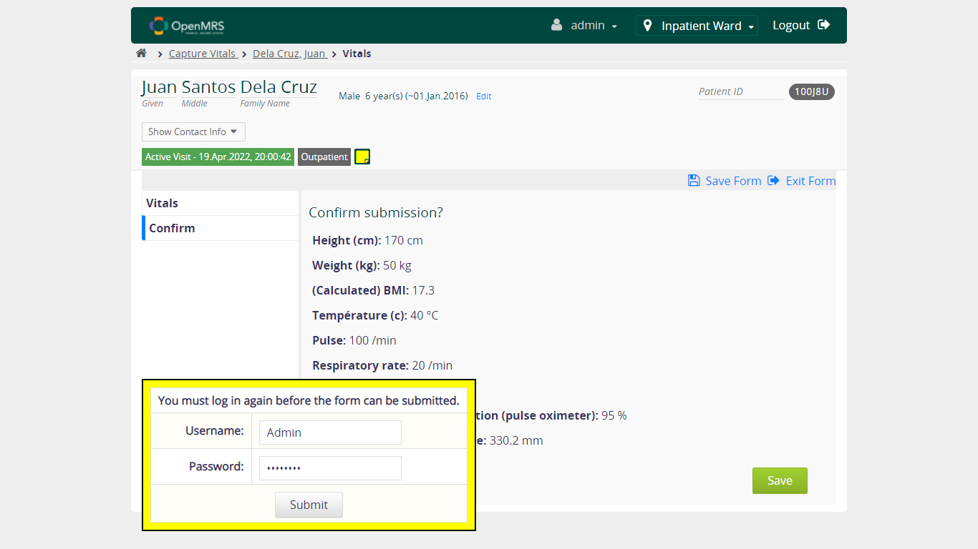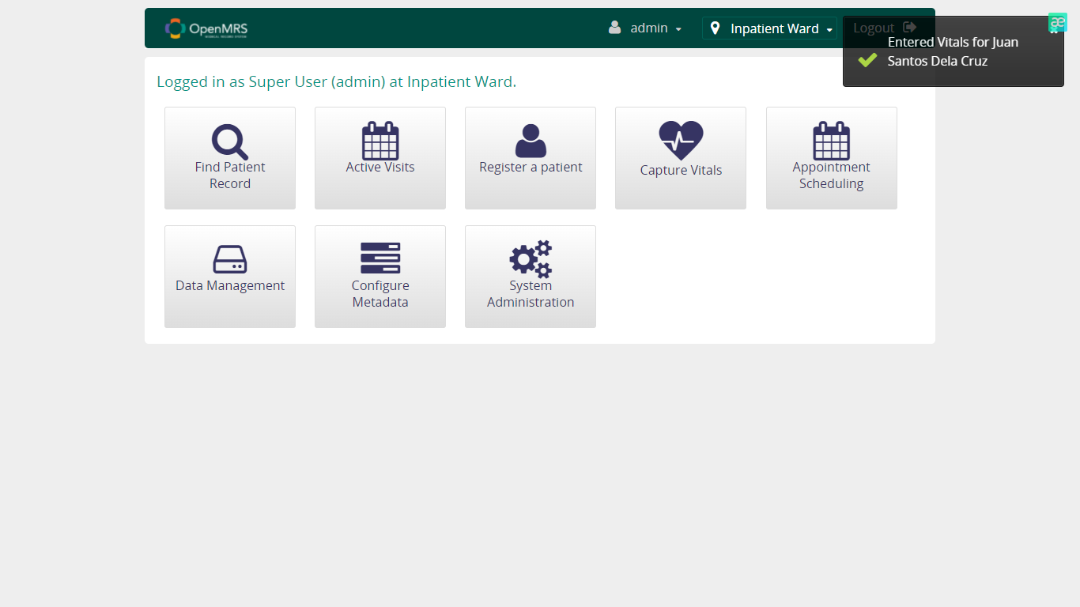

**Lab 2:**

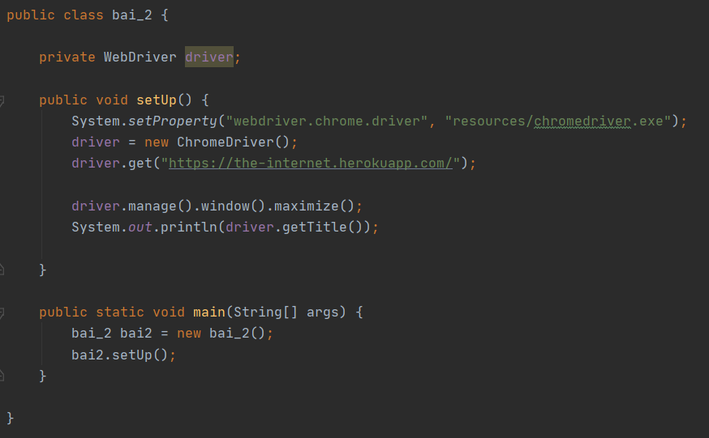

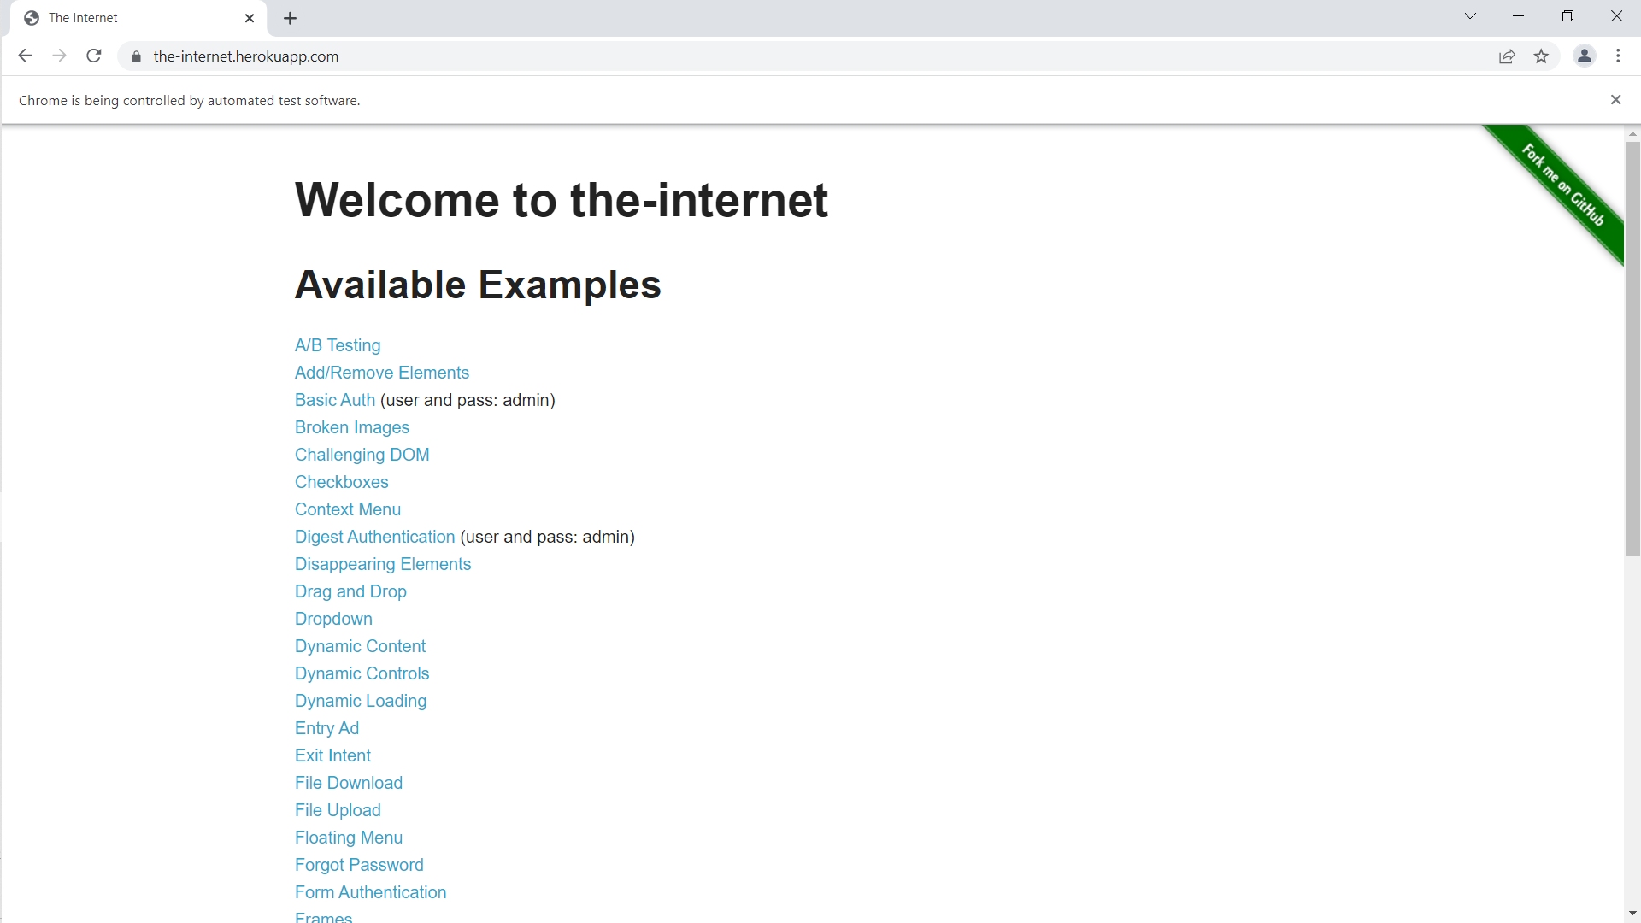

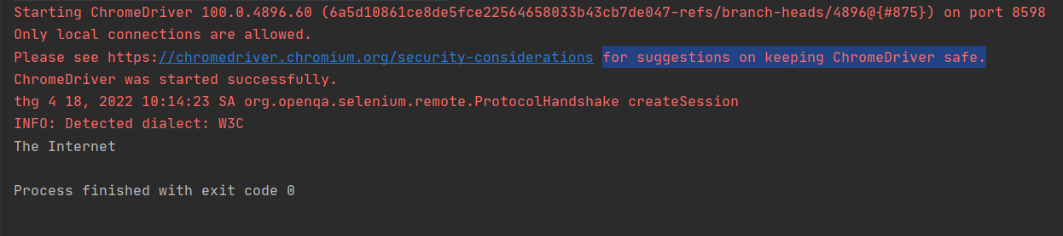

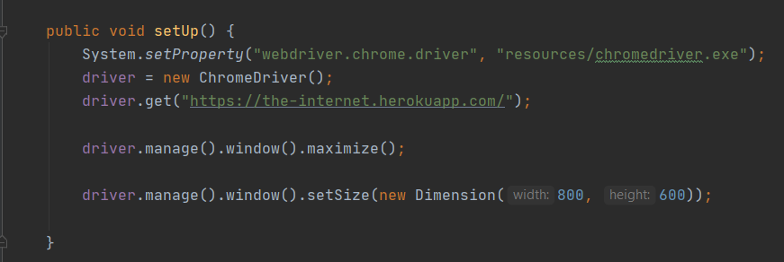

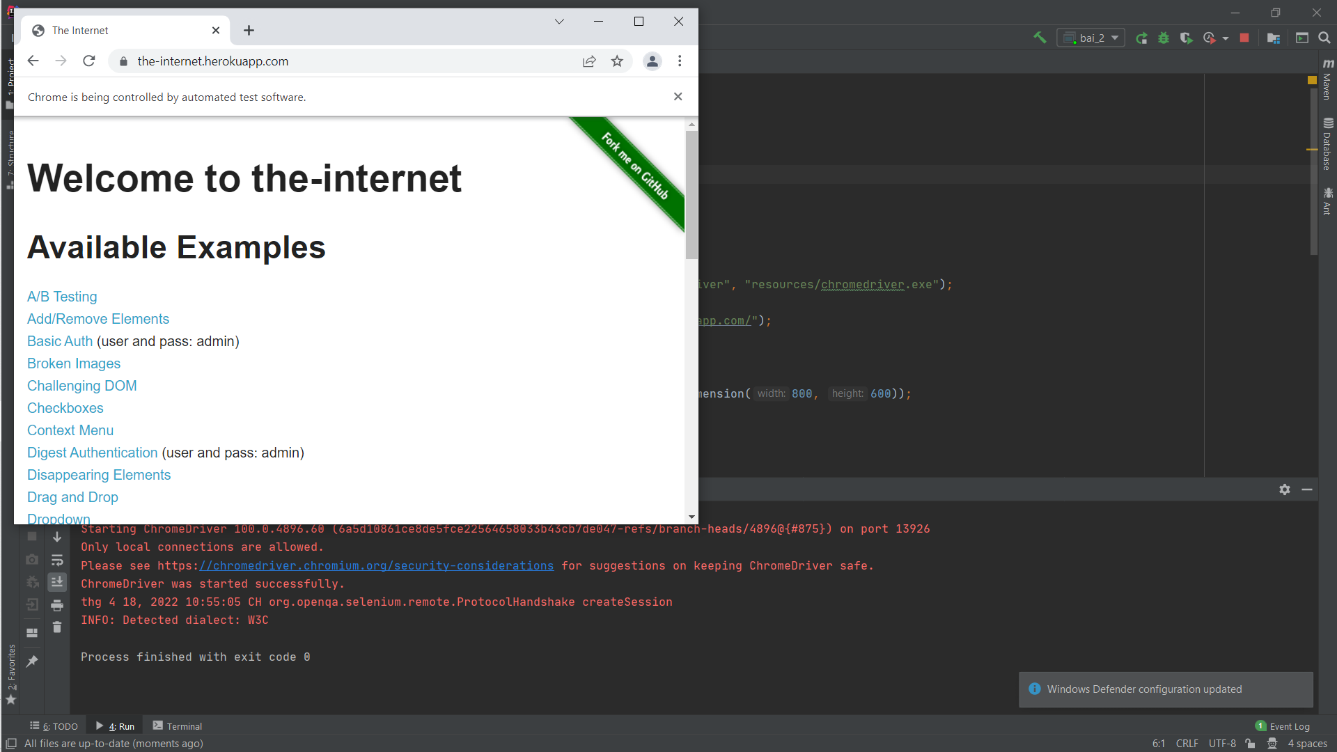

**Lab 3:**

* Tìm các phần tử trên form trong link: <https://demoqa.com/automation-practice-form>

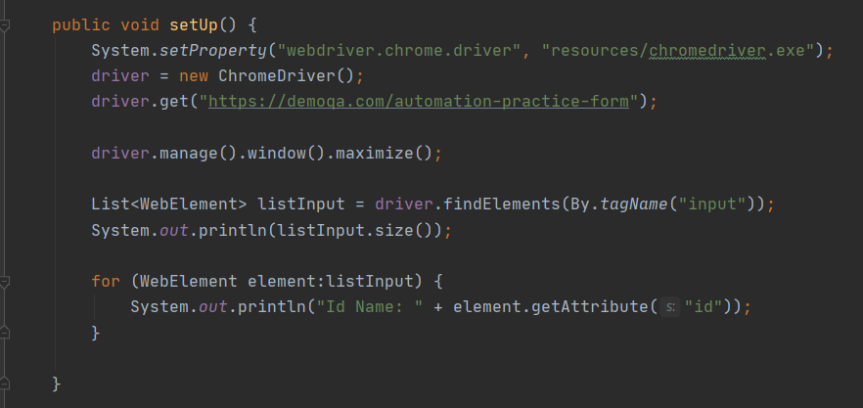

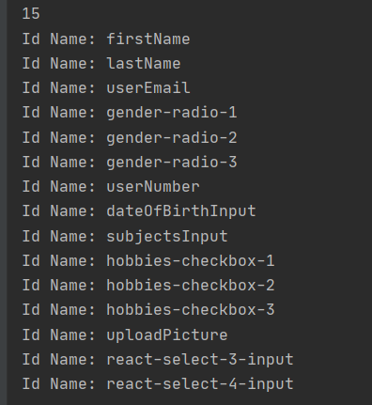

* Tìm các phần tử trên form trong link: <https://testpages.herokuapp.com/styled/basic-html-form-test.html>

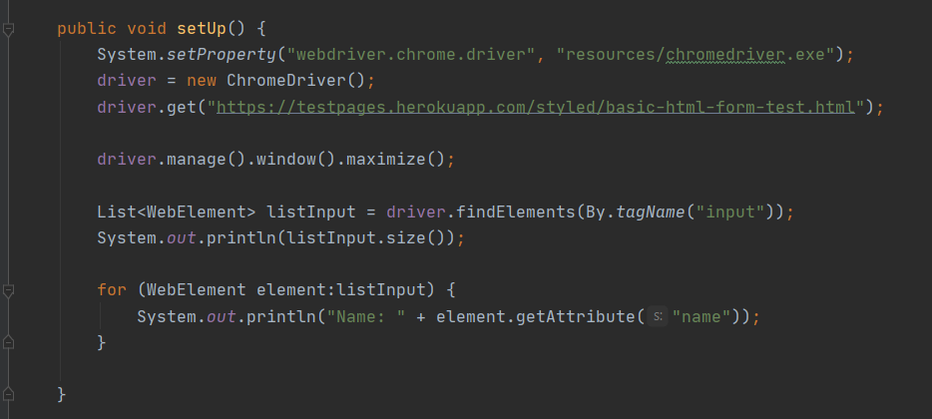

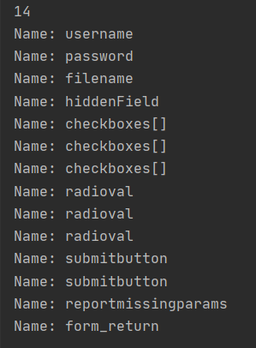

* Tìm các phần tử trên form trong link: <https://www.seleniumeasy.com/test/input-form-demo.html>

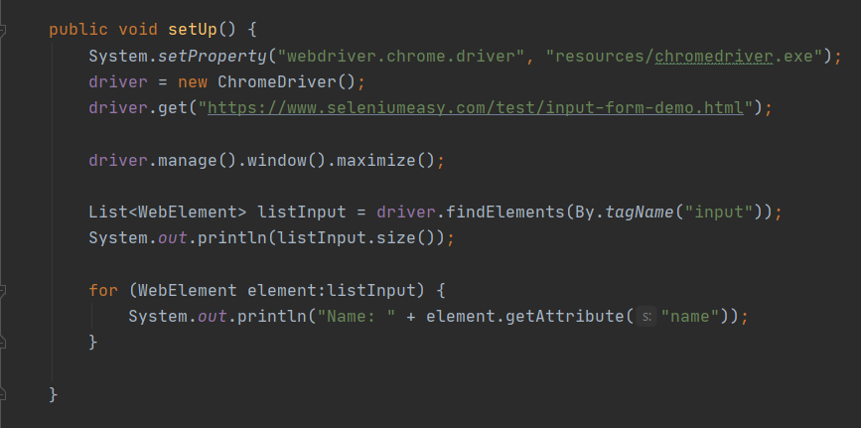

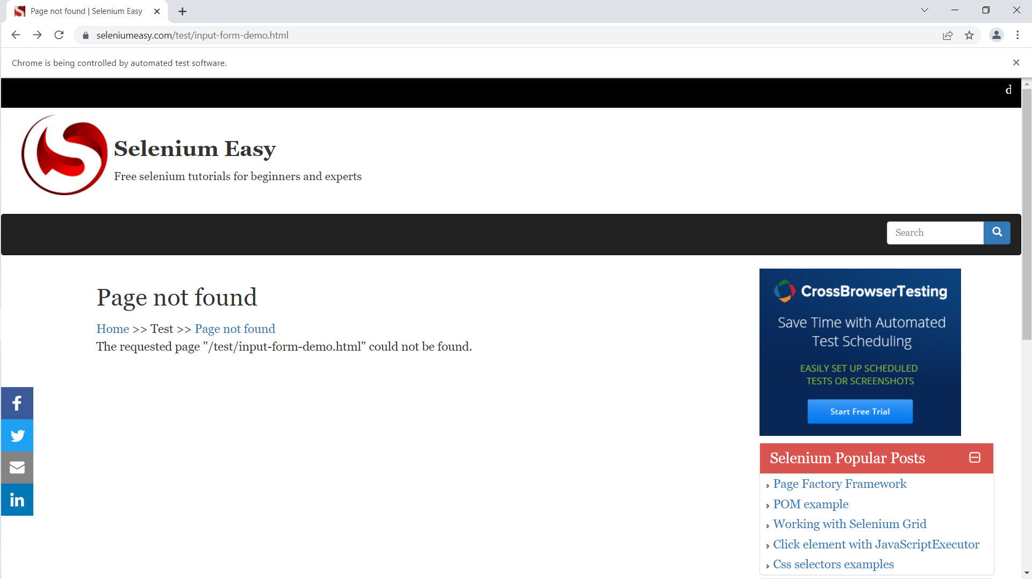

* Tìm các phần tử trên form trong link: <https://formy-project.herokuapp.com/form>

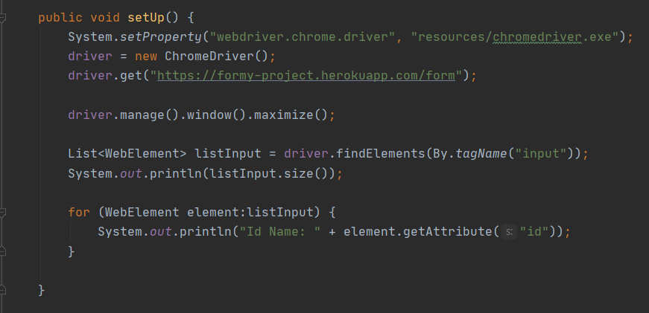

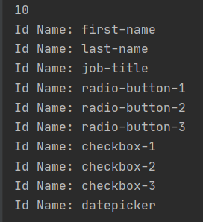

* Tìm các phần tử trên form trong link: <https://www.saucedemo.com/>

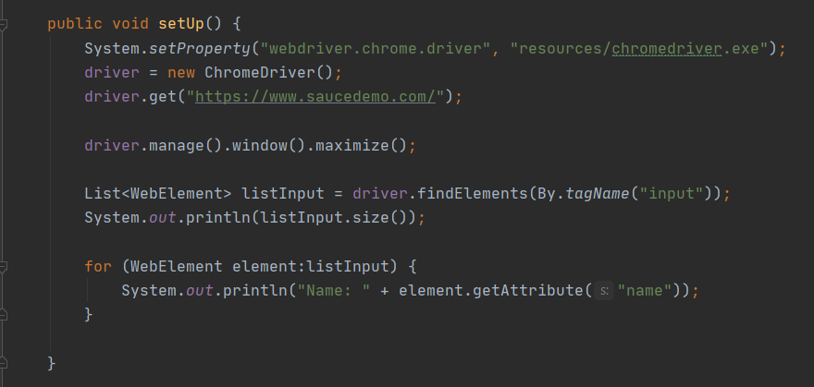

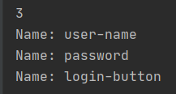

**Lab 4:**

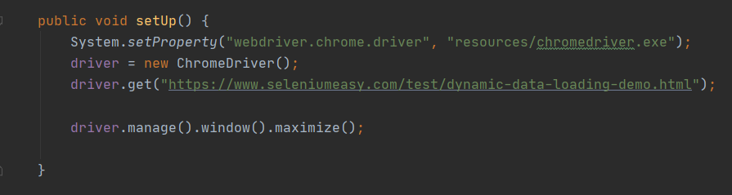

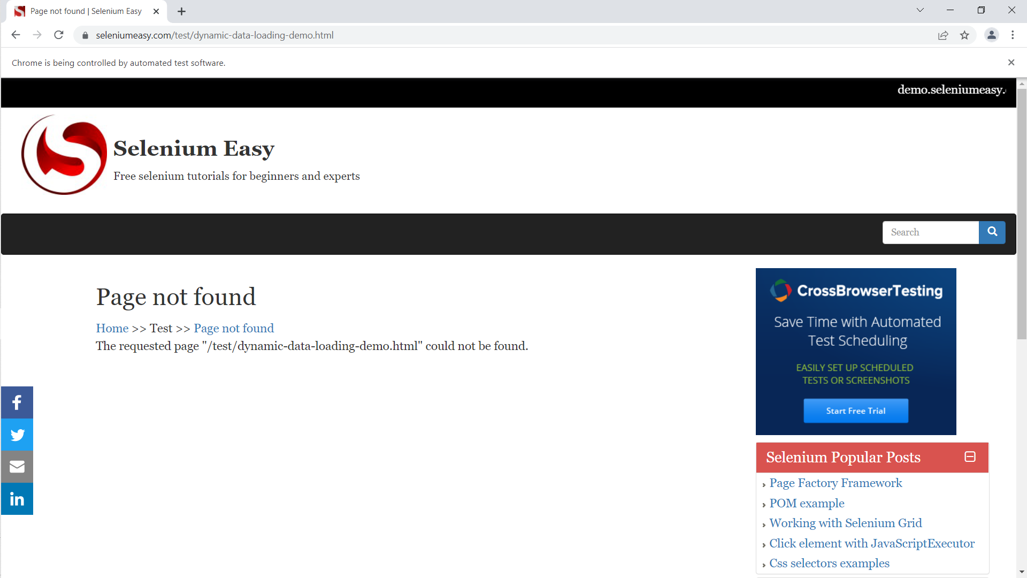

**Lab 5:**

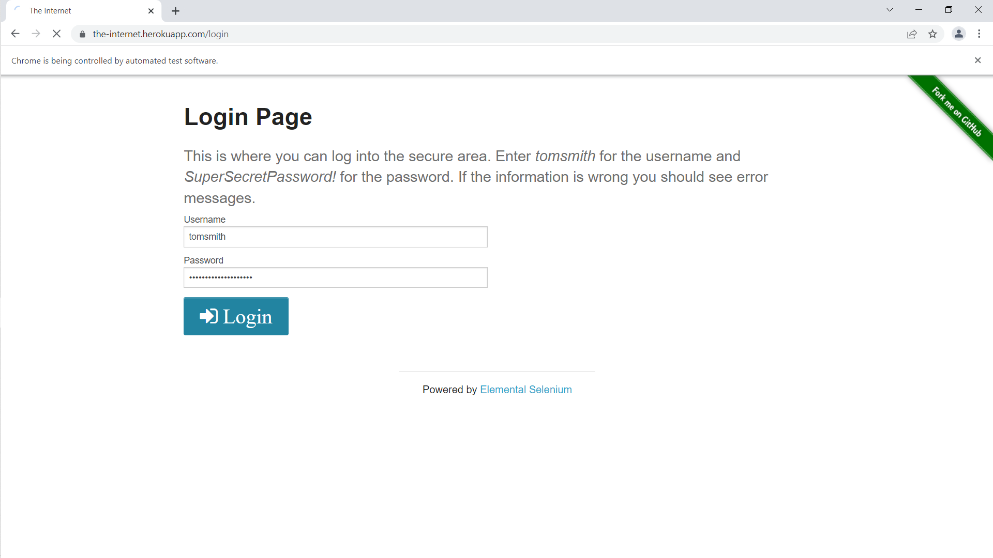

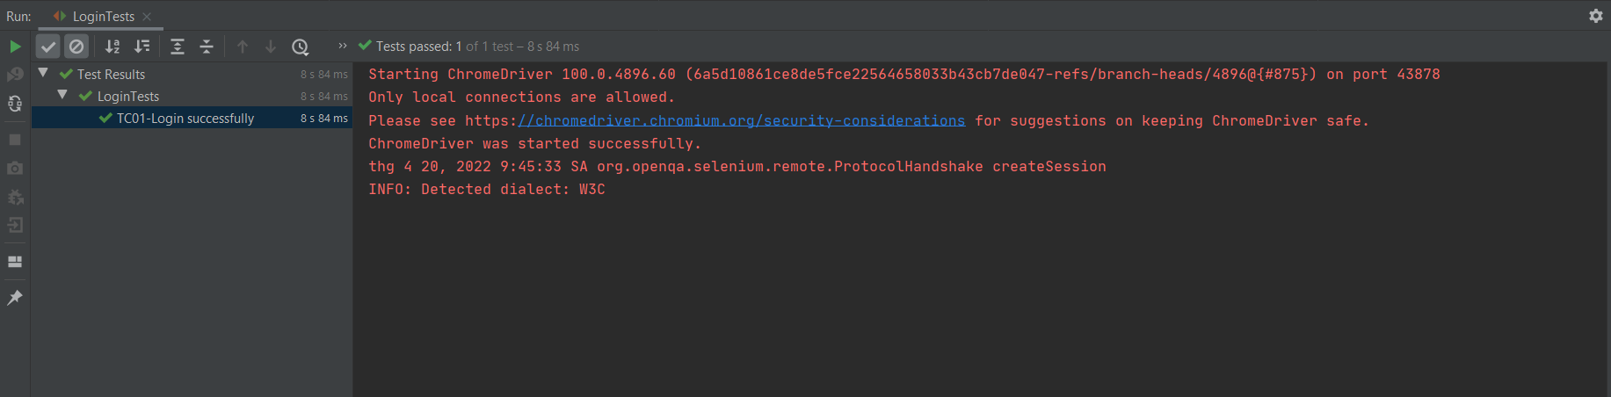

**Lab 6:**

